UNITED  NATIONS |  | EP
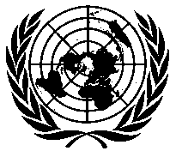 | United Nations  Environment  Programme | Distr.  GENERAL  UNEP/OzL.Pro/ExCom/81/6/Corr.1  8 June 2018  ORIGINAL: ENGLISH
EXECUTIVE COMMITTEE OF
THE MULTILATERAL FUND FOR THE
IMPLEMENTATION OF THE MONTREAL PROTOCOL
Eighty-first Meeting
Montreal, 18-22 June 2018

Corrigendum

COUNTRY PROGRAMME DATA AND PROSPECTS FOR COMPLIANCE

This document is being issued to:

- Replace the figure 102.94 ODP tonnes with 61.76 ODP tonnes in the footnote * of Table 4;

- Replace the figure 92.98 ODP tonnes with 55.79 ODP tonnes in the footnote ** of Table 4.

