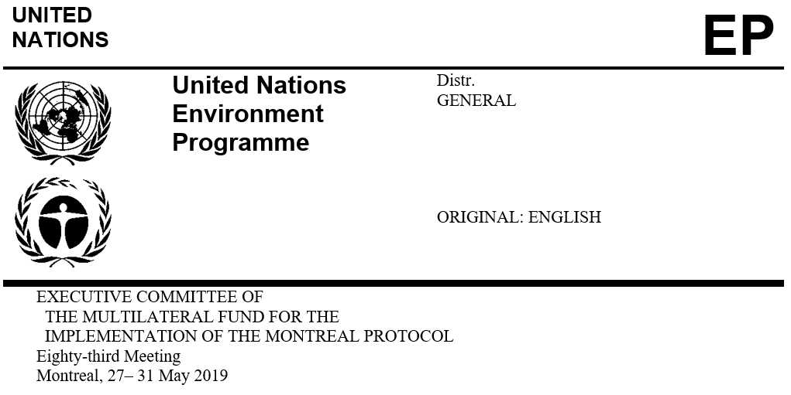

UNEP/OzL.Pro/ExCom/83/15
8 May 2019

Overview of issues identified DURING project review

This document consists of the following sections:

An overview of projects and activities submitted by bilateral and implementing agencies;

Issues identified during the project review process;
  - Projects and activities submitted for blanket approval; and
  - Investment projects for individual consideration.
Projects and activities submitted by bilateral and implementing agencies

Bilateral and implementing agencies submitted 101 funding requests for tranches of approved multi-year agreements, projects and activities amounting to US $96,021,850 (US $148,331,866 including amounts requested in principle), including agency support costs, where applicable. The funding requests covered:

Stage II of the HCFC production phase-out management plan (HPPMP) for one country (to be considered by the Sub-group on the Production Sector);

Tranches of approved HCFC phase-out management plans (HPMPs) for 19 countries;

An investment project to phase out HCFC-142b/HCFC-22 in the extruded polystyrene (XPS) foam sector in one country;

Renewals of institutional strengthening (IS) projects in 28 countries;

Preparation for stage II of HPMPs for nine countries and for stage III for four countries;

Control and phase-out of HFC-23 emissions in the production of HCFC-22 in one country (to be considered under agenda item 12(c));

An HFC-related investment project for one country;

Project preparation for HFC-related investment projects in three countries; and

Enabling activities for HFC phase-down for one country.

Following the project review process, 72 projects and activities totalling US $8,576,869, including agency support costs, are recommended for blanket approval, and 16 projects and activities totalling US $59,492,567 (including agency support costs), of which US $31,619,787 is for the third tranches of the XPS foam, industrial and commercial refrigeration (ICR), solvents and refrigeration servicing sector plans of stage II of the HPMP for China and US $25,138,537 for the first tranche of stage II of the HPPMP for China, are being forwarded for individual consideration. Together, the projects for blanket approval and those for individual consideration amount to US $68,069,436.

The project for enabling activities for HFC phase-down for one country (Syrian Arab Republic) is recommended for blanket approval and will be funded under the additional contributions.
HPMPs submitted and subsequently withdrawn (Islamic Republic of Iran, Pakistan, Serbia)

UNDP, on behalf of the Islamic Republic of Iran, submitted the request for the second tranche of stage II of the HPMP. Upon review of the proposal by the Secretariat and subsequent discussion with UNDP, the request could not be submitted for consideration by the Executive Committee as UNDP was unable to submit a report on the results of the conversion of the first 15 enterprises in the refrigeration and air-conditioning manufacturing sector to low-global-warming-potential alternatives, highlighting the lessons learned and challenges faced (decision 77/44(d)), and as UNIDO was unable to justify the incremental cost of several changes that would take place in the foam sector plan. The tranche request is expected to be submitted to the 84th meeting.

In line with decision 76/39(f), UNIDO had submitted a project for the conversion of an XPS foam enterprise (Symbol Industry) to dimethyl ether (DME), CO₂, and HFO in Pakistan. The total cost of the project as submitted was US $871,527, plus support costs of US $61,007 for UNIDO; with a cost effectiveness of US $11.36/kg. Despite exhaustive discussions, UNIDO and the Secretariat could not reach an agreement on the overall cost of the project by the deadline for project negotiation. The Secretariat subsequently requested that this project be resubmitted to the 84th meeting. The Secretariat further noted that deferring the submission of this project would not affect the compliance of the Government of Pakistan with Montreal Protocol obligations, as the Government had already agreed to reduce HCFC consumption by 50 per cent of its baseline by 2020 through the activities included in stages I and II of the HPMP, which did not include the conversion in the XPS foam sector.

UNIDO, on behalf of the Government of Serbia, submitted a project for the elimination of R-404A in the manufacturing of industrial freezing tunnels in the enterprise Eko Elektrofrigo. Subsequent to a discussion, the project was withdrawn as it did not appear to meet the criteria listed in decisions 78/3(g) and 79/45. In particular, the application appeared to be in the assembly sub-sector, rather than the manufacturing sector, and the replicability of the technology was limited. Noting that to date no stand-alone HFC projects have been submitted from the Europe and Central Asia region, and that geographic distribution is included amongst the criteria for consideration of HFC stand-alone projects specified in decision 79/45, the Secretariat suggested that UNIDO consider submitting another project from that region to the 84th meeting that meets the criteria of decision 78/3(g) and decision 79/45.

IS renewal requests

The Secretariat reviewed the terminal reports and requests for extension of IS funding for 28 countries against relevant decisions, including decision 74/51(c) on the funding level for IS projects, and decision 74/51(e) on the requirement to include specific performance indicators for planned activities. All requests were cross-checked against: previous IS reports; progress reports on the implementation of country programmes (CP); data reported under Article 7 of the Montreal Protocol; the latest reports on the implementation of HPMPs; bilateral and implementing agencies’ progress reports submitted to the 82nd meeting; and relevant decisions on compliance adopted by the Parties to the Montreal Protocol. All countries had 2017 CP implementation data, and 18 countries had submitted the 2018 data as at issuance of the present document. All countries reported that they had achieved all or a majority of the targets set for the specific performance indicators that are part of the progress report for the previous IS phase. The Secretariat recommended all IS projects submitted to the 83rd meeting for blanket approval.

Funding withheld pending submission of verification reports or meeting specific conditions

No approved funds are currently being withheld by the Treasurer pending submission of a verification report or meeting a specific condition.
Summary of prices of the controlled substances and alternatives

At the 79th meeting, the Executive Committee requested the Secretariat to include in this document a summary of the prices of the controlled substances and the alternatives to be phased in, as communicated by enterprises requesting funding in any new project proposal, including clarification of any differences between those and the prices reported in the CP data report. No new investment projects are being presented for consideration at the 83rd meeting.
Issues identified during project review

No new policy issues for the attention of the Committee were identified during the review of projects submitted for consideration at the 83rd meeting.

Projects and activities submitted for blanket approval
Verification reports of low-volume-consuming (LVC) countries’ compliance with their HPMP agreements

In line with decision 61/46(c), the Secretariat selected a sample of 17 countries for the purpose of verifying compliance with the HPMP agreement, as shown in Table 1. One of the criteria used to select the countries for verification was the proximity of the next tranche of their HPMP (between 2020 and 2021) and, where possible, not having been previously selected for verification (this included several Pacific Island Countries). However, noting the limited number of Article 5 countries classified as LVC countries that have not been previously selected to undertake verification, there may be some countries on this list where funding for verification was already provided in the past. In considering these, the Secretariat used additional criteria for selection: that their previous verification should have been approved more than four years ago and was completed, in addition to the criteria of geographic distribution, level of consumption, and distribution among bilateral and implementing agencies. The countries selected (four in Africa, nine in Asia, two in Europe, and two in Latin America and the Caribbean) are listed below.
Table 1. Sample of Article 5 countries for verification of compliance with their HPMP agreement
No. | Country | HCFC baseline (mt) | Lead/cooperating agency | Next tranche request
1 | Angola (stage II) | 290.0 | UNDP | 2021
2 | Armenia (stage II) | 126.7 | UNDP | 2020
3 | Burkina Faso | 525.1 | UNEP | 2020
4 | Cambodia | 272.2 | UNEP | 2020
5 | Cook Islands | 0.9 | UNEP | 2020
6 | Guatemala | 143.8 | UNIDO | 2020
7 | Honduras | 344.6 | UNIDO | 2020
8 | Kiribati | 1.0 | UNEP | 2020
9 | Lesotho | 62.7 | Germany | 2020
10 | Marshall Islands | 4.0 | UNEP | 2020
11 | Micronesia (Federated States of) | 2.6 | UNEP | 2020
12 | Montenegro | 39.0 | UNIDO | 2020
13 | Nauru | 0.2 | UNEP | 2020
14 | Niue | 0.2 | UNEP | 2020
15 | South Sudan | 75.0 | UNEP | 2019 (from 2018) / 2020
16 | Tuvalu | 1.6 | UNEP | 2020
17 | Vanuatu | 5.1 | UNEP | 2020

Secretariat’s recommendation

The Executive Committee may wish to request relevant bilateral and implementing agencies to include in their amendments to their respective work programmes, due for submission to the 84th meeting, funding, in the amount of US $30,000, plus agency support costs, for verification reports for stage I of the HPMPs for Burkina Faso, Cambodia, Cook Islands, Guatemala, Honduras, Kiribati, Lesotho, Marshall Islands, Micronesia (Federated States of), Montenegro, Nauru, Niue, South Sudan, Tuvalu and Vanuatu, and for verification reports for stage II of the HPMPs for Angola and Armenia.

Annex I to the present document lists 72 projects and activities totalling US $8,576,869, including agency support costs, that are recommended for blanket approval. The approval of these projects would include the relevant conditions or provisions in the corresponding project evaluation sheets, as well as the approval of implementation programmes associated with the relevant tranches of multi-year projects.

Investment projects for individual consideration

Sixteen projects/activities totalling US $59,492,567, including agency support costs, of which US $31,619,787, including agency support costs, is for the third tranches of the XPS foam, ICR, solvents and refrigeration servicing sector plans of stage II of the HPMP for China, and US $25,138,537, including agency support costs, for the first tranche of stage II of the HPPMP for China (US $109,769,643 including amount requested in principle, of which US $75,415,613 is for the HPPMP for China), after the review by the Secretariat, are proposed for individual consideration.

To facilitate the Executive Committee’s consideration of the investment projects for individual consideration, the Secretariat has classified the projects by sector, and has grouped them according to the issues, as shown in Table 2.

Table 2. Investment projects submitted for individual consideration
Country | Project | Agency | ExCom document number | Issue
Tranche request of stage I, stage II HPMP
China | HCFC phase-out management plan (stage I, annual progress reports)  Room Air-Conditioning | UNIDO | 83/22 |  | Proposed scheme to allocate IOCs
China (Overarching) | HCFC phase-out management plan (stage II) | UNDP/UNEP/ UNIDO/World Bank/Germany/ Japan | 83/22 |  | Revision of the Agreement (decision 81/45)
China  (XPS foam) | HCFC phase-out management plan (stage II, third tranche) | UNIDO/  Germany | 83/22 |  | Tranche above 5 million. All technical and cost issues resolved
China  (ICR) | HCFC phase-out management plan (stage II, third tranche) | UNDP | 83/22 |  | Tranche above 5 million. All technical and cost issues resolved
China (Servicing) | HCFC phase-out management plan (stage II, third tranche) | UNEP/Japan/ Germany | 83/22 |  | All technical and cost issues resolved
China (Solvent) | HCFC phase-out management plan (stage II, third tranche) | UNDP | 83/22 | All technical and cost issues resolved
Kuwait | HCFC phase-out management plan (stage I, third tranche) | UNEP and UNIDO | 83/29 | Extension of stage I and revision of Agreement. All technical and cost issues resolved
Morocco | HCFC phase-out management plan (stage I, third tranche) | UNIDO | 83/32 | Extension of stage I and revision of Agreement. All technical and cost issues resolved

Key aspects related to HFC-23 by-product control technologies (decision 82/85).
The request also includes the Government of Germany’s component of the fourth tranche for the refrigeration and air-conditioning servicing sector plan and the enabling programme.
The Executive Committee decided to note that during the implementation of stage II of the HPMP, the Government of Pakistan could submit an investment project to phase out the use of HCFC-142b in the extruded polystyrene foam manufacturing sector on the condition that the country’s baseline consumption was revised to include HCFC-142b and approved by the Meeting of the Parties to the Montreal Protocol.
The cost-effectiveness threshold established for the XPS foam sector is US $10.27/kg.
Decision 79/4(c).
The Secretariat was requested to provide, at the first meeting of each year, a list representing 20 per cent of countries with an HCFC consumption baseline of up to 360 metric tonnes (mt), and with an approved HPMP, to approve funding for them for the purposes of verification of that country’s compliance with the HPMP agreement for that year.
The request also includes the Government of Germany’s component of the fourth tranche for the refrigeration and air-conditioning servicing sector plan and enabling programme.

