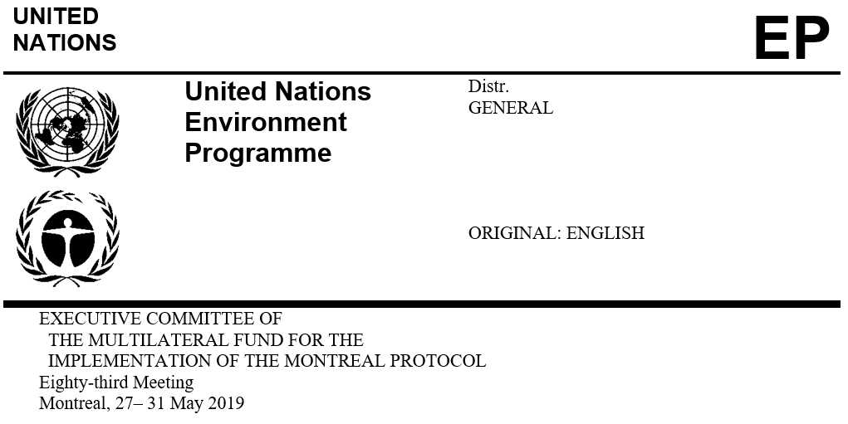

UNEP/OzL.Pro/ExCom/83/48/Corr.1
22 August 2019

Corrigendum

REPORT OF THE EIGHTY-THIRD MEETING OF THE EXECUTIVE COMMITTEE

This document is being issued to replace paragraph 68 with the following:

The Executive Committee decided:

To approve the terms of reference for the desk study for the evaluation of the energy efficiency in the servicing sector contained in document UNEP/OzL.Pro/ExCom/83/10/Rev.1;

That the desk study referred to in sub-paragraph (a) above will be submitted to the 86th meeting; and

To request the Senior Monitoring and Evaluation Officer to provide an update to the 84th meeting on the status of the desk study referred to in sub-paragraph (a) above.
(Decision 83/9)

