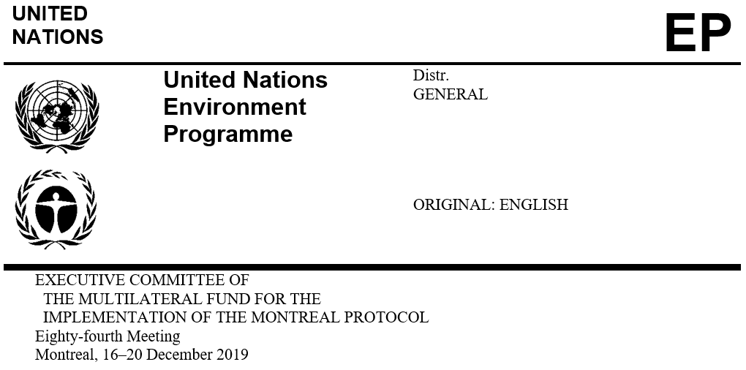

UNEP/OzL.Pro/ExCom/84/8
2 December 2019

APPROVED 2019, 2020 and 2021, AND PROPOSED 2022 BUDGETS OF THE FUND SECRETARIAT

This document presents the approved 2019, 2020 and 2021, and proposed 2022 budgets of the Fund Secretariat.
- It consists of the following sections:
- Approved 2019, 2020 and 2021 budgets
- Proposed 2022 budget
- Recommendation

The approved 2019, 2020 and 2021, and proposed 2022 budgets of the Fund Secretariat are presented in Annex I to the present document. Annex II provides the organization chart of the Secretariat and a summary table on role and responsibilities assigned to each post.
Approved 2019 budget

- The Treasurer has submitted the final 2018 accounts to the 84th meeting. Schedule 1.3 (actual expenses of the Secretariat budget in 2018) of the document indicates an unspent balance of US $1,743,969 of which an expenditure of US $97,506 has not been recorded in the 2018 accounts. Accordingly, it will be re-allocated to the approved 2019 budget, leaving an unspent balance in 2018 of US $1,646,463 (i.e., US $1,624,548 under the Secretariat budget and US $21,915 from the monitoring and evaluation work programme budget) to be returned to the Multilateral Fund at the 84th meeting.
- In reviewing the accounts for recent years, the Secretariat noted recurring savings in staff costs, largely due to the change in status of staff members which affects their benefits and entitlements in accordance with the United Nations staff regulations and rules, vacant posts pending filling, and the United States dollar/Canadian dollar exchange rate. The Secretariat also anticipates that staff movements due to retirement and new arrival in the next two years will result in one-off costs not budgeted for, that vacant posts will be filled, and that a potential change in the staffing structure will be required. In view of these, and noting that the last budget review had taken place in 2011, the Secretariat finds it timely to undertake a review of the staff costs in 2020 taking into account the Secretariat’s expenses presented in the final 2019 accounts.
Approved 2020 and 2021 budgets

The approved 2020 and 2021 budgets of the Fund Secretariat have maintained the staff cost at the same level pending discussion and a decision by the Executive Committee on staffing matters related to the upgrade of the three posts as presented below.

Staffing of the Secretariat

At the 83rd meeting, under Agenda item 3 “Secretariat activities” the Chief Officer explained that the responsibilities and complexity of the tasks associated with three posts had significantly increased as follows:

BL 1116 at P2 level. The responsibilities of the post have significantly increased as well as the complexity of the tasks. It is therefore recommended that the post be upgraded to P3 level as Programme Management Officer (instead of Associate Database Officer);

BL 1309 at G4 level. The responsibilities and tasks undertaken by the post have significantly evolved from performing clerical work to providing staff assistance. Based on a job description reflecting the current tasks of the incumbent, it is recommended that the post be upgraded to G5 level with a change in the post title to Staff Assistant; and

BL 1312 at G6 level. The responsibilities and tasks undertaken by the post have significantly evolved in volume and complexity as a result of the expansion of Umoja and the deployment of its next phase; it is therefore recommended that the post be upgraded to G7 level, as Senior Finance and Budget Assistant, noting that this post is funded from the programme support cost.

The Chief Officer therefore sought advice on whether he could submit requests to the Human Resources Management Service in Nairobi for a formal reclassification of the posts, the results of which would be reflected in the budgets of the Fund Secretariat to be submitted to the 84th meeting.

Subsequently, to allow the Executive Committee to obtain a clearer overview of the resources available and future needs of the Secretariat and assess the financial implication of the staffing proposal, the Secretariat was requested to inter alia present to the 84th meeting, an organization chart showing the staffing structure of the Secretariat and the roles and responsibilities assigned to each post (decision 83/1(b)).

In response to the decision, Annex II to the present document contains the organization chart of the Secretariat and a summary table on role and responsibilities assigned to each post.

With regard to the upgrade of the three posts, the Secretariat sent an advanced classification request for indicative levels of the three posts for information purpose, and received notices from the Classification Officer of the United Nations Office in Nairobi confirming that the three posts could be classified at one level higher than their present level.

The overall financial implication of the upgrades of the three posts has been estimated at US $17,000 (of which US $7,000 is from programme support costs).

The Executive Committee may wish to consider approving the upgrade of the three posts: from P2 to P3; G4 to G5; and G6 to G7, within the Secretariat budgetary allocations, and allowing for the revision of the post levels and change in titles in the approved 2020 and 2021 budgets accordingly.

Proposed 2022 budget
- The proposed 2022 budget is based on the 2021 budget. It makes provision for two meetings of the Executive Committee in Montreal, and continue to apply a 3 per cent inflation rate to staff cost only.

Recommendation
- The Executive Committee may wish:
- To note:

- The document on the approved 2019, 2020, and 2021, and proposed 2022 budgets of the Fund Secretariat contained in UNEP/OzL.Pro/ExCom/84/8;

- That US $97,506 in expenditures not recorded in the 2018 accounts had been reallocated to the 2019 budget;

- The return of US $1,646,463 (US $1,624,548 from the approved 2018 budget for the Secretariat and US $21,915 from the approved 2018 budget for the monitoring and evaluation work programme) to the Multilateral Fund at the 84th meeting;

- To approve the proposed 2022 budget of US $7,949,630, based on the 2021 budget, including two meetings of the Executive Committee in Montreal; and a 3 per cent increase in staff cost as reflected in Annex I to the present document;

- To approve the upgrade of the posts of the Associate Database Officer (BL 1116) from P2 to P3, the Team Assistant (BL 1309) from G4 to G5, and the Finance and Budget Assistant (BL 1312) from G6 to G7, with the corresponding change in titles starting 2020; and

- To request the Secretariat to continue monitoring its staff costs to assess the appropriate rate of increase for future years and to report back to the 86th meeting taking into account the Secretariat’s expenses presented in the final 2019 accounts.

UNEP/OzL.Pro/ExCom/84/6
Column E of Schedule 1.3 (Annex I of document UNEP/OzL.Pro/ExCom/84/6)
UNEP/OzL.Pro/ExCom/65/58
UNEP/OzL.Pro/ExCom/83/2

