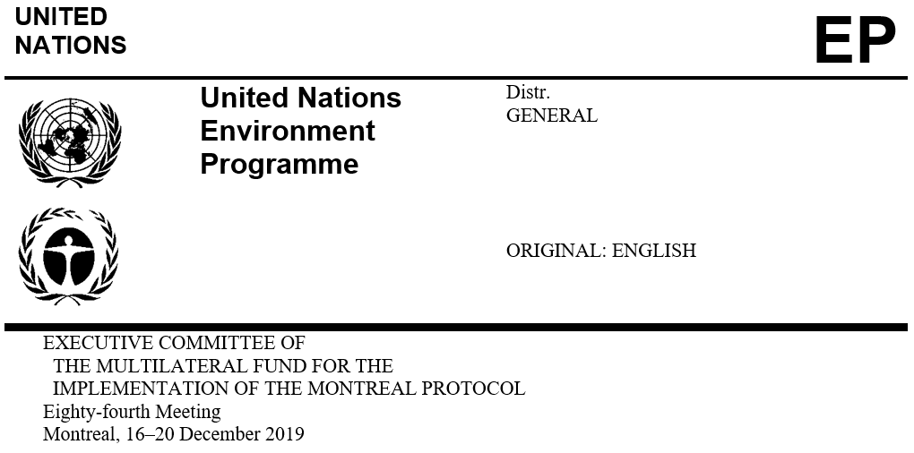

UNEP/OzL.Pro/ExCom/84/15/Rev.1
19 December 2019

DRAFT MONITORING AND EVALUATION Work Programme for THE YEAR 2020
Introduction

This document presents the draft Monitoring and Evaluation work programme for 2020 for consideration by the Executive Committee. The monitoring and evaluation activities in the work programme have been proposed following previous discussions by the Executive Committee on issues pertaining to monitoring and evaluation; the review of progress reports of on-going projects and project completion reports; and on discussions with bilateral and implementing agencies and the Secretariat. The work programme has also taken into account discussions by the Executive Committee on several agenda items relevant to monitoring and evaluation activities.

In particular, the draft Monitoring and Evaluation work programme is a continuation of the 2019 work programme approved at the 82nd meeting and consists of the following:
Evaluation activities

Revised desk study for the evaluation of the sustainability of the Montreal Protocol achievements: A desk study was submitted to the 84th meeting. Following some concerns from members of the Executive Committee on the low response rate from national ozone officers and bilateral and implementing agencies on the questionnaire, it was recommended that the Senior Monitoring and Evaluation Officer (SMEO) prepare a revised desk study. The desk study will contain additional information that will be collected from the national ozone officers (NOOs), and the bilateral and implementing agencies, via questionnaire, to obtain a more representative set of data. The revised desk study will be presented to the 85th meeting;

Desk study of the evaluation of regional networks of NOOs: The TOR for the desk study are being presented to the 84th meeting, and a desk study will be presented to the 85th meeting. The evaluation will build on previous evaluations and will undertake a thorough assessment of regional networks, inter alia: their role in the implementation of the Montreal Protocol, evolvement over time, impact at different levels to identify opportunities and gaps that could further strengthen the network meetings to address the current challenges being faced by the Montreal Protocol. Based on the findings of the desk study, the terms of reference (TOR) of the second phase of the evaluation will be presented to the 85th meeting;

Evaluation of the energy efficiency in the servicing sector: A progress report has been submitted to the 84th meeting and a desk study will be presented to the 86th meeting, with the objective to identify and assess, to the extent possible, best practices, lessons learned and additional opportunities for maintaining energy efficiency in the servicing sector. The desk study will review previously funded projects to identify energy efficiency-related activities in the servicing sector, and their applications in policies and regulations at the country level; and

Evaluation of the HCFC demonstration projects: As all the demonstration projects have been completed; the evaluation of the HCFC pilot demonstration projects will look at the lessons learned and recommendations from these projects on, inter alia, the selection of alternative technologies and their effects, as well as the insight they may provide for the phase-down of HFCs. The TOR will be presented to the 85th meeting and the desk study to the 86th meeting.
Monitoring activities

Consolidated project completion report (PCR) for both individual and multi-year agreement (MYAs) projects.

The SMEO will work closely with relevant bilateral and implementing agencies to submit all outstanding PCRs related to MYAs and individual projects to the 85th and 86th meetings, and to identify options to streamline the preparation and submission of PCRs.

The consolidated PCR will provide the Executive Committee with an overview of the results and lessons learnt as reported on the completion reports.

Additional issues of interest may arise during the implementation of the 2020 work programme that may need to be addressed by the Executive Committee. A certain degree of flexibility therefore might be allowed in its implementation as well as in the allocation of its budget in order to accommodate any such issues.

Schedule for submission

An overview of the activities contained in the proposed draft monitoring and evaluation work programme for 2020 is presented in Table 1.
Table 1. Schedule for submission of activities in the monitoring and evaluation work programme for 2020
85th meeting | 86th meeting
Consolidated PCR for MYA and individual projects | Consolidated PCR for MYA and individual projects
Desk study for the evaluation of the regional networks of NOOs | Desk study for the evaluation of energy efficiency in the servicing sector
Revised desk study for the evaluation of the sustainability of the Montreal Protocol achievements | Desk study for the evaluation of the HCFC demonstration projects
TOR for the second phase of the evaluation of the regional networks of NOOs
TOR for the evaluation of the HCFC demonstration projects
Budget

Table 2 presents the proposed budget for the monitoring and evaluation work programme for 2020.

Table 2. Proposed budget for the monitoring and evaluation work programme for 2020
Description | Amount (US $)

Revised desk study for the evaluation of the sustainability of the Montreal Protocol achievements
Report writing (5 days*US $500/day) | 2,500

Desk study for the evaluation of the regional networks of NOOs
Report writing (30 days*US $500/day) | 15,000

Desk study for the evaluation of the energy efficiency in the servicing sector
Report writing (30 days*US $500/day) | 0*

Desk study for the evaluation of the HCFC demonstration projects
Report writing (30 days*US $500/day) | 15,000
Sub-total | 32,500
Miscellaneous** | 4,000
Total | 36,500

* The US $15,000 which was allocated for the desk study for the evaluation of the energy efficiency in the servicing sector in the 2019 work programme will be reallocated to the 2020 work programme.
** Miscellaneous funds are planned to cover the unexpected additional travels expenses while on mission and the unexpected replacement of the Monitoring and Evaluation office equipment.
Action expected from the Executive Committee

The Executive Committee may wish:

To approve the proposed monitoring and evaluation work programme for 2020 contained in document UNEP/OzL.Pro/ExCom/84/15/Rev.1 and the related budget of US $36,500 as shown in Table 2 of that document; and

To reallocate the amount of US $15,000 for the desk study for the evaluation of the energy efficiency in the servicing sector from the monitoring and evaluation work programme for 2019 to the budget for 2020.

UNEP/OzL.Pro/ExCom/82/13/Rev.1
UNEP/OzL.Pro/ExCom/84/12
UNEP/OzL.Pro/ExCom/84/13/Rev.1
UNEP/OzL.Pro/ExCom/33/7 and Corr.1
UNEP/OzL.Pro/ExCom/84/14

