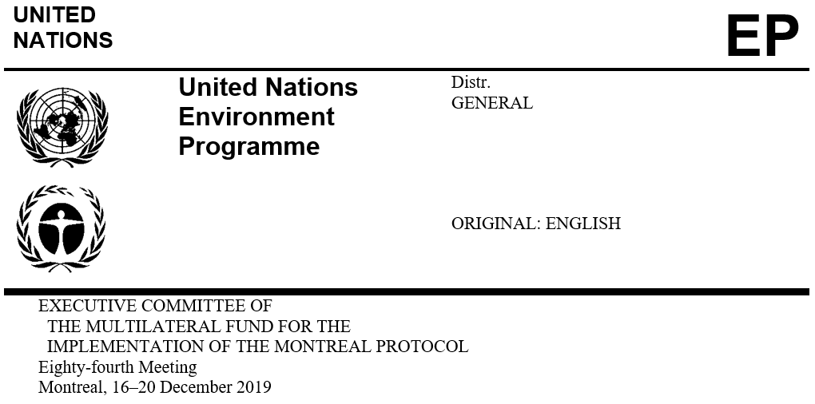

UNEP/OzL.Pro/ExCom/84/33
22 November 2019

bilateral cooperation

This document provides an overview of requests from bilateral agencies, and whether these are eligible in light of the maximum level of bilateral cooperation available for 2019 or 2018-2020 triennium. It cross-references relevant meeting documents that include a discussion on the bilateral requests, and contains the recommendation on the year of assignment for bilateral cooperation.

Overview

Eight projects for bilateral cooperation with a value of US $3,221,559 have been submitted to the 84th meeting as shown in Table 1.
Table 1. Projects for bilateral cooperation submitted to the 84th meeting
Agency | Country | Project title | Funding requested (US $) | Support costs (US $) | Amount recommended (US $)
France | Tunisia | HCFC phase-out management plan (stage I, third tranche) | 19,000 | 2,470 | (1)
Subtotal |  |  | 19,000 | 2,470
Germany | China | HCFC phase-out management plan (stage II, third tranches) (extruded polystyrene foam sector plan) | 356,514 | 42,502 | (2)
Germany | China | HCFC phase-out management plan (stage II, third and fourth tranches) (refrigeration and air-conditioning servicing sector plan and enabling component) | 500,000 | 60,000 | (2)
Germany | Egypt | HCFC phase-out management plan (stage II, second tranche) | 207,300 | 26,949 | (3)
Germany | Iran (Islamic State of) | HCFC phase-out management plan (stage II, second tranche) | 1,047,035 | 119,092 | (4)
Subtotal |  |  | 2,110,849 | 248,543
Italy | Iran (Islamic Republic of) | HCFC phase-out management plan (stage II, second tranche) | 504,004 | 60,996 | (4)
Subtotal |  |  | 504,004 | 60,996
Japan | China | HCFC phase-out management plan (stage II, third tranche) (refrigeration and air-conditioning servicing sector plan and enabling component) | 80,000 | 10,400 | (2)
Japan | Viet Nam | HCFC phase-out management plan (stage II, second tranche) | 163,980 | 21,317 | (5)
Subtotal |  |  | 243,980 | 31,717
Total |  |  | 2,877,833 | 343,726

(1) UNEP/OzL.Pro/ExCom/84/60
(2) UNEP/OzL.Pro/ExCom/84/42
(3) UNEP/OzL.Pro/ExCom/84/49
(4) UNEP/OzL.Pro/ExCom/84/51
(5) UNEP/OzL.Pro/ExCom/84/62
Allowable level of bilateral cooperation

The amount of funding being requested by the Governments of France, Germany, Italy and Japan at the 84th meeting, together with the funding amount that have been approved during the 2018-2020 triennium, does not exceed the 20 per cent allowable level of bilateral cooperation as shown in Table 2.
Table 2. Funding levels as bilateral cooperation during the 2018-2020 triennium (US $)
Agency | Funding |  |  | Allowable level | Year of assignment
 | Approved | 84th meeting | Total
France | 113,000 | 21,470 | 134,470 | 7,347,300 | 2019
Germany | 5,068,337 | 2,359,392 | 7,427,729 | 9,660,800 | 2018-2020
Italy | 371,762 | 565,000 | 936,762 | 5,667,300 | 2019
Japan | 90,400 | 275,697 | 366,097 | 14,637,099 | 2019

Recommendation

The Executive Committee may wish to request the Treasurer to offset the costs of the bilateral projects approved at the 84th meeting as follows:

  - US $XX (including agency support costs) against the balance of the bilateral contribution of the Government of France for 2019;

  - US $XX (including agency support costs) against the balance of the bilateral contribution of the Government of Germany for 2018-2020;

US $XX (including agency support costs) against the balance of the bilateral contribution of the Government of Italy for 2019; and

US $XX (including agency support costs) against the balance of the bilateral contribution of the Government of Japan for 2019.

