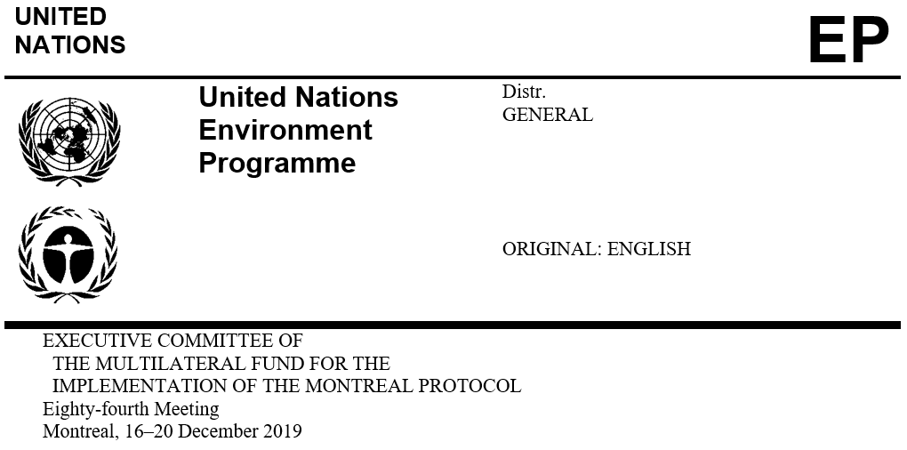

UNEP/OzL.Pro/ExCom/84/44
15 November 2019

PROJECT PROPOSAL: CONGO (THE)

This document consists of the comments and recommendation of the Secretariat on the following project proposal:

Phase-out

- HCFC phase-out management plan (stage I, fourth tranche) | UNEP and UNIDO

PROJECT EVALUATION SHEET – MULTI-YEAR PROJECTS

Congo (the)

(I) PROJECT TITLE | AGENCY | MEETING APPROVED | CONTROL MEASURE
HCFC phase out plan (Stage I) | UNEP (lead), UNIDO | 63rd | 35% by 2020

(II) LATEST ARTICLE 7 DATA (Annex C Group l) | Year: 2018 | 7.13 (ODP tonnes)

(III) LATEST COUNTRY PROGRAMME SECTORAL DATA (ODP tonnes) |  |  |  |  |  |  |  | Year: 2018
Chemical | Aerosol | Foam | Fire fighting | Refrigeration |  | Solvent | Process agent | Lab use | Total sector consumption
 |  |  |  | Manufacturing | Servicing
HCFC-22 |  |  |  |  | 7.13 |  |  |  | 7.13

(IV) CONSUMPTION DATA (ODP tonnes)
2009 - 2010 baseline: | 10.14 | Starting point for sustained aggregate reductions: | 10.14
CONSUMPTION ELIGIBLE FOR FUNDING (ODP tonnes)
Already approved: | 3.55 | Remaining: | 6.59

(V) BUSINESS PLAN |  | 2019 | 2020 | Total
UNEP | ODS phase-out (ODP tonnes) | 0.25 | 0.36 | 0.61
 | Funding (US $) | 28,250 | 39,550 | 67,800

(VI) PROJECT DATA |  |  | 2011 | 2013 | 2014 | 2015 | 2016 | 2017 | 2018 | 2019* | 2020 | Total
Montreal Protocol consumption limits |  |  | n/a | 10.14 | 10.14 | 9.13 | 9.13 | 9.13 | 9.13 | 9.13 | 6.59 | n/a
Maximum allowable consumption (ODP tonnes) |  |  | n/a | 10.14 | 10.14 | 9.13 | 9.13 | 9.13 | 9.13 | 9.13 | 6.59 | n/a
Agreed funding (US$) | UNEP | Project costs | 45,000 | 30,000 | 0 | 0 | 40,000 | 0 | 25,000 | 0 | 35,000 | 175,000
 |  | Support costs | 5,850 | 3,900 | 0 | 0 | 5,200 | 0 | 3,250 | 0 | 4,550 | 22,750
 | UNIDO | Project costs | 100,000 | 0 | 0 | 0 | 75,000 | 0 | 0 | 0 | 0 | 175,000
 |  | Support costs | 9,000 | 0 | 0 | 0 | 6,750 | 0 | 0 | 0 | 0 | 15,750
Funds approved by ExCom (US$) |  | Project costs | 145,000 | 30,000 | 0 | 0 | 115,000 | 0 | 0 | 0 | 0 | 290,000
 |  | Support costs | 14,850 | 3,900 | 0 | 0 | 11,950 | 0 | 0 | 0 | 0 | 30,700
Total funds requested for approval at this meeting (US$) |  | Project costs | 0 | 0 | 0 | 0 | 0 | 0 | 0 | 25,000 | 0 | 25,000
 |  | Support costs | 0 | 0 | 0 | 0 | 0 | 0 | 0 | 3,250 | 0 | 3,250
* The fourth tranche should have been submitted in 2018.

Secretariat's recommendation: | Blanket approval

PROJECT DESCRIPTION

On behalf of the Government of the Congo, UNEP as the lead implementing agency, has submitted a request for funding for the fourth tranche of stage I of the HCFC phase-out management plan (HPMP), at the amount of US $25,000, plus agency support costs of US $3,250 for UNEP only. The submission includes a progress report on the implementation of the third tranche and the tranche implementation plan for 2019 to 2021.
Report on HCFC consumption

The Government of the Congo reported a consumption of 7.13 ODP tonnes of HCFC in 2018, which is 29.7 per cent below the HCFC baseline for compliance. The 2014-2018 HCFC consumption is shown in Table 1.
Table 1. HCFC consumption in the Congo (2014-2018 Article 7 data)
HCFC-22 | 2014 | 2015 | 2016 | 2017 | 2018 | Baseline
Metric tonnes | 158.55 | 148.18 | 144.18 | 139.27 | 129.60 | 184.4
ODP tonnes | 8.72 | 8.15 | 7.93 | 7.66 | 7.13 | 10.14

Consumption of HCFCs in the Congo is only in the servicing sector, primarily in air-conditioning equipment; this is decreasing primarily due to controls on HCFC supply in the country and training on good practices that results in lesser use of HCFC during servicing of equipment. HCFC-free air-conditioning using R-410A and R-407C are in use in the market.
Country programme (CP) implementation report

The Government of the Congo reported HCFC sector consumption data under the 2018 CP implementation report which is consistent with the data reported under Article 7 of the Montreal Protocol.
Progress report on the implementation of the third tranche of the HPMP

Legal framework

The HCFC import/export licensing of ODS in the Congo is covered under the Regulation Framework Decree of 13 May 2002, which controls the import, export and re-export of ODS and equipment containing ODS (including HCFC). This is further strengthened with a sub-regional regulation established by the Communauté Economique et Monétaire de l’Afrique Centrale (CEMAC) in November 2004, which aims at harmonization of the regulations relating to the importation, marketing, use and re-exportation of ODS and their containers. The CEMAC regulations also control HCFC and HCFC-based equipment. The Government also proposes to implement regulations on certification of technicians in 2020.
Refrigeration servicing sector

The following activities have been conducted:

Three workshops for 69 customs and trade officers on the identification and control of HCFCs and HCFC-based equipment; one more training workshop for 25 participants is scheduled in November 2019;

Purchase and distribution of 13 refrigerant identifiers to customs, national ozone unit (NOU) office and administrative departments related to customs and border controls to strengthen the monitoring of trade of HCFCs;

Three workshops for 49 refrigeration technicians on good servicing practices for refrigeration and air-conditioning (RAC) equipment and safe handling of hydrocarbon-refrigerants. The Government is planning to organise three more training workshops for 90 participants by December 2019; and

Purchase and distribution of 30 R-290 air-conditioning units to the NOU, the Ministry of Tourism and Environment and to different Government departments in 12 other cities for publicising and show-casing low-global-warming potential (GWP) product technology and product performance.
Project implementation and monitoring unit (PMU)

The NOU has been overseeing the implementation of the HPMP and collecting relevant data with the assistance of two consultants. The PMU expenditures amount to US $5,000 for staff and consultant expenses, US $4,000 for travel and US $1,000 for communication expenses; this is equal to the funding allocated for the PMU.
Level of fund disbursement

As of October 2019, of the US $288,626 approved so far, US $261,953 had been disbursed (US $95,000 for UNEP and US $166,953 for UNIDO) as shown in Table 2. The balance of US $26,673 is expected to be disbursed by 30 June 2020.
Table 2. Financial report of stage I of the HPMP for the Congo (US $)
Tranche |  | UNEP | UNIDO | Total | Disbursement rate (%)
First tranche | Approved | 45,000 | 98,626* | 143,626 | 100
 | Disbursed | 45,000 | 98,626 | 143,626
Second tranche | Approved | 30,000 | 0 | 30,000 | 100
 | Disbursed | 30,000 | 0 | 30,000
Third tranche | Approved | 40,000 | 75,000 | 115,000 | 77
 | Disbursed | 20,000 | 68,327 | 88,327
Total | Approved | 115,000 | 173,626 | 288,626 | 91
 | Disbursed | 95,000 | 166,953 | 261,953
*After adjustment of balances returned to the 79th meeting.

Implementation plan for the fourth tranche of the HPMP

The following activities will be implemented between January 2020 and March 2021:

Strengthening national capacities (customs, environment inspectors, Department of Commerce) for monitoring and controlling the import and distribution of HCFCs: Three training workshops for 60 customs officers on the identification and control of HCFCs and HCFC-based equipment (UNEP) (US $8,000);

Strengthening technical capacity of refrigeration experts in good practices in refrigeration: Three training workshops for 90 RAC technicians on recovery and recycling of HCFCs and safe handling of hydrocarbon-refrigerants (UNEP) (US $12,000); and

PMU: Recruitment of two national consultants (one refrigeration expert and one customs expert) (US $5,000) in addition to the existing NOU team to assist in the monitoring of the effective implementation of all HPMP activities and collection of accurate data; monitoring staff to travel (US $4,000) and provide reports on the implementation of the HPMP, and communication (US $1,000) (UNEP).

SECRETARIAT’S COMMENTS AND RECOMMENDATION

COMMENTS

Progress report on the implementation of the third tranche of the HPMP

Upon request for clarification, UNEP explained that the delay in the submission of the fourth tranche was due to a change in the NOU with the retirement of the former national ozone officer (NOO) and delays in appointing the new NOO.
Legal framework

The Government of the Congo has already issued HCFC import quotas for 2019 at 6.88 ODP tonnes (125 mt), which is lower than the Montreal Protocol control targets by 25 per cent. For strengthening their national regulations to reduce dependence on HCFCs, the Government of the Congo is working with other CEMAC members to update regulations to ban import of HCFC-based equipment by 2020 and control use of HFC-based equipment.
Refrigeration servicing sector

UNEP confirmed that the training programme for refrigeration technicians covers safe use of flammable refrigerants; however, it assures that there is no retrofit of HCFC-22-based equipment with flammable refrigerants. The NOU is fully aware of the decisions of the Executive Committee relating to retrofit of equipment using flammable refrigerants in equipment designed for non-flammable refrigerants.
Sustainability of the HCFC phase-out

Under stage I, technical assistance and training equipment have been provided to the national training centres for training RAC technicians on an ongoing basis. For reducing dependence on HCFC-based RAC equipment, the Government is considering issuing a ban on import of such equipment in the near future. A combination of the above measures is expected to result in sustainable phase-out of HCFCs in the country.
Conclusion

The HPMP is progressing although the country faced challenges in the past, which caused a delay in submitting the current tranche. The country’s import licensing and quota system is operational. The consumption of HCFCs in 2018 is 21.9 per cent below the Montreal Protocol control targets. The activities so far implemented under the first three tranches including the strengthening of the centres of excellence in the country and national capacities for the control of HCFCs, and the distribution of refrigeration servicing equipment and tools, and those planned under the fourth tranche that include training of customs and enforcement officers and training of service technicians and experts, will further strengthen the servicing sector and ensure the long-term sustainability of the activities proposed under stage I of the HPMP. The disbursement level for the third tranche is at 77 per cent of the funds approved.
RECOMMENDATION

The Fund Secretariat recommends that the Executive Committee takes note of the progress report on the implementation of the third tranche of stage I of the HCFC phase-out management plan (HPMP) for the Congo; and further recommends blanket approval of the fourth tranche of stage I of the HPMP for the Congo, and the corresponding 2020–2021 tranche implementation plan, at the funding level shown in the table below:
 | Project title | Project funding (US $) | Support cost (US $) | Implementing agency
(a) | HCFC phase-out management plan (stage I, fourth tranche) | 25,000 | 3,250 | UNEP

As per the letter of 8 October 2019 from the Ministère du Tourisme et de l’Environnement of the Congo to the Secretariat.
Decisions 72/17 and 73/34

