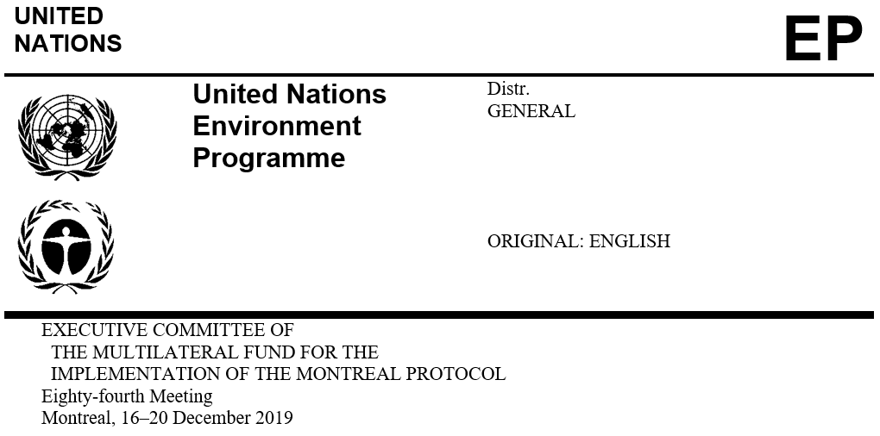

UNEP/OzL.Pro/ExCom/84/57*
14 November 2019

PROJECT PROPOSAL: PAKISTAN

This document consists of the comments and recommendation of the Secretariat on the following project proposal:

Foam

• HCFC phase-out in extruded polystyrene (XPS) foam sector | UNIDO

*Reissued for technical reasons on 28 November 2019
PROJECT EVALUATION SHEET – NON-MULTI-YEAR PROJECT

PAKISTAN

Project title(S) Bilateral/implementing agency
(a) | HCFC phase-out in extruded polystyrene (XPS) foam board manufacturing at Symbol Industries, Lahore | UNIDO

National co-ordinating agency | Ozone Office, Ministry of Climate Change

LateSt reported consumption data for ODS addressed in project
A: Article-7 data (ODP tonnes, 2018, as of october 2019)
HCFCs | 190.19
B: COUNTRY PROGRAMME SECTORAL DATA (ODP tonnes, 2018, as of november 2019)
HCFC-22 | 154.35
HCFC-141b | 32.85
HCFC-142b | 2.99

HCFC consumption remaining eligible for funding (ODP tonnes)

Current year Business Plan ALLOCATIONS |  | Funding US $ | Phase-out ODP tonnes
 | (a) | n/a | n/a

PROJECT TITLE:
ODS use at enterprise (ODP tonnes) (average 2016-2018): |  | 3.68
ODS to be phased out (ODP tonnes) (based on 2018 figures): |  | 4.68
ODS to be phased in (ODP tonnes): |  | n/a
Project duration (months): |  | 30
Initial amount requested (US $): |  | 787,750
Final project costs (US $):
 | Incremental capital cost: | 420,000
 | Contingency (10 %): | 46,600
 | Incremental operating cost: | 107,338
 | Total project cost: | 619,938
Local ownership (%): |  | 100%
Export component (%): |  | 2%
Requested grant (US $): |  | 619,938
Cost-effectiveness (US $/kg): |  | Actual: 8.09
 |  | Threshold: 10.27
Implementing agency support cost (US $): |  | 43,396
Total cost of project to Multilateral Fund (US $): |  | 663,334
Status of counterpart funding (Y/N): |  | Y
Project monitoring milestones included (Y/N): |  | Y

SECRETARIAT’S RECOMMENDATION | For individual consideration

PROJECT DESCRIPTION
Background

At its 76th meeting, the Executive Committee approved, in principle, stage II of the HCFC phase-out management plan (HPMP) for Pakistan for the period 2016 to 2020 to reduce HCFC consumption by 50 per cent of its baseline. In approving the HPMP the Committee, inter alia, noted that during the implementation of stage II, the Government could submit an investment project to phase out the use of HCFC-142b in the extruded polystyrene (XPS) foam manufacturing sector on the condition that the country’s baseline consumption was revised to include HCFC-142b and approved by the Meeting of the Parties (decision 76/39(f)).

At their Twenty-Ninth Meeting, the Parties to the Montreal Protocol approved the request by Pakistan to revise its consumption data for HCFC for the baseline years 2009 and 2010 (decision XXIX/16). The revised baseline included consumption of HCFC-142b. Subsequently, at the 83rd meeting, the Executive Committee noted that the Agreement between the Government of Pakistan and the Executive Committee had been updated to reflect the country’s baseline of 248.11 ODP tonnes as reported under Article 7 of the Montreal Protocol (decision 83/58(a)(ii)).

In line with decision 76/39(f), UNIDO, as the lead implementing agency, submitted a project proposal for the HCFC phase-out in extruded polystyrene (XPS) foam board manufacturing at Symbol Industries, Lahore at the 81st meeting, at a total cost of US $1,007,756 (excluding agency support costs). The project proposed to phase-out 2.73 ODP tonnes of HCFC-22 and 4.84 ODP tonnes of HCFC-1412b and to convert the enterprise to CO_{2,} dimethyl ether (DME), and HFOs. Subsequent to the project review process, UNIDO requested that the project be withdrawn.

At the 83rd meeting, UNIDO resubmitted the project proposal at a total cost of US $871,527 (excluding agency support costs). The project proposed to phase-out 1.69 ODP tonnes of HCFC-22 and 2.99 ODP tonnes of HCFC-1412b and to convert the enterprise to CO_{2,} dimethyl ether (DME), and HFOs. technologies. As an agreement on the overall eligible cost of the project could not be reached, UNIDO was requested to resubmit the project proposal to the 84th meeting, noting that deferring the submission of the project to a future meeting would not affect the compliance of Pakistan, as the Government had already agreed to reduce HCFC consumption by 50 per cent of its baseline by 2020 through the activities that were included in stages I and II of the HPMP, which did not include the conversion of the XPS foam enterprise.

On behalf of the Government of Pakistan, UNIDO has resubmitted to the 84th meeting the project proposed to phase-out 1.69 ODP tonnes of HCFC-22 and 2.99 ODP tonnes of HCFC-1412b (representing the consumption in 2018) for Symbol Industries, at a total cost of US $787,750, plus agency support costs of US $59,081. Implementation of the project will result in the complete phase-out of HCFC-22 and HCFC-142b used in the XPS foam sector eligible for funding; the Government of Pakistan commits not to issue any import quota for HCFC-142b once the project is completed.
Project description

Symbol Industries, the only enterprise manufacturing XPS foam in Pakistan, is locally owned and has been manufacturing XPS foam boards of various thickness since 2005. The manufacturing plant is located in Lahore; it has an annual production capacity of approximately 1,728 mt with an average annual production of approximately 575 mt over the 2016-2018 period.

The production process is fully automated from the dosing of the raw materials (polystyrene, additives and blowing agent). The HCFC consumption by the enterprise, based on a 60:40 ratio of HCFC-142b: HCFC-22, is presented in Table 1.
Table 1. Consumption of HCFCs by Symbol Industries
Year | HCFC-142b |  | HCFC-22 |  | Total
 | mt | ODP tonnes | Mt | ODP tonnes | mt | ODP tonnes
2016 | 16.50 | 1.07 | 11.00 | 0.61 | 27.50 | 1.68
2017 | 46.02 | 2.99 | 30.68 | 1.69 | 76.70 | 4.68
2018 | 46.00 | 2.99 | 30.67 | 1.69 | 76.67 | 4.68
Total | 108.52 | 7.08 | 72.35 | 3.98 | 180.87 | 11.03
Average | 36.17 | 2.35 | 24.12 | 1.33 | 60.29 | 3.68

The selected technology is CO₂ as the main foaming agent with DME as a solvent, and HFO-1234ze. As DME is moderately flammable, safety measurements are required.

The total capital cost for the conversion of Symbol Industries has been estimated at US $1,229,800; however, the Government of Pakistan is requesting US $680,412 from the Multilateral Fund, and the balance of US $539,388 will be co-financed by the enterprise. The funding requested includes the retrofit of the main and primary twin screw extruder to operate with the alternative technology (US $200,000); new secondary single screw extruder (US $150,000); storage tanks for CO₂, DME, and HFO including piping and metering systems (US $165,950); other fixtures (slot die, board calibration, hydraulic screen, static mixer) (US $76,000); safety elements (US $12,000); safety audit (US $14,606); and contingencies (US $61,856). Incremental operating costs (IOCs) have been estimated at US $107,338 for a one-year period, bringing the total project cost to US $787,750.

The project duration is 30 months. No import quota for HCFC-142b will be issued after the completion of the project, and no later than 1 January 2023.
SECRETARIAT’S COMMENTS AND RECOMMENDATION

COMMENTS

UNIDO reiterated the commitment by the Government of Pakistan to issue a ban for new manufacturing of XPS foam based on HCFCs, and a ban on imports of HCFC-142b once the conversion of Symbol Industries is completed.
Technology

Noting the challenges with the supply of HFO-1234ze in sufficient quantities in the local market, in line with decisions 74/20(a) and 77/35(a)(v) UNIDO provided a letter from an international supplier that has all the chemicals required for the conversion of the XPS foam enterprise, and would be provided as required following procurement procedures. UNIDO had also indicated that no high-GWP HFCs will be used in the event that HFOs would not be available.
Incremental cost

The discussions on incremental capital costs (ICCs) related to retrofitting the existing extruders rather than requesting new extruders; the proposed modifications necessary for safety including the addition of a secondary single screw extruder; the request for plant safety modifications which appeared not to be sufficient given the flammability of DME; and the extensive technical assistance and production trials that would be required. As a result of the discussions, agreement was reached as follows: the cost of equipment (i.e., extruders, storage tanks for the new chemicals, piping and metering systems, and other fixtures) were adjusted from US $591,950 to US $365,000; plant safety modifications were increased from US $12,000 to US $51,000; technical assistance and trials including a safety review were increased from US $14,606 to US $50,000; and contingency costs from US $61,856 to US $46,600. IOCs was agreed at the level requested (US $107,338).

Based on the above, the total cost of the project as agreed amounted to US $619,938 (i.e., US $512,600 ICCs plus US $107,338 IOCs), with a cost-effectiveness of US $8.09/kg. UNIDO confirmed that Symbol Industries had committed to provide all required co-financing to complete the conversion in time.
Revision of the Agreement

Noting that the Executive Committee allowed the Government of Pakistan to submit the project proposal for the phase-out of HCFCs by Symbol Industries during implementation of stage II of the HPMP, a request for the revision of Agreement between the Government and the Executive Committee to include the approval of the project proposal will be submitted when the third funding tranche will be submitted.
Impact on climate

The conversion of Symbol Industries for manufacturing XPS foam in Pakistan would avoid the emission into the atmosphere of 161,313 tonnes of CO₂ equivalent per year, as shown in Table 2.
Table 2. Impact on the climate of the XPS foam projects
Substance | GWP | Tonnes/year | CO₂-eq (tonnes/year)
Before conversion
HCFC-142b | 2,310 | 46.00 | 106,260
HCFC-22 | 1,810 | 30.67 | 55,512.7
After conversion
HFO-1234ze | 6 | 76.67 | 460.02
Impact |  |  | (161,312.68)

RECOMMENDATION

The Executive Committee may wish to consider:

Approving the project for the conversion of Symbol Industries from HCFC-142b/HCFC-22 to HFO/CO₂/DME used in the manufacture of XPS foam boards in the amount of US $619,938 plus support costs of US $43,396 for UNIDO;

Deducting 4.68 ODP tonnes (1.69 ODP tonnes of HCFC-22 and 2.99 ODP tonnes of HCFC-142b) from the remaining HCFC consumption eligible for funding;

Noting:

That there will be no remaining consumption of HCFC-142b eligible for future funding; and

The commitment of the Government of Pakistan to ban import of HCFC-142b starting 1 January 2023 and ban manufacturing of XPS foam based on HCFCs once the conversion project is completed;

That the updated Agreement between the Government of Pakistan and the Executive Committee for stage II of the HCFC phase-out management plan (HPMP) would be revised to include the approval of the project proposal referred to in sub-paragraph (a) above, and the deduction of HCFC tonnage referred to in sub-paragraph (b) above, and would be submitted together with the third funding tranche at the first meeting in 2020.

UNEP/OzL.Pro/ExCom/76/42
Quito, Ecuador, 5–9 November 2018.
Based on 300-day 16 hour-day operation time at an average production capacity of 360 kg/h (the capacity ranges between 320 to 400 kg/hour depending of the thickness of the boards).
Based on US $1.40/metric kilogram of HCFC to be phased out in line with decision 74/50(c)(i)(v).

