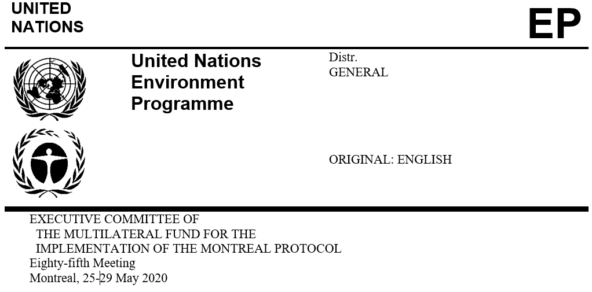

UNEP/OzL.Pro/ExCom/85/20/Corr.1
12 May 2020

Postponed to 19-22 July 2020*

Corrigendum

PROJECT PROPOSAL: BRUNEI DARUSSALAM

This document is issued to:

- Add to the end of paragraph 14(c), “and procure equipment and tools to strengthen the training centre IBTE (UNDP) (reallocated budget of US $29,903 from the previous tranche);”

* Due to coronavirus disease (COVID-19)

