Simple tips for all participants in remote meetings to improve connection and sound
The two most important points for adequate sound and video are: a laptop connected via Ethernet cable to the modem, and a headset with microphone.
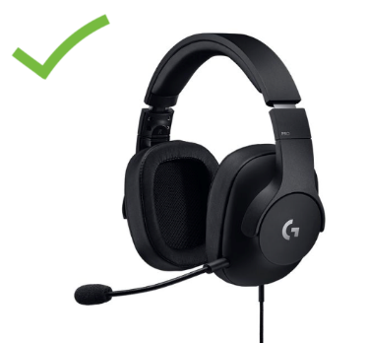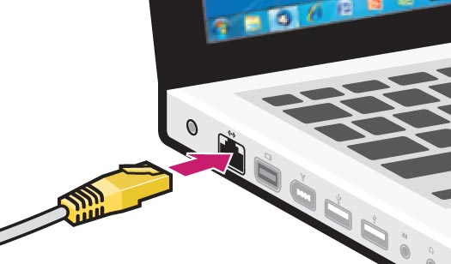

The following tips are the bare minimum to provide adequate sound and video for remote meetings:
- Connect using a laptop or desktop computer only (no tablets or mobile phones).
- Plug your laptop directly into your modem with an Ethernet cable.
- Always use headphones to eliminate echo and feedback.
- Use headphones with an integrated microphone. Any microphone is better than just the computer mic, but ideally a noise-cancelling microphone, or headsets approved for use in Skype for Business or call centres (e.g. https://en-ca.sennheiser.com/call-center-office-headset-usb-sc-60-usb-ml).
- If a proper headset cannot be procured in time, earbuds with an integrated microphone are better than nothing, though far from ideal – order a headset now for future meetings!
- Please keep your video on and try to improve connection by connecting with an Ethernet cable rather than switching video off – interpreters need to see the speaker.
- Once set up, please don’t touch or tap on your microphone, or move your computer! This is very painful on the ears of listeners.
Following these simple and low-cost tips will vastly improve your ability to be seen, heard and interpreted during remote meetings!

