UNITED  NATIONS |  | EP
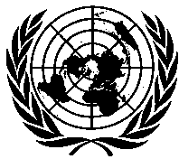 | United Nations  Environment  Programme | Distr.  GENERAL  UNEP/OzL.Pro/ExCom/86/18/Corr.1  10 November 2020  ORIGINAL: ENGLISH
EXECUTIVE COMMITTEE OF
THE MULTILATERAL FUND FOR THE
IMPLEMENTATION OF THE MONTREAL PROTOCOL
Eighty-sixth Meeting
Montreal, 2-6 November 2020
Postponed to 8-12 March 2021

Corrigendum

PROGRESS REPORT OF UNEP AS AT 31 DECEMBER 2019

This document is issued to:

Replace “31 Mar 21” with “30 Jun 2021” in the rows for Serbia in Table 2; and

Replace “31 March 2021” with “30 June 2021” in paragraph 21(e).

Due to coronavirus disease (COVID-19)

