UNITED  NATIONS |  | EP
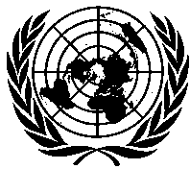 | United Nations  Environment  Programme | Distr.  GENERAL  UNEP/OzL.Pro/ExCom/87/28/Corr.1  22 June 2021  ORIGINAL: ENGLISH
EXECUTIVE COMMITTEE OF
THE MULTILATERAL FUND FOR THE
IMPLEMENTATION OF THE MONTREAL PROTOCOL
Eighty-seventh Meeting
Montreal, 28 June-2 July 2021

Corrigendum

PROJECT PROPOSAL: GHANA

This document is being issued to:
- Replace “Although a calculation of the impact on the climate was not included in the HPMP,” with “A calculation of the impact on the climate was provided in the HPMP;” in the last sentence of paragraph 39.

Online meetings and an intersessional approval process will be held in June and July 2021 due to coronavirus disease (COVID-19).

