UNITED  NATIONS |  | EP
   | United Nations  Environment  Programme | Distr.  GENERAL  UNEP/OzL.Pro/ExCom/91/Inf.2  4 November 2022  ORIGINAL: ENGLISH
EXECUTIVE COMMITTEE OF
THE MULTILATERAL FUND FOR THE
IMPLEMENTATION OF THE MONTREAL PROTOCOL
Ninety-first Meeting
Montreal, 5-9 December 2022
Item 15 of the provisional agenda

Technical feasibility study on the usability, systems architecture and technology of the Secretariat databases

(Submitted by the Consultant)

Note by the Secretariat

The attachment to the present document contains the technical feasibility study on the usability, systems architecture and technology of the Secretariat databases, prepared by the consultant, in response to the request of the Executive Committee to the Secretariat to update the information strategy of the Multilateral Fund (decision 89/1(c)(ii)). The technical feasibility study is reproduced as submitted to the Secretariat and no editing has been made to it.

Contract No: 2500302288
Consultancy to United Nations Environment Programme Secretariat Multilateral Fund for the Implementation of the Montreal Protocol on Substances that Deplete the Ozone Layer
Technical feasibility study on the usability, systems architecture and technology of the Secretariat databases

Version 4.0

Andy Murdock (Consultant)
For the Multilateral Fund Secretariat

24th October 2022

Page Intentionally left blank

Acknowledgements
The author is grateful to those who have given their time to provide useful information in support of developing these requirements.

Acronyms
Term | Definition
API | Application Programmer’s Interface
BLA | Bilateral Agencies
BLOBs | Binary Large Objects
CP | Country Programme
EDMS | Electronic Document Management System
ExCom | Executive Committee members
FAQs | Frequently Asked Questions
HCFC | Hydrochlorofluorocarbon
HFCs | Hydrofluorocarbons
HPPMP | HCFC Production Phase-out Management Plan
HPMP | HCFC Phase-Out Management Plan
IA | Implementing Agencies
ITT | Invitation To Tender
MLF | Multilateral Fund
MLFS | Multilateral Fund Secretariat
MP | Montreal Protocol
MYAs | Multi-Year Agreements
NOU | National Ozone Unit
ODP | Ozone Depletion Potential
PCRs | Project Completion Report
PRP | Preparatory funding
SMEO | Senior Monitoring and Evaluation Officer
TEAP | Technology and Economic Assessment Panel
UNEG | United Nations Evaluation Group
UNEP | United Nations Environment Programme

Executive Summary
At its 89th meeting, subsequent to the consideration of the Multilateral Organisation Performance Assessment Network (MOPAN) assessment of the performance of the Multilateral Fund (MLF) for the Implementation of the Montreal Protocol, the Executive Committee requested the Secretariat of the Multilateral Fund to update the information strategy of the MLF, to include a detailed plan for information and knowledge management, the website/information technology requirements, the resources needed and clear timelines for implementation and to submit the strategy for consideration by the Executive Committee at the 91st meeting (decision 89/1(c)(ii)).
The update of the information strategy of the MLF is essentially the development of a new knowledge management system that is proposed in this document. It aims not only at preserving the existing data and information and providing efficient, secure, and user-friendly access to them for all stakeholders, but also at organizing and transforming these data and information to knowledge that could be passed on to various types of stakeholders to facilitate their learning and decision-making processes, as relevant, through different tools. Examples of such tools include: a revamped website, a revamped meeting portal, an online reporting tool under the country programme data extending to HFCs, a data portal, country profiles and a searchable online collection of the MLF policies, guidelines, and procedures.
Accordingly, a business analysis consultancy was undertaken to assess the current state of knowledge management within the Secretariat based on reviews of the website, documents, submission processes, existing databases, and discussions with stakeholders (users). The business analysis consultancy resulted in recommendations for improvements. The consultancy has shown that the existing systems supporting knowledge management in MLF are outdated, disconnected and not very functional or engaging in terms of data discovery, analysis and visualisation.
In addition, there is a proliferation of disparate databases which are held in a variety of formats with duplicative data, leading to multiple data sets which lack functionality in terms of data discovery, analysis, and visualisation. This results in difficulties for query and analysis of data across the entire data holding, which often must be done with considerable manual handling, making the process time consuming and prone to errors. This also limits the optimum use of data across different processes in the Secretariat to support its efficient operation. In addition, these databases are not available on the MLF website; relevant stakeholders or the public who need information contained in these databases would require submitting their requests to the Secretariat by emails.
The review also noted that the MLF website is outdated, poorly designed, and is not user-friendly. It is a static website that simply provides basic information of the MLF, serves the purpose of providing links to various documents, such as Executive Committee meeting documents, evaluation-related documents, project-related guides and technical reports and the document on “Policies, procedures, guidelines and criteria of the Multilateral Fund”. It lacks practical search features that would allow users to access content highlights, key facts or interactive information allowing users to visualise and analyse the MLF data and understand the work of the MLF.
Further, the assessment showed that the current structure of the databases has limited the potential to view and interrogate the data due to its design and manual handling. This existing approach presents a risk because of the reliance on a few key individuals with data management skills and institutional memory to locate and pull the required data and information together. Therefore, consolidating the data of the existing databases into a master database and offering a new user-friendly, ‘self-service’ data portal within the website would provide greater flexibility, new capabilities, potential new insights, and a ‘single source of truth’ and would increase the accessibility of data for users both in and out of the Secretariat. It is envisaged that this master database will also generate the information and data required to upgrade the content of the website which will be developed using the state-of-the-art technology and following the best security protocols.
In analysing the processes in the Secretariat that support the Executive Committee’s work vis-à-vis data and information requirements, it was noted that the improved master database and website should support a more efficient and seamless process for the business planning, project review and monitoring. Another limitation of the current system is that it lacks the features that allow online submissions for projects and other ad hoc data and information requirements. Such functionality could be provided by a revamped knowledge management system, and it could have multiple benefits including creation of a single source of authoritative MLF data, simplified data management, reduced risks through automation, more accessible data and a flexible and highly functional system where users are able to access a rich variety of self-service tools and analytical capability. These benefits will be felt by the Secretariat, the Executive Committee, the implementing and bilateral agencies, the countries whose projects and other submissions are under review and facilitate a more efficient review process in one virtual space.
Several main users were interviewed as part of the analysis to assess their needs and identify current challenges. Their views and comments, and their aspirations for a new knowledge management system including a revamped website have been reflected in the assessment.
The review and discussions with users identified a number of specific tools that will be delivered within the new system and with a reformatted database and revamped website.
The proposal for a new knowledge management system will be implemented in three phases.
Phase 1 – Master database and revamped website which lays the foundations for the knowledge management system and corporate website and focuses on the creation of a master database which consolidates the data and information from the many different sources into a ‘single source of truth’ and which serves as the foundation for the system. Having a master database moves the system from a complex disparate structure to a more integrated, accessible, and simplified architecture.
Phase 2 – Core products will focus on the main functionality for the knowledge management system including:

- Online reporting of country programme data;
- Online reporting of project completion reports;
- Country profiles: history of consumption, information on approved projects and relevant Executive Committee decisions;
- Meeting portal – improved access of the meeting documents in current and past meetings of the Executive Committee;
- “Handbook” / Electronic Document Management System - access to decisions, policies, procedures, and guidelines; and
- Data portal including country programme data, projects, lessons learnt– self-service data access area with filters and dashboards including access for public users.

Phase 3 – Agencies’ portal and other enhancements will establish an agencies’ portal to support a more efficient review process and user interface through the implementation of an online submission and review functionality. allowing implementing and bilateral agencies to submit projects, business plans and progress reports and the Secretariat to make comments and suggestions back within the system. Taking into account the experience and lessons on the implementation of the pilot project for project review in phase 2, the portal will first concentrate on online submission and review of the remaining types of projects. Other kinds of submissions such as business plans and progress reports will be considered at a later stage.

The other major aspect of phase 3 is the creation of an application programming interface (API) which will enable external developers to directly connect official MLF published data using machine-to-machine communication. This will allow easier sharing of data. For example, an application developed by a government using the country programme data to calculate average consumption in a sector, funding eligibility, climate impact, etc.

The project timelines and costs are set out below and are based on a phased approach:
Initial funding Request

Phase | Timescales | Costs ($US)
Phase 1 - Master database and website | 24 months | $250,000 - $350,000
Phase 2 - Core products | 18 months | $450,000 - $550,000
Phases 1 and 2 will run in parallel creating a 24-month program associated with the initial funding request and which will deliver the foundations and core functionality for the system.

Subsequent funding request

Phase | Timescales | Costs ($US)
Phase 3 - Agencies’ portal and other enhancements | 9 months | $300,000 to $400,000
A separate project of 9 months will commence when phases 1 and 2 are completed and will focus on system enhancements including an online submission and review with a separate funding request to a later meeting of the Executive Committee.
The new system will support improved knowledge management aspects such as tracking project status and accessing comments and project experience which is critical for rapid appraisal of a project’s status or country’s programme. It will also significantly improve the MLFS process and enable new analysis and insights from MLF data and in ways which are not currently possible.

Introduction
Since its establishment in 1992, the Secretariat of the Multilateral Fund for the Montreal Protocol on Substances that Deplete the Ozone Layer has collected various datasets in different platforms and formats. These datasets have been, and continue to be, used in the review of projects submitted for approval by the Executive Committee (ExCom), in tracking progress and achievement of objectives, and spending over the implementation period after approval and following completion, act as a historical record of progress, spending and lessons learnt.
In addition, these datasets provide high-level summary information on how the Multilateral Fund (MLF) has been managed through the years and how it has assisted countries to meet their compliance targets under the Montreal Protocol.
Part of the terms of reference of the Multilateral Fund Secretariat (MLFS) is to gather, store, and share the information collected through the operative years of the MLF throughout the organization and its stakeholders. This enables better use of and provides easier access to this vast data resource. It also facilitates institutional knowledge and reinforces the project review and monitoring process along with better managed data reporting. The current presence of disparate datasets supports the development of a new Knowledge Management System (KMS) that will efficiently integrate and organize the current data and information available to effectively implement this responsibility.
At its 89th meeting, subsequent to the consideration of the Multilateral Organisation Performance Assessment Network (MOPAN) assessment of the performance of the Multilateral Fund (MLF) for the Implementation of the Montreal Protocol, the Executive Committee requested the Secretariat of the Multilateral Fund to update the information strategy of the MLF, to include a detailed plan for information and knowledge management, the website/information technology requirements, the resources needed and clear timelines for implementation and to submit the strategy for consideration by the Executive Committee at the 91st meeting (decision 89/1(c)(ii)).
The update of the information strategy of the MLF is essentially the development of a new knowledge management system that is proposed in this document. It aims not only at preserving the existing data and information and providing efficient, secure, and user-friendly access to them for all stakeholders, but also at organizing and transforming these data and information to knowledge that could be passed on to various types of stakeholders to facilitate their learning and decision-making processes, as relevant, through different tools. Examples of such tools include a revamped website and a revamped meeting portal, an online reporting tool under the country programme data extending to HFCs, a data portal, country profiles, a searchable online collection of the MLF policies, guidelines, and procedures.
Accordingly, a business analysis consultancy was undertaken to assess the current state of knowledge management within the Secretariat based on reviews of the website, documents, submission processes, existing databases, and discussions with stakeholders (users). The business analysis consultancy resulted in recommendations for improvements.
The specific aims of the Project and a description from the consultancy Terms of Reference are set out in Table 1 below along with the benefits (Figure 1).

Table 1 – Project Aims and Benefits with a description from the Terms of Reference
Aims | Benefits | Description
Preservation of the existing data. | Ensures the last three decades of data are secured for future use as a baseline for comparison, progress reporting and planning | Support the development of knowledge management systems that will efficiently organize, integrate and analyse the data and information available in the Secretariat to capture lessons learned that would be useful in transforming current workflows for better efficiency and reporting;
Provision of efficient and user-friendly access to existing data for all stakeholders. | - reduced time to find information | Facilitate dissemination of the Multilateral Fund’s achievements through a revamped website and social media engagement; update the information technology platforms and tools currently in use to facilitate improved reporting and monitoring; and make evaluation products visible to facilitate the use of the learning, replicability and implementation of recommendations.
Presentation of information to various types of stakeholders. | - availability of consistent information reduces verification time and double checking  - KMS will facilitate the easy and efficient transfer of knowledge among staff;
Development of tools for achieving these goals, including:  - a revamped website,  - an online reporting tool for HFCs and HCFC  - a revamped inventory of data  - a searchable online collection of the Multilateral Fund policies, guidelines and procedures  - Mobile compatible platform to access all Secretariat tools. | - streamlined processes

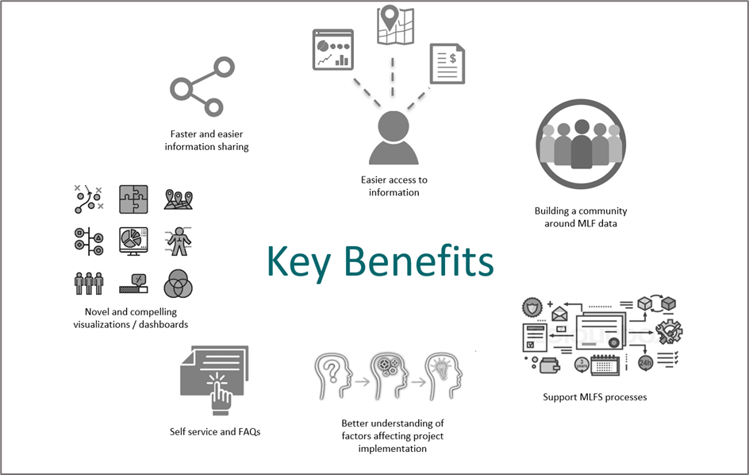
Figure 1 - Benefits of the new Knowledge Management System
The scope of work for this consultancy was as follows:
- Collect, review and analyze the current data sets available in the Secretariat to fully ensure that all information is accounted for and recorded;
- Ensure that data in the form of queries can be easily accessible to all Secretariat staff, implementing and bilateral agencies, and members of the Executive Committee (a comprehensive list of databases was provided);
- Ensure that data and data flows assist in the project cycle and in the project review and explore the possibilities of an online submission template to facilitate electronic recording of data and information, and exchange of information with the Secretariat and implementing and bilateral agencies;
- Support a knowledge management system that will efficiently organize and integrate data, maintain data security and analyze the data and information available in the Secretariat to capture lessons learned that would be useful in transforming current workflows for better efficiency and reporting;
- Review and analyze the present online reporting system for CP data and propose an updated and more use-friendly system that would integrate the new CP data reporting forms once revised;
- Describe a system for easy updates, access, and improved search functions to the policies, guidelines and procedures of the Multilateral Fund in the form of a handbook;
- Provide a proposal for how the website can be modernized to improve communication, web access, navigation, and enhance the overall user experience for its various stakeholders and audiences.
- Define data security features for ensuring data safety, such as user access controls.
This report has been completed as part of contract: 2500302288 “Technical feasibility study on the usability, systems architecture and technology of the Secretariat database”.

Methodology
The approach to the work is set out below and follows standard business analysis techniques to review the current organisation in terms of the processes, data and systems, staff resources etc, to identify weakness in the current situation and approaches. Potential approaches for a Knowledge Management System are proposed.

Scope
The scope of this review is focussed on workflows and data within the MLF itself and the implications on the direct interactions with the Implementing Agencies and the Executive Committee as it fulfils its mandate. In addition, an overall understanding of the user needs (e.g., ExCom members, Agencies) is also needed to define the processes and IT tools.

Desk study
A variety of background documents and information were kindly provided by MLF Secretariat staff to the consultant as well as sign-posting to relevant materials on the MLF website. These included:
- ExCom Meeting Summaries;
- Annual Progress Reports;
- Project Completion Reports; and
- Monitoring and Evaluation Reports
- Description and content of existing data sets
- Description of the various MLF processes
Material was reviewed to better understand the MLF processes, together with the key roles and responsibilities and to identify key datasets supporting the decision-making process.

Stakeholder interviews
Stakeholders from across the MLF were interviewed for this work via video conferencing and online workshops. This provided an opportunity to assess needs more closely and to discuss points requiring clarification. It also provided an insight to the level of technical capability of the MLFS and stakeholders in terms of data management, although this was not assessed in detail.

Review of IT and data infrastructure
Key to understanding the challenges and potential of a future system is to understand the current data and tools which support the MLF. Data have been collected in a number of different ways and stored in a variety of formats in order to support the work, including use of legacy, standalone formats such as MS Excel, MS Access etc. but with little to minimal improvement in functionality provided to users.
Databases were reviewed for their content, granularity and format but the review also sought to highlight potential duplication and double-handling of data. A summary of the databases is provided in Appendix A and which helps understand the potential improvements needed for the creation of a new Master MLF database.

The current situation

Overview of the MLF process
The processes of the MLFS are well understood by MLFS staff and are only described in brief here and include at a high level:

- Business planning –Implementing and bilateral Agencies submit three-year rolling business plan which provides an overview of planned activities for the subsequent three years.
- Project review and submission – the review of submitted projects by MLFS and the refinement of the activities, timescales and costs within those projects through discussion with Implementing Agencies. (The process has been mapped for this review as a MS Visio diagram - available on request). Submission and approval of projects by ExCom.
- Progress and financial reporting – the annual progress and financial reporting provides the latest status of project implementation including disbursement of funds on a project-by-project basis as approved by the Executive Committee. The reports are used as a basis to ensure projects are delivering the requirements and to track spending against budgets.
- Monitoring of projects – ensures projects are delivering the activities and change specified and tracking the level of spending against the budget. The progress and financial reporting provide evidence to ExCom in support of future funding decisions in that country.
- Project completion – reviews the success of the project such as whether planned reduction targets were met and delivered within budget or if there is over/under spend. The lessons learnt are also captured in terms of successes and challenges. This ensures that project experience can be shared with other countries seeking to implement similar projects and to help them both to learn from successes and also to avoid similar mistakes.
- Monitoring and evaluation – monitoring and evaluation tracks the overall progress of the MLF and delivery against the objectives. It looks at specific areas of activities commissioned by ExCom, such as progress on reduction of certain substances or phase out of harmful technologies. This takes a more strategic view of all projects and requires insights from multiple databases.

The proposed new system needs to support all of the above activities and make the process more effective than it currently is. The changes will also enable a much wider potential with the data in terms of analysis that can provide greater insight and support to ExCom planning and decision making.
Prior to this report, MLF workflows had only been documented at a high level. A flow diagram of the project review process has been created as part of this work (not presented here but available on request) and it is recommended that similar workflow diagrams be created for other MLFS process, to identify weaknesses and dependencies and to support the induction of new staff.

Assessment of the Secretariat’s existing databases
A significant portion of the study was to review the existing MLF databases. A list of core databases was provided with the consultancy Terms of Reference and some information is also provided in the ExCom MLF Primer document.
Due to the long history of the MLF, databases originally built to support MLF activities were created at a time when the IT technology was much more file-based than now. Databases were created for a specific purpose, and it was not possible to easily connect them. While the old individual databases may have suited their specific purposes in the past, the evolving situation with the vast breadth of information available for projects, technologies, etc, means that it will be possible to make MLF systems and processes more efficient by creating a more integrated database that connects the separate pieces.
It should be noted that many of the databases are in fact ‘flat’ data sources and are stored in templated MS Excel worksheets or MS Word documents and tables and are not as such, structured databases. The exception are MS Access databases.
The way that the Fund is administered based on the ExCom meetings, means that for convenience many individual databases have been created for each meeting or for specific years. While this ensures all project data are self-contained and associated with the meeting or year they refer to, this rather limits MLFS’s ability to interrogate the data more strategically across the entire data holdings and over time as they are not interconnected.
When data are stored in individual databases such as a database for each individual year, it is more difficult to query the data because the query must be run multiple times, (once for each database) and then the results assembled in a single place to allow users to view them.
The fact that there are multiple individual databases also means that a change in one, such as the addition of a new column, may not necessarily have also been made in the other databases. This can easily lead to inconsistencies and errors without careful procedures, and it creates an unnecessary data management overhead.
When the data are held together in a single database, it is possible to connect them more easily and to run queries across the different datasets because they are usually held as related tables or where the individual years are stored within a specific column. This integrated approach is much more flexible and easier to change.
Moreover, there is no formal manner for recording project submissions (other than a listing in the project submission database described in Table 2 and Figure 2 and the process of project review, meaning information shared during the review process with the IAs also need to be recorded for legacy purposes, which would help in capacity and knowledge building of the Secretariat and its various immediate stakeholders.
Figure 2 provides a high-level overview of the many different databases and highlights data formats, duplication and double / manual handling of the data from one system to another.

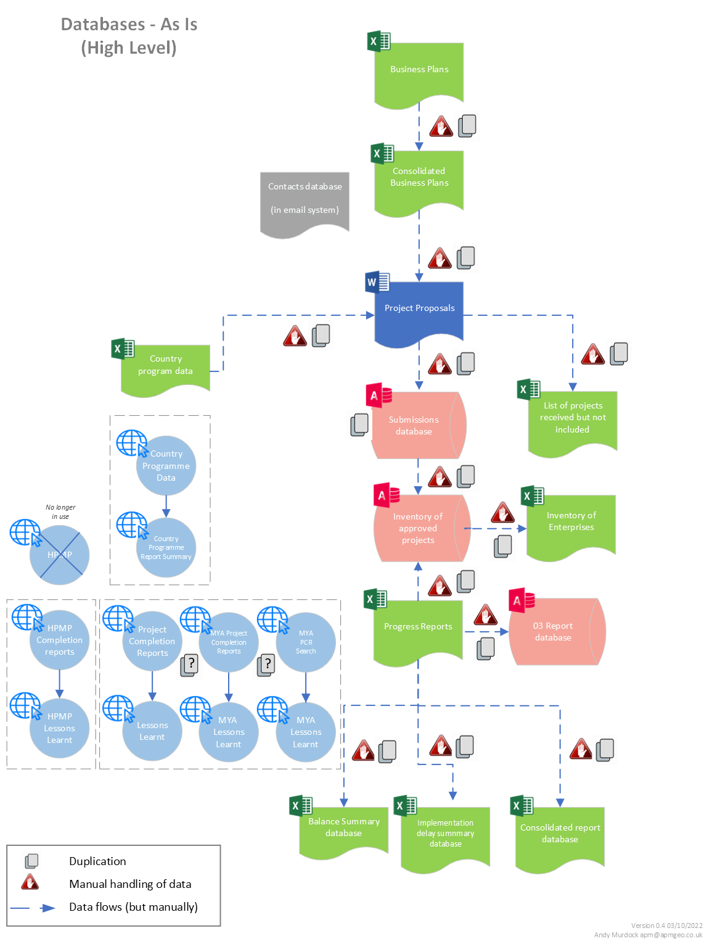
Current challenges
- Multiple copies  - Old formats  - Difficult to analyze | - Disparate and disconnected,  - Not easily accessible  - Manual offline submission
Figure 2 - High Level Data Architecture / ‘Databases’ - As Is
A brief summary of the existing databases is provided in Table 2 below with further details in Appendix A.
The review of MLF databases shows that the data are of high quality. In addition, although working within the constraints of the data format used, the design of the MS Access databases appears to be well thought through and logically structured.
However, the way the data are collected, the systems used, and the overall MLF data landscape could be considerably improved to remove the duplication and manual handling of data, to enable much greater use and reuse of the data and to support data discovery and sharing.
The current disparate nature of the MLF databases and the lack of integration not only creates a complex and inefficient data management environment, but it is also seriously limiting the potential of MLFS to exploit the rich dataset that it has assembled over the last three decades.
The rationalisation and re-organisation of the data is an essential prerequisite activity that needs to be undertaken in order to enable MLF to develop the tools that are needed, and which are described below. This will enable queries across the full range of data years, countries, substances, technologies etc. and to support data visualisation and presentation as interactive dashboards, tables, charts, maps etc.
The proposed changes to the data structures will make it much easier for a wide range of users to interrogate the MLF data and to be confident that they are working with authoritative data from the same official source. This concept of a single source of truth is central to the objectives of the new knowledge management system. This approach ensures that while sensitive data is protected and will be limited to certain users, all users will be accessing the data from the same central source, and which is managed in one place. This shared access is not currently possible and is only achievable with a modern, cloud-based enterprise IT infrastructure and using an online database and interactive website.
The crucial work needed to build such a system will involve creating a new database structure (data model) that identifies the key data and duplicates it from its current location into the new structure. Where data are held in more than one place, only a single master version will be held in the new database.
In addition, data connections (relationships) will be duplicated, and new connections will be made between data elements to better connect the data together. Using common identifiers such as country identifiers, substance codes etc, these new linkages will support new ways to analyse and visualise data.
Creation of the new data model and the migration and transformation of the data to fit the new structure is a significant activity that needs to be undertaken as a first stage to the creation of the new Knowledge Management system.
This new database also provides an opportunity for the inclusion of new data in support of MLF activities such as the capture of additional project experience (similar to the lessons learnt) and which forms a narrative alongside the project. These proposed changes to the database will improve the processes in the Secretariat. This is discussed further in Table 2 below.
The current way of working also relies on just a few key staff who have been working with the data for several years and know how to access it and interrogate it to deliver the requirements. There is a strong reliance on this organisational memory but the work to recover data can be a laborious process. MLFS staff have become accustomed to this way of working. There is a risk that to deliver the data needs of ExCom and others, the process relies on these staff but if they were to leave or be unavailable, this knowledge may be lost. In the long term this approach is not sustainable and does not provide for succession planning and the legacy of data, nor does it support the efficient on-boarding of new staff.
While current systems capture data, they do not do this using a logical workflow that can be followed one step at a time. It is possible to design the data collection approach around the current business process with information being collected as part of a logical and structured workflow and where users step through the process add relevant data and commentary as they proceed through project design, submission and review, implementation and completion. This type of approach has the advantage that at any point in a project it is very clear what the current status is and the activities and decisions that have led to the current situation.
In addition to database reorganisation and management there is a wider focus on knowledge management more generally including addressing the fact that current systems are ineffective at capturing the shared experience of projects and lessons which improve the activities of MLF as a whole. This type of knowledge management is a collective exercise and needs to be undertaken based on country profile, interaction with country (e.g., feedback received during network meeting, consultations during other meetings like OEWG, ImpCom), information on project submission and on country structure. The new system seeks to capture this type of information.
Finally, the current databases and systems are not built in a way to maximize the value of the collected data through the ability to query, visualise and present information in ways which support MLFS activities and reporting. This will be enabled within the new system.
Table 2 – List of Existing MLF Databases
Database | Content | Business area | Format
Submissions Database | These databases contain information extracted from project proposals submitted by the Implementing and bilateral agencies for each meeting. It also includes the amount reviewed and recommended by the Secretariat for each activity. The information in this database is subsequently used for the Inventory of Approved Projects once the project is approved. | Project Proposals | MS Access
Inventory of Approved Projects | Provides specific information about projects approved by the Executive Committee, including the country or region, the sector, the Executive Committee meeting at which it was approved and the type of project, implementing agency, ODS phase-out and funds approved and disbursed. | Business planning | MS Access
Business Plans Database | Each year, Implementing and bilateral Agencies submit three-year rolling business plan which provides an overview of planned activities for the subsequent three years. The business plan would be considered at the last meeting of each year and endorsed by the Executive Committee. Individual projects in the business plans are approved as a part of the project approval process and after approval, these projects form a part of the inventory of approved projects mentioned above. | Business planning | MS Excel
Progress Reports | Each year, Implementing and bilateral agencies submit annual progress reports that include all the projects that have been approved under the Fund, with emphasis on the on-going projects. The consolidated progress report would be considered at the first meeting of the year if that meeting were convened on or after 1 July, and at the second meeting of the year if it were convened earlier (Decision 77/60). | Programme implementation | [**]MS Excel
03 Report Database | This database contains consolidated information from all progress reports submitted by the implementing and bilateral agencies since 1994. It also includes Secretariat comments and agencies responses since 1999. | Programme implementation | MS Access
Prefilled Format for Individual Project Completion Report (PCRs) | This web page allows Implementing and Bilateral agencies to pre-fill individual PCR formats to include latest information contained in the inventory database and actual data from the last progress reports. | Evaluation | www
Multi-Year Agreement (MYA) Project Completion Reports (PCRs) | PCRs for MYA projects that are related to phase out of CFC, Halon, Methyl Bromide, CTC and TCA are submitted under this database including CFC phase-out plans, CTC phase-out plans, domestic refrigeration, Foam, Halon, Methyl Bromide, ODS phase-out plans, Process agent, Production CFC, Production ODS, Production TCA, refrigeration management plans, Refrigeration servicing, Solvent, and Tobacco. | Evaluation | www
HPMP Project Completion Reports (PCRs) | PCRs for HCFC Phase-Out Management Plan (HPMPs) are submitted under this database. | Evaluation | www
HPMP MYA database | No longer in use | Programme implementation | www
PCRs Lesson Learnt for Individual Projects | Lessons learned from individual project completion report (PCRs) using Access database which is then uploaded in the web.  The website has simple filters for country agency, sector and type as well as a key word search. | Programme implementation, Evaluation | MS Access / www
PCRs Lesson Learnt for MultiYear Agreement (MYA) Projects | Lessons learned from MYA project completion reports (PCRs)  An online search engine to access the lessons learned from MYA PCRs was developed so that stakeholders could easily access it when they develop or implement similar projects. Queries can be structured by categories (country, agency, sector, and type) and by keywords. | Programme implementation, Evaluation | www
Country Programme Data | Data on consumption and production of controlled substances submitted every year by Article 5 countries. T | Data Reporting | www (and MS Excel)
Inventory of Enterprises | The database is a streamlined version of the HPMP MYA database that includes data for all the HCFC-based enterprises that had been approved for conversion to alternative technologies, as stand-alone projects or contained in HPMPs comprising inter alia data on the sector and application, the amounts of HCFCs to be phased out and alternative chemicals to be phased in, and associated costs. | Project Planning, Programme implementation and Administration | MS Excel
Contacts database | Lists all the key people responsible and points of contacts people for specific projects. | Administration | MS Outlook
Evaluation Consultants Roster | A list of consultants that provide technical expertise for MLFS Evaluation. The list is a simple excel spreadsheet with contact details and the specific areas of expertise in engineering | Administration | MS Excel

Assessment of the MLF website

First impressions / Overall appearance
The current MLF corporate website was developed several years ago with very little improvements made to date. It is very outdated particularly in design, and the content is not user-centred. It lacks graphics and no simple summaries or dashboards on the work, progress, and achievements of the Implementation of the Montreal Protocol.
While a huge amount of information is stored on the MLF website, it is not based on a content management system and it mostly refers to meeting and project-related documentation, including meeting reports and documents, guides for the preparation and presentation of projects, etc. It is extremely difficult to know what is available and to search unless you know what you are looking for.
The website also does not have a user-friendly approach as it lacks different sections, updates and news, information on the work of the MLF institutions that is not related to meeting documentation and projects. The website presents itself as a repository of information for users who are familiar with the Montreal Protocol and its financial mechanism, but it is not inviting or welcoming enough to newcomers, or to the general public. The homepage is barren and does not showcase the importance of the fund, its work, results and success. There is a need for a revamped and inviting homepage, a data portal and content browser to better access information on the site.
There is also no public facing analytical capability or interactive map of countries, Country Profiles, news and links to associated work, entities, partners, initiatives and discoveries, trends, etc. or answers to Frequently Asked Questions (FAQs).
The new design will require consideration and definition of the key goals of the website which are multi-purpose and include:
- a secure store for MLF data
- a gateway for online reporting
- a platform for viewing and analysing MLF data
- a repository for documents procedures guidelines
- a public facing / communication tool
This functionality should all be driven by the new database and specific tools are discussed in Section 5.3.

ExCom and other documents
The formal nature of the ExCom meetings and the workings of the MLFS generate large numbers of documents which record meetings, agreements and decisions. These documents are continually referred to throughout the work of ExCom, the Secretariat and the Implementing Agencies and include many documents that become a public record for others to view externally and disseminated via the current website. There are also a series of policies, procedures and guidelines which help support the work of MLFS.
While a useful referencing system is available for these documents (e.g. UNEP/OzL.Pro/ExCom/88/77) and to identify the decisions etc. the documents are not currently connected in an easy manner or searchable for key information.
Reports are published as .pdf. It is not easy to pull this information back without having to browse the documents and find the relevant section. It has been recognised that PDF format is one of the least Open, achieving only 1 star in the 5 star Open Data Scheme. While other formats (MS Excel and MS Word) are also provided, there is a need to ensure that content is findable and discoverable to users. This includes machine findability.
There is considerable scope to make this process much more efficient and user friendly by creating an Electronic Document Management System (EDMS) where users can browse interactive documents including hyperlink to specific documents or specific sections in documents.
The current ways of working rely heavily on a few key staff with the technical database skills to retrieve and prepare data as part of the Secretariat function. From the stakeholder interviews, these staff members are universally held in very high regard for the support they provide in preparing data.

Identification of main users of data and information related to the MLF
The main users of the system are:
- Multilateral Fund Secretariat including the evaluation and monitoring function;
- Executive Committee members;
- Implementing/bilateral agencies;
- Article 5 countries that report country programme data; and
- All other users.
Several main users were interviewed as part of the analysis to assess their needs and identify current challenges. User personas were developed for these main user types which documented at a high level their role, needs (current and future), priorities and pain points. These are provided in Appendix B. Their views and comments, and their aspirations for a new knowledge management system including a revamped website have been reflected in the assessment.
Common issues identified by Users are shown in Table 3.
Table 3 – Common issues identified by Users
Issue | Description
Difficult to access to data | No direct access, must go through key MLFS staff
No ‘self-service’ portal and analysis tools | There is no easy way to view and directly analyse MLF data based on different filters such as country, substance, technology etc
No online reporting | There is no single point for data entry / reporting which would put the data into a single master database
Double entry of data | Often data needs to be duplicated or exported for analysis. This process is prone to errors and can lead to inconsistencies.
Difficult to access and retrieve decisions and agreements | It is currently not easy to pull back decisions that relate to common categories (e.g. substances / technologies) or to search across agreements that are held in single huge document.
Current website is visually poor and not engaging for users | A more modern and engaging website is needed with MLF key facts or highlights and which can easily address frequently asked questions (FAQs)
Not easy to track and view project knowledge and experience | In the current website it is difficult to access project knowledge and experience as most exchanges are made via emails. The website would benefit from being able to capture the process and to allow comments at different stages of projects.
It should be noted that although all users will access the same system, each one will be able to view only the specific data and information relevant to their user profile and permitted access. The system will have a security mechanism in place that will restrict sensitive and confidential data and information to certain users. In addition, the level of functionality in terms of what people can do with the system will also vary for different users. For each user type, the roles and permissions for the system will be clearly defined as part of the project design.

Proposal for an integrated and efficient knowledge management system and revamped website

Overview
The terms of reference set out the following key deliverables from this consultancy:
- Proposal for an integrated and efficient knowledge management system.
- In addition, a number of specific tools have been identified as critical to the effective and enhanced running of the MLF including:

- Online reporting of country programme data;
- Online reporting of project completion reports;
- Country profiles: history of consumption, information on approved projects and relevant Executive Committee decisions;
- Meeting portal – improved access of the meeting documents in current and past meetings of the Executive Committee;
- “Handbook” / Electronic Document Management System - access to decisions, policies, procedures, and guidelines; and
- Data portal including country programme data, projects, lessons learnt– self-service data access area with filters and dashboards including access for public users.

- Proposal for an updated Secretariat website that will include knowledge management tools as indicated in points 1 and 2 above and presents a new visual look with enhanced functionalities to provide better experience to users.
This section sets out a proposal for a new MLFS knowledge management system. It should be noted that this is not a detailed specification for the system but sets out the main objectives and some significant data management tasks that will need to be undertaken. The main components of the system are also set out within a proposed new high-level architecture.
MLFS recognise that current workflows and the systems that support their work could be improved to make them more efficient and to provide easier access to data. The changes that are needed should be implemented in a way that clearly demonstrates the benefits and added value to users, in order to encourage uptake and to dispel the idea that changes might be onerous or burdensome.
The proposals for the new system will considerably simplify the data management by creating an Enterprise Database in the Cloud that can act as a ‘single source of truth’ for all MLF data and which is better integrated, more consistent and which will reduce the current duplication. In addition, the new system will have a structure which is flexible enough to adapt to changes and new requirements which may occur from time to time: for example with the Article 5 alternative substances reporting, energy efficiency targets and gender relevant information related to projects.

The initial aims for the new Knowledge Management System are:
- preservation of the existing data;
- provision of efficient and user-friendly access to existing data for all stakeholders;
- presentation of information to various types of stakeholders;
- development of the specific tools (set out above) for achieving these goals.
In addition, and with a view to future improvements, the system will also include tools to organize, integrate and analyse the information available in the Secretariat to enable a more efficient project analysis, decision making, communication, etc.

Phase 1 - Master database and revamped website

User specifications
Several preparatory tasks are needed to create the foundations on which to build the system. The first step is to gather more detailed user requirements or user stories which define the specific user needs.
User stories provide a short description of a task which needs to be created as a piece of system functionality by the developers. Core functionality such as browsing a data catalogue would be a shared by all users, others may be more specific or vary with user access level.
User personas have already been created (see Appendix B) and at a high level set out the needs of the main user groups. There are also generic requirements which ‘All Other Users’ have which need to be addressed by the system.
The main roles identified thus far for the system are:
- Multilateral Fund Secretariat (MLFS) officer.
- Executive Committee (ExCom) Member.
- Implementing / Bi-Lateral Agency.
- Article 5 Countries
- All Other Users (including external parties).
MLF need to set out in a simple roles and permissions table (matrix), which roles have access to which data. Selected MLFS staff will also have additional administrator privileges added to their basic MLFS role (e.g. the ability to add users).

Data governance
It is understood that ultimate responsibility for the MLF data resides with ExCom and that the day-to-day responsibility for data management resides with the Multilateral Fund Secretariat. Existing MLF governance structures are in place but will need to be reviewed in light of the new system.

Master database
Phase 1 lays the foundations for the knowledge management system and corporate website and focuses on the creation of a master database which consolidates the data and information from the many different sources into a ‘single source of truth’ and which serves as the foundation for the system. Having a master database moves the system from a complex disparate structure to a more integrated, accessible, and simplified architecture. A proposed future architecture is shown in Figure 3.
While individual developers will implement IT systems differently, the main components can be defined in general terms to provide a guide of what is required and the key modules envisaged.
Figure 3 shows a considerable simplification of the disparate datasets into a single source of truth from which all other parts of the application and the MLF processes are served. The development and specifications should allow for some flexibility for changes to the workflows in future and be able to capture knowledge and experience gathered throughout the entire process and the dialog between IAs and the MLFS etc as projects move through the process.
The MLF has been operating for over 30 years and has gathered a considerable amount of data. It is critical that this unique dataset is preserved because it provides the baseline, current status and historical context for the present and future direction and planning of activities within the scope of the Montreal Protocol and its financial mechanism. The changes proposed here will ensure the integrity and long-term security of the data, by unifying existing databases, locking historical data so that it is accessible but cannot be modified and ensuring that the necessary backup and recovery mechanisms are put in place.
The objectives of phase I will be to preserve the existing data and information, simplify the databases with a new data model and develop a master database, and once this model is developed, to migrate historical data into the new structure. This phase will also define the database rules both for data inputs and use and establish security and user access control.
The proposed master database will be designed to ensure that data are more efficiently accessed and utilized, entered once, updated regularly, and used many times across the activities of the Secretariat. In practical terms the master database will directly feed different areas of the new knowledge management system and the revamped website will become the main point of access for all MLF data and information and queries. The emphasis initially will be on the internal use of data and information by the Secretariat including by the monitoring and evaluation cluster for evaluation purposes, the implementing and bilateral agencies. The functionality will also have some public-facing information to be expanded in the latter phase of development.
The core rationale of the new design is to simplify the data management and to create a ‘single source of truth’ of Master Database for all MLF data. The principle is that the data are entered once by the relevant data creator, quality assured and then made available and ‘pre-filled’, to other parts of the application via queries, summaries, visualisations etc. This ‘collect once, update regularly and use many times’ approach maximises the value of data by improving efficiency, removing duplication and ensuring consistency of data across different parts of the organisation. This forms the basis for MLFS Knowledge Management.
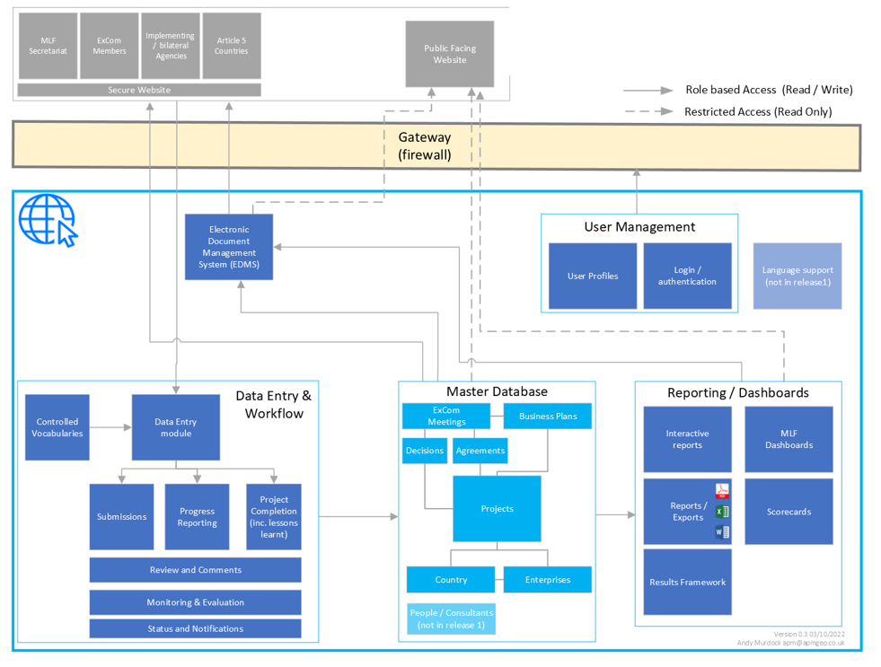
Future benefits / new capabilities
- Single source of truth  - Modern solution  - Integrated and connected | - Accessible to different types of User  - Richer analysis and visualization  - Online submission

Figure 3 High Level – Proposed future (‘To Be’) Architecture showing main system components
Several database tables are duplicated across existing MLF databases and not always containing the same attributes (e.g. country_ID, sectors etc). Several databases have a similar structure (schema) and can be consolidated. In addition, some information can be held and referenced as lookup tables such as directory and contact details. The consolidation of data into a single source of truth will also be more efficient in terms of data storage needed.
To achieve this, a new unified data model needs to be defined that integrates the many disparate systems into a relational structure where data can be linked allowing queries across the entire data holding. As with the system architecture itself, the developers will determine the precise data model (data architecture) but in the meantime, a high-level database design has been created showing the core database elements (blue), other important tables (orange), some controlled lists (green) and their basic relationships. To establish the single source of truth, it will be necessary to define data standards, consistent data types, structures etc and primary keys to support linking of the data.
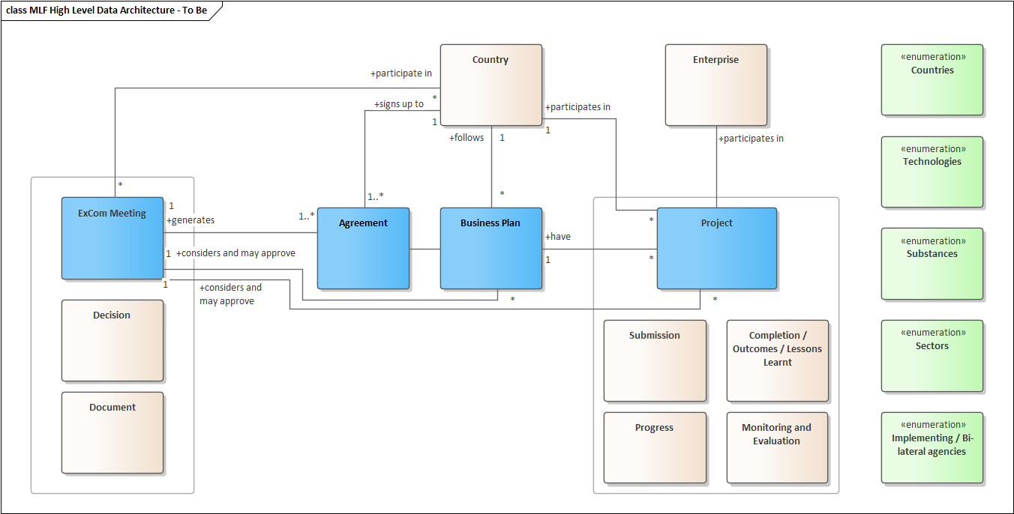

Figure 4 – High Level Data Architecture for proposed Master Database.

Migration of historical data
Once the data model has been defined, it will be necessary to transfer and transform the existing data into the new structure. For each dataset, the migration of historical data is a ‘one-off’ task and is likely to involve some manual work and the level of complexity will vary depending on the formats and consistency of data. Typical steps include:
- quality control of transformed data (checking entries and missing data fields)
- data integrity checks
- it may be necessary to pull data from multiple tables to transform the data as needed. Merging and extracting data to the final format.
- missing connections / relations need to be checked and connected
Document scraping techniques and AI based classification can be used to partly automate the process and to say, extract lessons learnt or to classify documents. The formulaic nature of many MLFS documents lends itself to the identification and extraction of relevant sections but approaches still need to be developed and tested.
The migration of historical data also needs to be prioritised into the different phases of work.

A revamped data inventory (Data Store)
In addition, the database will need to be implemented within a modern enterprise database system to deliver a revamped data inventory or data store which will be accessible by users. It will be the responsibility of the successful developer and MLF IT staff to determine the most suitable technology but possibly SQL Server or PostGreSQL.
Associated metadata (information about the data) also needs to be created which describes the datasets contents, format, origins etc and which is needed to support discovery and use.

Database rules
In addition to the simple database validation of user input described above, additional database rules will also need to be included to support the work of the MLFS. An example is a simple calculation to ensure that the amounts of HCFCs to be phased out with funds from the Multilateral Fund are within the remaining consumption eligible for funding.
Database rules and a Data Dictionary would summarise the database tables and fields and also include definition of terms will also be needed for the status tracking through the process. For example, when certain fields are entered or boxes checked within the application, it will be possible to update the statuses in the system. The fact that these operations will be time-stamped means that it will be possible to see how long different aspects of the process have taken and whether there are any ‘bottle-necks’. It will also support reporting to ExCom etc because having deadlines and flags within the database means that summary data can be extracted automatically

Create controlled vocabularies
Most of the databases use some standard lookups which are duplicated across the different systems. In the new Knowledge Management System, these should be managed as data standards with controlled lists for items such as substances, sectors etc.

Security and user access control
Some data held by MLFS is sensitive information, including personal data, evaluation feedback and commercial in confidence data that relates to patents, market share and other proprietary information about enterprises. This will not need to be available to all MLFS and access will need to be controlled based on roles and permissions matrix described earlier. MLFS will need to determine exactly who has access to what. It is proposed that a simple username and strong passwords will suffice for most of the system but those users accessing sensitive information will be required to login using two-factor authentication.

Revamped website
In addition, a revamped website will ensure that the site is more attractive and facilitates easy access to content and will provide a platform to share knowledge and showcase the successes of the Multilateral Fund. Specific improvements and the resulting benefits for phase 1 are set out in Table 4 below.
The new system should allow users to search them by topic, by meeting, by year, by country, etc. Currently it is very difficult to identify and to track decisions that for example refer to a given topic and have been adopted by the ExCom at different meetings. This functionality is also important to understand when a decision has been superseded, or amended, by another one adopted at a later stage, for example.
There are various formats that can support discoverability, other than .pdf. and utilising semantic web. Essentially the task here is to enrich the documents with metadata (information about the documents) which adds things like descriptions, keywords, tags etc alongside the files themselves and which allows them to be categorised and queried. More sophisticated search tools (e.g Elastic search) can also browse within the content of the files to pull back relevant documents and specific sections within them. What’s involved?
There is the potential to use modern search engine technology (such as elastic search and AI) to retrieve information based on key words. But longer term, more detailed document metadata will need to be created with tags and other information in order to allow more comprehensive and reliable searches (e.g. pulling out all decisions) within an EDMS.
Given that MLFS has already an existing investment in Microsoft, SharePoint seems a logical platform for the EDMS but ultimately the choice of software used will be determined during the procurement process and discussions with suppliers.
The revamped website will be designed to the relevant UN specifications and with reference to the newly promulgated Administrative Instruction on Website Publishing (ST/AI/2022/2).

Table 4 – Phase 1 – Master database and revamped website (deliverables and benefits)
Item | Description | Benefits
Master database | A consolidated database will be built on a modern enterprise platform in the cloud and under a new integrated data model. | - A ‘single source of truth’ for MLF data  - Reduced risks of transcription errors / inconsistencies  - Better connected information supporting process tracking, analysis and visualization  - Ability to create key tables, facts and figure for official documents (at least in part) from the database.
Revamped website | This will replace the current MLF website and act as the main entry point for MLF data and information. Functionality will be based on user role with ‘internal’ and public facing areas. | - A more engaging modern design, aesthetically appealing and intuitive  - A single-entry point for users to view, analyze and submit information  - Richer user experience including most of the core products described in phase 2

Phase 2 – Core products
Phase 2 will focus on the main functionality for the knowledge management system including:

Online reporting of country programme data
The new system will support online data entry allowing Article 5 to enter country programme data via user friendly forms. It is likely that a ‘tabbed’ interface will be created in order to break the data entry task down into more manageable sections. The entered data will be checked and validated for the content and quality. All entered data will then flow directly into the master database. This will also build on the previous years of data and be available for use elsewhere in the system.

Online reporting of project completion reports
As with country programme data, data entry for project completion report will be facilitated via online forms allowing users to report on project outcomes and lessons learnt. Data quality will be insured through data entry validation.

Country profiles
Users will be able to view and interrogate profiles for specific countries and to rapidly see the history of consumption, information on approved projects and relevant Executive Committee decisions etc. The country profiles could be accessed from a launch pad based on a list, map or both and with the users being presented with a page of facts and figures for the country and formatted in as an engaging interactive report comprising charts, tables and graphics. It will be possible to browse and click on interactive content allowing users to access greater detail as needed.

Revamped Meeting portal
A revamped meeting portal will improve access to the meeting documents for current and past meetings of the Executive Committee. It will also be possible to search more easily across all documents than is currently possible and based on the content of the documents and not just the titles. For example, finding all meetings where a specific substance or technology was discussed. There will also be multiple ways to find and browse the documents in addition to the current approach where documents are ordered by meetings.

“Handbook” / Electronic Document Management System
The creation of a new Electronic Document Management System (EDMS) will enable much easier access to decisions, policies, procedures, and guidelines; and the documents will be enhanced with metadata to support searches utilising modern search engine approaches such as ElasticSearch which enable the content within the documents to be search and summarised. This will provide a richer and more interactive user experience and connecting related documents.

Data portal
A significant benefit of the new knowledge management system will be the creation of self-service data portal which will be available to users allowing interactive interrogation of the data including country programme data, projects and lessons learnt. The portal would have a variety of dashboards and filters allowing interrogation the MLF database. All users will access the same authoritative single source of data but with security controls also in place to ensure that sensitive data are protected and only available to those who need it and it will be possible to tailor the portal to different users in order to achieve this.

Combining database and core products
Through the core products of phase 2, data and information of approved projects and their lessons, as well as success stories relating to the Multilateral Fund would be available online facilitating knowledge sharing. Specific improvements and the resulting benefits for phase 2 are set out in Table 5 below.
The Master Database and single source of truth will feed relevant data directly to dashboards, reports etc on the website and into these products and will be available to query. The level of access via any public facing website will be more limited though to protect personal and commercial data.
Data and summaries would be sharable (subject to access permissions), either as summaries, reports and downloads in specific formats. ‘Social media friendly’ products which can be shared within posts will also be available. Part of this functionality will be exposed in a public facing website during this phase with the potential to expand this in future.
Table 5. Phase 2 – Core products (deliverables and benefits)
Item | Description | Benefits
Online reporting of country programme data | A new online reporting format will be developed to also cover the reporting of HFCs. This will provide easy access for Article 5 countries in reporting country programme data. It will also provide historical consumption and production trend in different sector as reported by the countries. | - Facilitates reporting of data, and providing easy access to historical data and analysis  - Provides the context for current project decisions by the Executive Committee
Online reporting of project completion reports | The existing online reporting format will be improved and migrated to the new system. | - An improved online reporting format to facilitate reporting
Country profiles | The country profile database will provide information on demographics, economic parameters and drivers affecting production and consumption of controlled substances. It will provide easy access to historical picture of consumption, relevant decisions of the Executive Committee, information on approved projects and progress toward project implementation. | - Simple visual and interactive summary of a country’s status / progress, easy access to historical data
Meeting portal | Updated approach to the organisation of meeting information and documents | - Easier access to pre-session, in-session and post-session meeting documents for every meeting of the Executive Committee  - Better organisation of meeting documents to allow easier following of discussion per agenda item
“Handbook” –Electronic document management system (EDMS) | Direct access to decisions, policy, guidelines, and procedures as well as other documents. These will be organised and linked in a more intuitive way and categorized with metadata to support searching. | - Easier access to information using modern search engine and Artificial Intelligence (AI) approaches to make the documents easier to search based on key words and content.
Data portal including country programme data, projects, lessons learnt | A new self-service data portal allowing the master database to be searched and including a variety of interactive dashboards and other visualizations (totals, charts, map etc). | - The portal will be driven directly from the master database and will be constantly updated as the data is updated including dashboards, interactive reports, and other content  - Flexible and providing consistent information in an intuitive way and accessible for different users  - Initially focused on supporting MLF processes operations but eventually also supporting public users  - It will also be possible to extract and access data in open formats to exploit in other tools offline
Phase 2 will also run a pilot project for project review, focusing on renewal requests for institutional strengthening projects and requests for project preparation which are more straight-forward and have existing submission templates. This will lay the groundwork for phase 3 and will give users an indication of what to expect from the submission and review process.

Phase 3 – Agencies’ portal and other enhancements

Agencies’ portal – Online submission and review
This phase will establish an agencies’ portal to support a more efficient review process and user interface through the implementation of an online submission and review functionality allowing implementing and bilateral agencies to submit projects, business plans and progress reports and the Secretariat to make comments and suggestions back within the system.
Considering the experience and lessons on the implementation of the pilot project for project review in phase 2, the portal will first concentrate on online submission and review of the remaining types of projects. Other kinds of submissions such as business plans and progress reports will be considered at a later stage.

Application Programmer’s Interface (API) and documentation
The other major aspect of phase 3 is the creation of an application programmer’s interface (API) which will enable external developers to directly connect official MLF published data using machine-to-machine communication. Publishing content to enable re-use would enable wider dissemination and use of data. Data would need to be adequately structured as described above, to realise this ambition. This will allow direct Machine to Machine (m2m) communication of data and will enable developers of other systems to automatically execute queries and pull data from the MLF Knowledge Management System into their own applications and databases. For example, if they wished to create their own dashboard based on MLF data for a country or countries.
A detailed API specification should also be made available to provide the necessary documentation to enable developers to understand the data content and the capabilities of the API.
The development of an API is probably a lower priority in terms of the overall development, and it is likely that the developers will build the initial system in a way that it will already support API calls during earlier stages.
Specific improvements and the resulting benefits for phase 3 are set out in Table 6 below.
Table 6. Phase 3 – Agencies’ portal and other enhancements (deliverables and benefits)
Item | Description | Benefits
Agencies’ portal – Online submission and review | A series of pages to support direct entry of information into the master database. But also drawing country programme data as context from the work implemented in phase 1.  Process management within the system allowing users to know when a project has been submitted, comments made, revisions sent.  The forms will clearly show the current stage in the submission and review process (and can be aggregated across all submissions) and where the ‘history’ of comments and revisions can be seen.  Online submissions of business plans and progress reports will be considered at a later stage. | - Removes duplication and the need for manual handling  - Improved data quality and consistency  - More streamlined communication between implementing agencies and the Secretariat  - Easier to see status of project or all projects in review / submission process  - Clear audit trail of submission and review
Enhanced support for external users (data download, creation of an API) | Access to data in a machine-readable way via an API and using open standards. | Will allow external developers to automatically pull official MLFS data into their own systems directly  - Easier sharing of data  - Facilitates third party use of MLF data

Indicative costs and timescales
A three-phase project has been proposed which will enable the work to progress in stages. A high-level costing and time estimate is shown below based on experience of similar developments and the level of work needed. This does not include MLFS staff time needed to support these activities nor the cost of the procurement exercise to find a suitable developer.
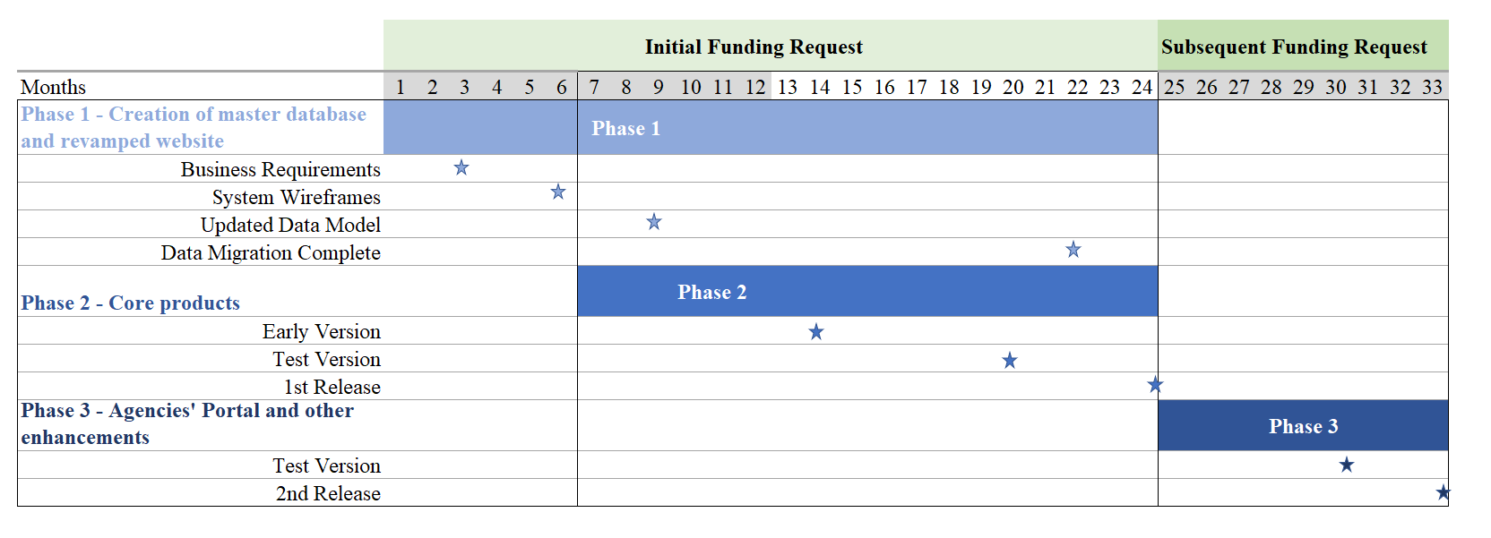
* Excluding the time required for procurement

The initial funding request will range from US $700,000 to US $900,000.
Table 7. Summary of phases and estimated costs and timescales*
Phase 1: Master database and website
Tasks |  | Cost | Timescale
1.1 | Define and prioritise more detailed user requirements (functional and non-functional) | $250,000  to $350,000 | 24 months
1.2 | User processes (and advice on governance and administering and managing data) | $250,000  to $350,000 | 24 months
1.4 | Identify the technology and any customisations needed specifically for MLF | $250,000  to $350,000 | 24 months
1.5 | Unify databases into a new master database (migration) | $250,000  to $350,000 | 24 months
1.6 | Implementation of a new technology - configuration (proxies, security assessment, new coding) | $250,000  to $350,000 | 24 months
1.7 | Revamped website (including user interface design) | $250,000  to $350,000 | 24 months
1.8 | Testing and acceptance | $250,000  to $350,000 | 24 months

Phase 2: Core products
Tasks |  | Cost | Timescale
2.1 | Online reporting of country programme data | $450,000  to $550,000 | 18 months
2.2 | Online reporting of project completion reports | $450,000  to $550,000 | 18 months
2.3 | Meeting portal | $450,000  to $550,000 | 18 months
2.4 | Country profiles | $450,000  to $550,000 | 18 months
2.5 | “Handbook” / Electronic document management system | $450,000  to $550,000 | 18 months
2.6 | Data portal including country programme data, projects, lessons learnt | $450,000  to $550,000 | 18 months
2.7 | Pilot project for project review on IS projects | $450,000  to $550,000 | 18 months
2.8 | Testing and acceptance | $450,000  to $550,000 | 18 months

Phase 3: Agencies’ portal and other enhancements
Tasks |  | Cost | Timescale
3.1 | Agencies’ portal – Online submission and review | $300,000  to $400,000 | 9 months
3.2 | Enhanced support for external users (data download, creation of an API) | $300,000  to $400,000 | 9 months

* Excluding time required for procurement.

Further detailed assessment across the full data holdings is needed to create a more accurate estimate of costs and timescales.
MLFS will need to define have an initial list of user stories and priorities ready for an Invitation to Tender. The developers will also require the following information to be able to provide a quotation:
- Scope of the work (what is in and out of scope).
- Instance where database structures and format (schemas) vary requiring more work to unify.
- Main functionality / system modules.
- Roles and permissions.
- Workflow definitions.
- Volumetrics on existing databases.
- Non-functional requirements (e.g. Service levels for the system (up time, recovery, helpdesk) backup frequency etc).

Appendix A Summary of MLF databases

A.1 Submissions Database
Submissions database
Format: | MS Access (c.90 databases, 1 for each meeting)
Description: | These databases contain information extracted from project proposals submitted by the Implementing and bilateral agencies for each meeting. It also includes the amount reviewed and recommended by the Secretariat for each activity. The information in this database is subsequently used for the Inventory of Approved Projects once the project is approved.
Content: | Information on the proposed project (country, sector, IA, funds etc)

A.2 Inventory of Approved Projects
Inventory of Approved Projects
Format: | MS Access
Description: | Provides specific information about projects approved by the Executive Committee, including the country or region, the sector, the Executive Committee meeting at which it was approved and the type of project, implementing agency, ODS phase-out and funds approved and disbursed. It is updated following each meeting and distributed to bilateral and implementing agencies.
Content: | Contains about 10,000 entries of key project information related to approved projects.

A.3 Business Plans Database
Business Plans Database
Format: | MS Excel (1 database per year)
Description: | Each year, Implementing and bilateral Agencies submit three-year rolling business plan which provides an overview of planned activities for the subsequent three years. The business plan would be considered at the last meeting of each year and endorsed by the Executive Committee. Individual projects in the business plans are approved as a part of the project approval process and after approval, these projects form a part of the inventory of approved projects mentioned above.
Content: | Business plans for 3-year cycles

A.4 Progress report
Progress Reports
Format: | Size: 1 report per year per IA/BLA line items for each project
Description: | Each year, Implementing and bilateral agencies submit annual progress reports that include all the projects that have been approved under the Fund, with emphasis on the on-going projects. The consolidated progress report would be considered at the first meeting of the year if that meeting were convened on or after 1 July, and at the second meeting of the year if it were convened earlier (Decision 77/60).
Content: | Implementation details for all approved projects

A.5 03 Report database
03 Report Database
Format: | MS Access (single database)
Description: | This database contains consolidated information from all progress reports submitted by the implementing and bilateral agencies since 1994. It also includes Secretariat comments and agencies responses since 1999.
Content: | (as above). The inventory table is duplicated in this database and remarks seem to appear in both. The 03 database has a query form to enable the generation of a formatted progress report with the remarks (where available) and a basic graph.

A.6 Prefilled Format for Individual Project Completion Report (PCRs)
Prefilled Format for Individual Project Completion Report (PCRs)
Format: | www
Description: | This web page allows Implementing and Bilateral agencies to pre-fill individual PCR formats to include latest information contained in the inventory database and actual data from the last progress reports. http://www.multilateralfund.org/pcrword/pcrmya.aspx
Content: | Access to approved project data for use in project completion reports

A.7 Multi-Year Agreement (MYA) Project Completion Reports (PCRs)
Multi-Year Agreement (MYA) Project Completion Reports (PCRs)
Format: | www
Description: | PCRs for MYA projects that are related to phase out of CFC, Halon, Methyl Bromide, CTC and TCA are submitted under this database including CFC phase-out plans, CTC phase-out plans, domestic refrigeration, Foam, Halon, Methyl Bromide, ODS phase-out plans, Process agent, Production CFC, Production ODS, Production TCA, refrigeration management plans, Refrigeration servicing, Solvent, and Tobacco. http://www.multilateralfund.org/pcr/Login.aspx
Content: | Similar to PCR database

A.8 HPMP Project Completion Reports (PCRs)
HPMP Project Completion Reports (PCRs)
Format: | www
Description: | PCRs for HCFC Phase-Out Management Plan (HPMPs) are submitted under this database. http://www.multilateralfund.org/hpmppcr/login.aspx
Content: | The same as PCR and MYA PCR databases

A.9 HPMP MYA database
HPMP MYA database
Format: | www
Description: | Database of multi-year agreements related to HCFC Phase-Out Management Plan (HPMPs)
Content:

A.10 PCRs Lesson Learnt for Individual Projects
PCRs Lesson Learnt for Individual Projects
Format: | Access / www
Description | Lessons learned from individual project completion report (PCRs) using Access database which is then uploaded in the web.  The website has simple filters for country agency, sector and type as well as a key word search. Search engines for individual PCRs are respectively accessible at:  http://www.multilateralfund.org/pcrindividual/search.aspx
Content: | The specific lessons learnt from the project. The idea is that this information can be viewed by others implementing similar projects or with similar technologies to learn from their experience of good practices and difficulties encountered.

A.11 PCRs Lesson Learnt for MultiYear Agreement (MYA) Projects

PCRs Lesson Learnt for MultiYear Agreement (MYA) Projects
Format: | www
Description: | Lessons learned from MYA project completion reports (PCRs)  An online search engine to access the lessons learned from MYA PCRs was developed so that stakeholders could easily access it when they develop or implement similar projects. Queries can be structured by categories (country, agency, sector, and type) and by keywords. Search engines for MYA PCRs are respectively accessible at:  http://www.multilateralfund.org/myapcr/search.aspx
Content: | Lessons learnt for MYA plus high level agreement info.

A.12 Country Programme Data
Country Programme Data
Format: | www (and Excel)
Description: | Data on consumption and production of controlled substances submitted every year by Article 5 countries.  Most of the country programmes data from 2011 to 2018 were submitted in the website. Except for 2019 to 2021, the data were submitted in Excel during the trial period. There is significant potential for inconsistencies with multiple different versions of CP MS Excel files. The Web form is more like what will be needed in the new system to be able to see the CP data. A new format in MS Excel for CP data has been approved at recent meeting and will need to be implemented in the Master database.
Content: | Tabs as per spreadsheet (A) Annex A, B and C Group 1 and Annex E (B) Annex F (C) Average estimated price of HCFCs, HFCs and alternative (D) Annex F, Group II- Data on HFC-23 generation (E) Group II- Data on HFC-23 emissions (F) Comments by bilateral and implementing agencies. In 3 languages (English, French and Spanish)

A.13 Inventory of Enterprises
Inventory of Enterprises
Format: | Excel
Description: | The database is a streamlined version of the HPMP MYA database that includes data for all the HCFC-based enterprises that had been approved for conversion to alternative technologies, as stand-alone projects or contained in HPMPs comprising inter alia data on the sector and application, the amounts of HCFCs to be phased out and alternative chemicals to be phased in, and associated costs.  Online resource: www.multilateralfund.org/hpmp
Content: | Data are duplicated from the HPMP MYA database.

A.14 Contacts database
Contacts database
Format: | Assumed to be Microsoft Outlook
Description: | Lists all the key people responsible and points of contacts people for specific projects.
Content: | Not seen

A.15 Evaluation Consultants Roster
Evaluation Consultants Roster
Format: | Excel - Size: currently 34 individuals
Description: | A list of consultants that provide technical expertise for MLFS Evaluation. The list is a simple excel spreadsheet with contact details and the specific areas of expertise in engineering
Content: | Name, address emails and phone number, profile doc on Inspira, years of experience, education (highest level), area of expertise gender, citizenship, other remarks (experience specific projects and MLFS contacts).

Appendix B User Personas

B.1 Multilateral Fund Secretariat (MLFS) - Data Persona
Overview
I support the ExCom in the discharge of its functions. This requires administration of the MLF process and support for project submission, review, and monitoring and evaluation during the implementation of projects.
I need to be able to see the full details of projects across the entire lifecycle from proposals to completion and including review (providing comments), progress reporting, finances, completion reports and lessons learnt)
In the project review process I will also make recommendations to ExCom on the various submissions.
I develop the three-year plan and budget and a system of funds disbursement; manage the business planning cycle of the Fund; monitor the expenditures and activities of the implementing agencies; prepare policy papers and other documents; review and assessment of project-related submissions of the implementing agencies; liaise between the Executive Committee, governments and the implementing agencies; service the meetings of the Executive Committee.
Priorities
- simplification of processes and data collection
- efficiency savings
- self-service system
- system support and easy modifications
- secure system for sensitive data
- improve visualisation and analytical capabilities
- identification of potential project / programme needs for future and risks.
Needs
- online submission of business plans, projects, progress reports, PCRs
- ability to extract and analyze data as requested by the Executive Committee
- develop a Corporate scorecard
- ability to track the status of projects through the process (submitted, approved, ongoing, completed)
- ability to make comments and receive responses from implementing agencies
- ability to provide information and statistics on request based on the MLF data for ExCom and others
- ability to quickly access relevant information in official documents
Pain Points
- receive a lot of very similar requests for basic data which I have to extract in manual inefficient way
- disparate databases - it is very difficult to analyse data across different meetings etc without manual interventions
- double entry of data (e.g. project proposals information is copied and pasted to database, questionnaires etc)
- existing systems are not user friendly
- existing web systems are no longer supported and there are no arrangements for small changes. Some online systems no longer used and have reverted to offline
- not easy to access guidance documents, procedures etc - no EDMS
- difficult to interrogate all projects under an agreement - not linked

B.2 Executive Committee Member - Data Persona
Overview
I sit on the governing body that reviews business plans, provides policy guidance, approves projects consistent with Montreal Protocol objectives and guidance.
I review high level information such as past progress, financial information and the recommendations and other outputs.
The information helps me to understand the historical and current context regarding a country, its progress and successes when deciding on whether to approve future funding.
Priorities
- easy access to information about past performance, decisions and agreements, including those which are not project related
- ability to summarise and access country level and financial data in different ways
Needs
- summaries and high level information
- country data in terms of the current and past situation (production and consumption data and financial info - how much given etc) - the timeline
- business plans and project information
- tags (such as sector, country, SIDS etc) so that data can be aggregated and summarized in different ways
- project progress summaries to be able to see how things have progressed
- hyperlinks to key decisions, agreements and other information within documents
- notifications for when documents are available for review would be useful
Pain Points
- no direct access to data and having to contact the Secretariat for information which could be available online.
- The way decisions are noted and retrieved could be made easier - currently copied and pasted from Word documents into a database (compendium of all decisions)
- it is difficult to search the PDFs and not easy to pull out multiple decisions related to a specific country, sector etc.
- Database of all agreements sits in one huge document which is un-wieldy and difficult to navigate
- it is difficult to have the information you want.

B.3 Implementing Agencies / Bi-lateral Agencies - Data Persona
Overview
I am responsible for identifying needs and beneficiaries of MLF funds and designing projects that can help Country Parties and Enterprises reduce the ODS and controlled substances they consume or produce within their activities.
I design and develop budgets for projects working with Country Parties and in-country enterprises. I create business plans with multiple projects which seek to deliver the goals of the Montreal Protocol. I submit the business plans and projects to The Multilateral Fund Secretariat for review and comments. I revise the project scope and funds as needed to ensure projects meet requirements and are approved.
Following approval of projects I work on implementation, regularly reporting on progress and project spend to the MLFS.
On completion of projects, I report on outcomes and lessons learnt.
Priorities
- robust user friendly data systems
- consistent data
- easy entry and retrieval of data
- easy method to report on project progress and completion
- version tracking for iterations to submissions and other reports
- databases / datasets that are connected
- traceability and transparency
- needs to be common for internal and external purposes
Needs
It should be noted that the needs of IAs may differ from those of Bi-lateral Agencies
- an easy way to submit project proposals and associated documentation online.
- a mechanism that allows me to receive comments from MLF Secretariat and to provide a response.
- a system to report on progress of the projects I am charged with implementing
- a mechanism to report on completed projects and lessons learnt
- a mechanism that allows me to see the status of a project in the process
- the ability to generate and receive notifications about progress through the process or reminders
- ability to share information on a periodic basis on implementation of projects
Pain Points
- current system is very out-dated and cumbersome to work with
- inconsistency in the numbers generate
- no clear lineage for the numbers which are prefilled so have to manually validate
- data are submitted but there is no central system with which to retrieve it back again.
- current process relies on email exchanges
- lack of document database means it is extremely difficult to access information such as decisions, agreements etc without relying on corporate memory and manual searching
- in the repository for official documents the information is not easily accessible if you don't know how to look for it
- no linkage of financial systems
- current financial reporting is extremely time consuming and based on a huge Excel spreadsheet
- system does not currently handle MYA projects well

B.4 Article 5 Countries / Bi-lateral Agencies - Data Persona
Overview
Priorities
Needs
Pain Points

B.5 All other Users / Bi-lateral Agencies - Data Persona
Overview
Not easily characterized within a single persona but these users require read access only
I need to be able to access official information on the countries, business plans and projects that will support me in my role.
Some of these roles will require both read and write access to the Master database in order to enter data.
There are several different roles with differing specific needs. Roles include: Fund Treasurer, Donor countries, NGOs, Academic Community, Country Parties, Enterprises, Interested Public, MOPAN,
Priorities
Depend on specific roles
- easy access to official data
- more efficient ways of working
- self-service of data
- during design, need to carefully see which data can be shared given sensitivity of this data
Needs
Requirements are specific to the specific roles but generic requirements include:
- the general public needs to be able to understand what the work of the MLF is about and what the achievements are.
- to understand the lessons learnt and possibly replicate some of these lessons to other processes.
- self-service platform including public facing data portal
- ability to enter data into a central official location
- ability to find and retrieve authoritative and consistent information and query and filter for my specific interests (country, sector etc.)
- ability to create summaries and reports from the data
- ability to access and download data for use in my own systems and research
Pain Points
- difficulty discovering information and no easy way to discover what is available (metadata, categories etc.)
- difficulty accessing directly information about a country, progress, business plan, project when needed
- difficulty accessing information within official documents
- website needs to be more user friendly
- manual processes transferring data to and from relevant reports / databases

UNEP/OzL.Pro/ExCom/91/1
http://multilateralfund.org/aboutMLF/executivecommittee/Shared%20Documents/2022%20Primer.pdf
Decisions 74/6(b) and 75/6(b).

