UNITED  NATIONS |  | EP
   | United Nations  Environment  Programme | Distr.  GENERAL  UNEP/OzL.Pro/ExCom/86/99  9 February 2021  ORIGINAL: ENGLISH
EXECUTIVE COMMITTEE OF
THE MULTILATERAL FUND FOR THE
IMPLEMENTATION OF THE MONTREAL PROTOCOL
Eighty-sixth Meeting
Montreal, 2-6 November 2020
Postponed to 8-12 March 2021

THE WORLD BANK’S WORK PROGRAMME AMENDMENTS FOR 2020
Note from the Secretariat

As explained in paragraph 8 of document UNEP/OzL.Pro/ExCom/86/31, Overview of issues identified during project review, the World Bank submitted work programme amendments for 2020 for consideration of the Executive Committee at its 86th meeting containing the following two funding requests: preparation of an HFC phase-down management plan for Malaysia, and project preparation of an HCFC production phase-out management plan (HPPMP) for India.
- During the project review, the Secretariat noted that neither project met the requirements of the Executive Committee for submission for the following reasons:

At the time of the submission of the request for project preparation for an HFC phase-down plan for Malaysia, the country had not yet ratified the Kigali Amendment, which is a prerequisite for the submission of requests related to HFCs, in line with decision 79/46(b)(iii); and

Project preparation for the HPPMP for India could only be requested after a technical audit has been completed, in line with decision 32/78.

Based on the above, the Secretariat did not issue the work programme amendments for 2020 for the World Bank at the 86th meeting.

Subsequently, on 21 October 2020, the Government of Malaysia ratified the Kigali Amendment; therefore, the request for funding for a project preparation for an HFC phase-down plan, was eligible. As the World Bank work programme amendments for 2020 was not issued, the Secretariat was only able to submit the request under the section on Requests for preparatory funding for HFC phase-down plans included in the work programmes of UNDP, UNEP, UNIDO and the Government of Germany of document UNEP/OzL.Pro/ExCom/86/31. In that document, the Executive Committee was invited to consider the requests for the preparation of HFC phase-down management plans for the 24 countries listed in Table 1 (including the request from the Government of Malaysia), once the guidelines for funding the preparation of HFC phase-down management plans have been agreed, in line with decision 84/54(a)(iii).

Subsequently, at the intersessional approval process established for the 86th meeting, the Executive Committee agreed to consider all issues presented in document UNEP/OzL.Pro/ExCom/86/31 except for the requests for project preparation for HFC phase-down plans submitted as part of the bilateral cooperation of the Government of Germany, work programme amendments of UNDP, UNEP and UNIDO for 2020 and for Malaysia submitted by the World Bank, which would be forwarded to the postponed 86th meeting for further consideration.

In view of the above, the present document is being issued for consideration at the postponed 86th meeting.
COMMENTS AND RECOMMENDATION OF THE FUND SECRETARIAT

The World Bank is requesting approval from the Executive Committee of US $250,000, plus agency support costs of US $17,500, for its 2020 work programme amendments listed in Table 1.

Table 1: The World Bank’s work programme amendments for 2020
Country | Activity/Project | Amount requested (US $) | Amount recommended (US $)
ACTIVITIES RECOMMENDED FOR INDIVIDUAL CONSIDERATION
Project preparation for HFC phase-down management plans
Malaysia | Preparation of an HFC phase-down management plan | 250,000 | *
Subtotal |  | 250,000 | *
Agency support costs |  | 17,500 | *
Grand total |  | 267,500 | *
* For individual consideration

ACTIVITIES RECOMMENDED FOR INDIVIDUAL CONSIDERATION

Project preparation for HFC phase-down management plans
Project description

The World Bank submitted a request for the preparation of an HFC phase-down management plan for Malaysia as designated implementing agency, as shown in Table 1. The project proposal is contained in Annex I to the present document.

Secretariat’s comments

The World Bank as designated implementing agency, provided a description of the activities required for the preparation of an overarching strategy for HFC phase-down for Malaysia including the corresponding costs of each activity using the format for requests for project preparation for stages of HCFC phase-out management plans (HPMPs). The submission included information about the estimated imports of HFCs and HFC blends for 2015 to 2018 based on information and data collected during the implementation of the enabling activities; list of activities for the project preparation including updating the HFC consumption survey; development of the HFC phase-down strategy including stakeholder consultations; and development of investment and technical assistance activities in the HFC-consuming sectors.

The amount requested for the preparation of the HFC phase-down plan was based on the funding for enabling activities (contained in decision 79/46(c)). The Secretariat noted that the funding amounts of project preparation requests are indicative, as the actual amounts will be decided when the Executive Committee considers document UNEP/OzL.Pro/ExCom/86/88, Draft guidelines for the preparation of HFC phase-down plans for Article 5 countries (decision 84/54(a)).

While the actual funding level for preparation of HFC phase-down management plans still has to be decided, the Secretariat reviewed the submission based on the experience of reviewing requests for preparation of HPMPs, and taking into account guidance provided and decisions adopted by the Executive Committee for such projects. Following this review, the Secretariat noted that the submission for the request for Malaysia met the requirements for submission as the country had ratified the Kigali Amendment, and it included an endorsement letter indicating the country’s intention to take early action on HFC phase-down. The activities listed for project preparation were also similar to those required to prepare HPMPs; some activities resembled those included under the enabling activities for HFC phase-down for which funding had already been provided and which is currently ongoing.

The World Bank clarified that the project preparation for the overarching strategy for HFC phase-down for Malaysia would draw on the activities implemented under the enabling activities, as these were the first actions associated with the phase-down of HFCs and had contributed to the ratification of the Kigali Amendment. Approval of funding for the request at the 86th meeting will allow implementation of HFC phase-down to begin by 2022, and achieve compliance with the Kigali Amendment.

The Secretariat informed the World Bank that it will be unable to make a recommendation on this request as guidelines on funding these requests will be discussed at the 86th meeting.

Secretariat’s recommendation

The Executive Committee may wish to consider, in line with discussions under agenda item 9(a), Overview of issues identified during project review, and agenda item 13(c), Draft guidelines for the preparation of HFC phase-down plans for Article 5 countries (decision 84/54(a)), the request for project preparation for HFC phase-down management plan for Malaysia as listed in Table 1.

Annex I
REQUEST FOR PROJECT PREPARATION OF STAGE I KIGALI HFC PHASEDOWN MANAGEMENT PLAN FOR MALAYSIA
(Extract from the World Bank’s work programme amendments for 2020)

Background

The Government of Malaysia is fully committed to the Montreal Protocol (MP) and the Climate Change Convention. It acceded to both the Vienna Convention for the Protection of the Ozone Layer and the Montreal Protocol on Substances as well as all the subsequent amendments as indicated in Table 1. Malaysia was expected to ratify the Kigali Amendment in 2020 after the Cabinet approved the ratification in early 2020. However, the change in government leadership in March 2020 requires the new Cabinet to re-approve the ratification. The Ministry of Environment and Water had already restarted the process and now expect the ratification would take place in early 2021.
Table 1: Malaysia Ratification Dates - Vienna Convention, MP, and Amendments
Instrument | Date of Ratification
Vienna Convention | 29-Aug-1989
Montreal Protocol | 29-Aug-1989
London Amendment | 16-Jun-1993
Copenhagen Amendment | 5-Aug-1993
Montreal Amendment | 26-Oct-2001
Beijing Amendment | 26-Oct-2001
Kigali Amendment | Expected early 2021

As of 1 January 2010, Malaysia has fulfilled its commitment to phase out consumption of all controlled substances with the exception of hydrochlorofluorocarbons (HCFCs).
Findings from Enabling Activities for HFC Phasedown in Malaysia
The enabling activities for HFC phasedown in Malaysia was approved by the 80th ExCom (decision 80/52) and completed in June 2020.
HFC Consumption in Malaysia
Based on the information and data collected during the implementation of the enabling activities, total consumption of HFCs from 2015 through 2018, grouped into pure HFCs and HFC blends, are shown in Table 2. The import data collected from both the primary and secondary sources indicate that only 11 out of the total 18 pure HFCs controlled by the MP were imported during 2015–2018. In addition to pure HFC imports, Malaysia also imported 19 HFC blends during the same period. Malaysia does not produce HFCs.
Table 2: Consumption of Bulk HFCs and HFC Blends from 2015 to 2018 (MT)
Chemical | 2015 | 2016 | 2017 | 2018
Pure HFCs | 3,067.45 | 4,124.54 | 4,313.48 | 4,552.96
HFC blends | 3,822.00 | 3,790.58 | 3,901.75 | 3,813.25
Total | 6,889.45 | 7,915.12 | 8,215.23 | 8,366.21

Major consumption of HFCs can be classified into six sectors: (a) AC, (b) refrigeration, (c) mobile AC, (d) foam, (e) fire protection, and (f) solvent cleaning as depicted in Figure 1.
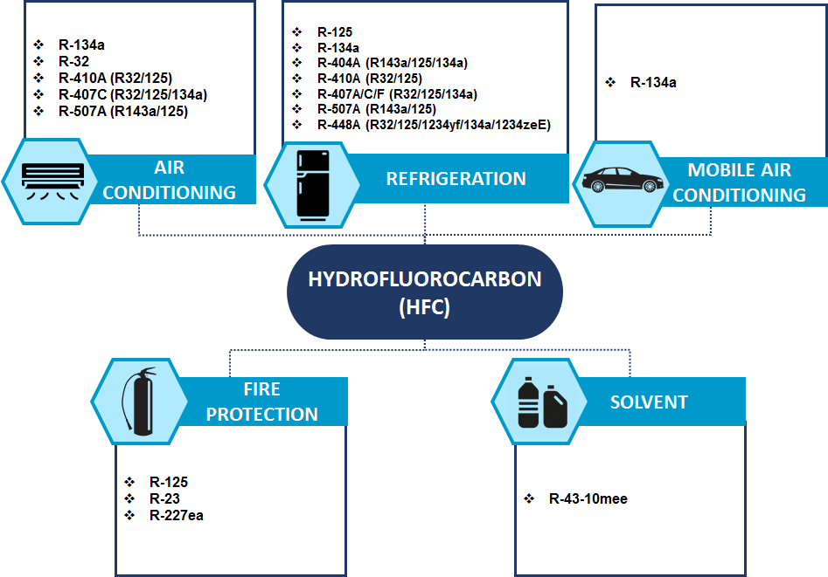
Figure 1: HFC Consumption by Industry Sector
Kigali HFC Baseline for Malaysia
According to the Kigali Amendment, the HFC baseline consumption for Malaysia (as an Article 5, Group 1 country) will be determined by the average HFC consumption between 2020 and 2022 plus 65 percent of the GWP of the HCFC baseline. The calculated GWP of 65% of HCFC consumption baseline of Malaysia is 8.20 million tons CO2 equivalent.
The average HFC consumption between 2020 and 2022 is estimated from the data collected from 2015 through 2018 with the assumption that HFC consumption for each subsector/application will follow the same growth rate. The average HFC consumption for the baseline period (2020 to 2022) is estimated to be 10,631.31 MT, which is equivalent to 21.93 million tons of CO2 equivalent (mtCO2e). Thus the estimated HFC baseline for Malaysia is 30.13 mtCO₂ (21.93 mtCO₂ from HFCs and 8.20 mtCO₂ from 65 percent of the HCFC baseline).
HFC Projection under Business-as-Usual Scenario
Based on the 2015-2018 consumption data and growth rate in each application, consumption forecast in key sectors under the business-as-usual (BAU) scenario from 2018 to 2045 is shown in Figure 2 below.
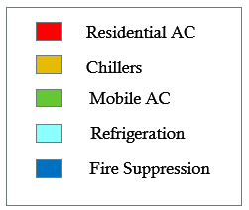
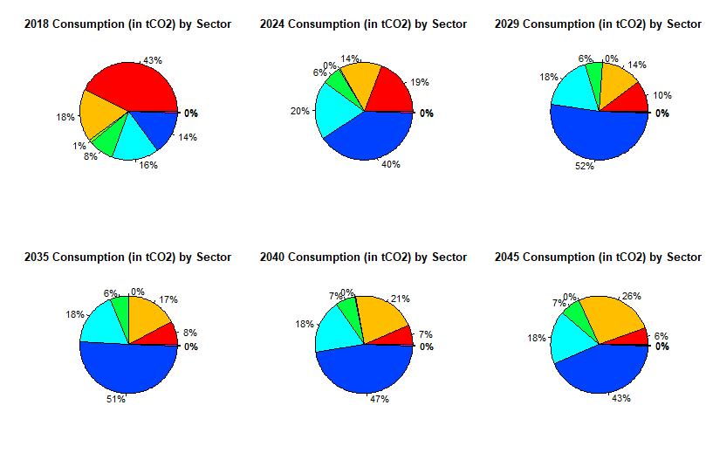
Figure 2: 2018 versus Projected 2024 Consumption in Key Sectors under BAU Scenario
Under the BAU scenario, Malaysia HFC consumption would quickly grow and exceed the freeze target in 2024 as shown in Table 3.

Table 3: HFC Consumption under the BAU Scenario (million tCO2)
million tCO2 | 2018 | 2024 | 2029 | 2035 | 2040 | 2045
HFC Consumption (BAU) | 16.32 | 32.21 | 50.52 | 70.30 | 92.51 | 123.58

Phasedown Intervention
The study developed under the HFC enabling activities considers sector-specific interventions from 2024 to 2045 to support full compliance with all the phasedown targets during the same period. Considering the likely technology pathways that the sectors and applications will follow under the BAU scenario, and taking into account the Stage II HPMP, a series of interventions in the key HFC sectors and subsectors are considered for each major control period of the KA that would enable Malaysia to, at a minimum, comply with the estimated baseline consumption and subsequent reductions up to the final 2045 reduction step. HFC consumption projections for the four scenarios described earlier are shown in Figure 3. All proposed scenarios would secure Malaysia’s full compliance with its estimated phasedown obligations under the KA.
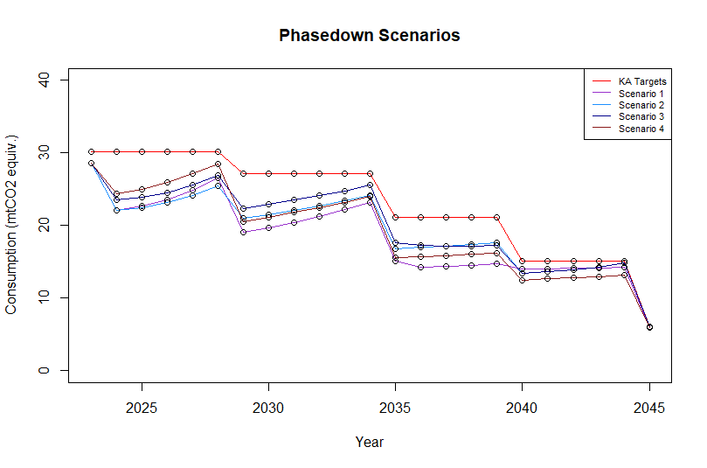
Figure 3: Malaysia's HFC Phasedown Schedule against Intervention Scenarios
However, the COVID-19 pandemic could depress the demand for HFCs and HFC-based equipment during the baseline years (2020–2022). This could result in a lower HFC baseline than the estimate presented above. Phasedown options that are more aggressive than those considered may be required if the demand is restored to normal levels after the baseline years.

Objectives

The Stage I Kigali HFC Phasedown Management Plan (KPMP), to be developed under this activity, will support Malaysia in meeting its compliance with the first two target steps: freeze by 2024 and 10% reduction by 2029. It will serve as the platform for reflecting Malaysia’s evolving situation while proposing needed investment, policy, and technical assistance interventions for achieving sustainable HFC reductions.

Proposed approach and activities

The proposed approach includes the following activities:

    - Update Malaysia HFC survey (inclusion of 2019 and 2020 HFC consumption) and analyze the impact of COVID-19 pandemic that may depress the demand of HFCs and HFC-based equipment during the baseline years (2020 – 2022), resulting in a lower HCFC baseline than the previous estimate. Update HFC consumption projection for the immediate period (2024 – 2029) after the baseline years in case the demand returns to normal post COVID-19 pandemic.
    - Develop sector policies and plans to curb the demand of HFC for the fire suppression sector and refrigeration and air-conditioning sectors which are identified as major and high growth HFC consumption sectors by the previous study undertaken as part of the HFC enabling activities. Conduct comprehensive surveys of manufacturing and servicing enterprises in these sectors;
    - Develop investment and technical assistance activities in the manufacturing and servicing fire suppression and, refrigeration and air-conditioning sectors including technical and financial viability of recovery, recycle and disposal of HFCs;
    - Develop HFC quota allocation options and procedures for consideration of DOE, METI and Customs Department and action plan for implementing the new WCO HS system for HFCs will enter into force in 2022.
Estimated budgets
Activities | Unit cost (US$) | No. | Budget(US$)
National workshops | 10,000 | 2 | 20,000
National consultant service |  |  | 100,000
International consultant service |  |  | 30,000
Domestic travel | 600 | 10 | 6,000
International travels and accommodation | 8,000 | 4 | 32,000
Industry consultation workshops | 4,000 | 6 | 24,000
Communication, translation, printing, etc. |  |  | 5,500
Review the consultant’s report and finalize the KPMP document |  |  | 10,000
Sub-total |  |  | 227,500
Contingency (~10%) |  |  | 22,500
Total |  |  | 250,000

Due to coronavirus disease (COVID-19)
Funding for the preparation of national implementation plans to meet initial reduction obligations for the phase-down of HFCs could be provided, at the earliest, five years prior to those obligations, after a country had ratified the Kigali Amendment and on the basis of guidelines to be approved in the future.
With regard to the timing of approval of project preparation funding for the ODS production sector, the Executive Committee decided that the current procedure of approving project preparation funding after the completion of technical audit should continue to be applied.
Held from 10 November 2020 to 14 December 2020.
Paragraph 120 of document UNEP/OzL.Pro/ExCom/86/IAP3.
The project proposal as submitted was extracted from the World Bank’s work programme amendments for 2020 submitted in September 2020.

