UNITED  NATIONS |  | EP
   | United Nations  Environment  Programme | Distr.  GENERAL  UNEP/OzL.Pro/ExCom/91/70  4 November 2022  ORIGINAL: ENGLISH
EXECUTIVE COMMITTEE OF
THE MULTILATERAL FUND FOR THE
IMPLEMENTATION OF THE MONTREAL PROTOCOL
Ninety-first Meeting
Montreal, 5-9 December 2022
Item 15 of the provisional agenda

UPDATE OF THE INFORMATION STRATEGY OF THE Multilateral Fund INCLUDING A DETAILED PLAN FOR INFORMATION AND KNOWLEDGE MANANAGEMENT, WEBSITE/INFORMATION TECHNOLOGY REQUIREMENTS, RESOURCES NEEDED AND CLEAR TIMELINES FOR IMPLEMENTATION (DECISION 89/1(C)(II))

Introduction

At its 89th meeting, subsequent to the consideration of the Multilateral Organisation Performance Assessment Network (MOPAN) assessment of the performance of the Multilateral Fund (MLF) for the Implementation of the Montreal Protocol, the Executive Committee requested the Secretariat of the Multilateral Fund to update the information strategy of the MLF, to include a detailed plan for information and knowledge management, the website/information technology requirements, the resources needed and clear timelines for implementation and to submit the strategy for consideration by the Executive Committee at the 91st meeting (decision 89/1(c)(ii)).

The update of the information strategy of the MLF is essentially the development of a new knowledge management system that is proposed in this document. It aims not only at preserving the existing data and information and providing efficient, secure, and user-friendly access to them for all stakeholders, but also at organizing and transforming these data and information to knowledge that could be passed on to various types of stakeholders to facilitate their learning and decision-making processes, as relevant, through different tools. Examples of such tools include a revamped website and a revamped meeting portal, an online reporting tool under the country programme data extending to HFCs, a data portal, country profiles, a searchable online collection of the MLF policies, guidelines, and procedures.

Accordingly, a technical feasibility study consultancy was undertaken to assess the current state of knowledge management within the Secretariat based on reviews of the website, documents, submission processes, existing databases, and discussions with stakeholders (users). The technical feasibility study consultancy resulted in recommendations for improvements.

The present document consists of the following five sections: I–an assessment of the Secretariat’s existing databases and the MLF website, II–an identification of main users of data and information related to the MLF, III–a proposal for a new knowledge management system with the description of three phases for its implementation, IV–relevant timelines and estimated costs, and V–a recommendation for the consideration of the Executive Committee. The technical feasibility study prepared by the consultant is contained in document UNEP/OzL.Pro/ExCom/91/Inf.2.
- Assessment of the Secretariat’s existing databases and the MLF website

The analysis has shown that the existing databases in the Secretariat supporting knowledge management in the MLF, although comprehensive, are outdated and disconnected. There is a proliferation of disparate databases which are held in a variety of formats with duplicative data, leading to multiple data sets which lack functionality in terms of data discovery, analysis, and visualisation. This results in difficulties for query and analysis of data across the entire data holding, which often has to be done with considerable manual handling, making the process time consuming and prone to errors. This also limits the optimum use of data across different processes in the Secretariat to support its efficient operation. In addition, these databases are not available on the MLF website; relevant stakeholders or the public who need information contained in these databases would require submitting their requests to the Secretariat by emails.

The review also noted that the MLF website is outdated, poorly designed, and is not user-friendly. It is a static website that simply provides basic information of the MLF, serves the purpose of providing links to various documents, such as Executive Committee meeting documents, evaluation-related documents, project-related guides and technical reports and the document on “Policies, procedures, guidelines and criteria of the Multilateral Fund”. It lacks practical search features that would allow users to access content highlights, key facts or interactive information allowing users to visualise and analyse the MLF data and understand the work of the MLF.

Further, the assessment showed that the current structure of the databases has limited the potential to view and interrogate the data due to its design and manual handling. This existing approach presents a risk because of the reliance on a few key individuals with data management skills and institutional memory to locate and pull the required data and information together. Therefore, consolidating the data of the existing databases into a master database and offering a new user-friendly, ‘self-service’ data portal within the website would provide greater flexibility, new capabilities, potential new insights, and a ‘single source of truth’ and would increase the accessibility of data for users both in and out of the Secretariat. It is envisaged that this master database will also generate the information and data required to upgrade the content of the website which will be developed using the state-of-the-art technology and following the best security protocols.

In analysing the processes in the Secretariat that support the Executive Committee’s work vis-à-vis data and information requirements, it was noted that the improved master database and website should support a more efficient and seamless process for the business planning, project review and monitoring. Another limitation of the current system is that it lacks the features that allow online submissions for projects and other ad hoc data and information requirements. Such functionality could be provided by a revamped knowledge management system, and it could have multiple benefits (as briefly elaborated in paragraph 22) for the Secretariat, the Executive Committee, the implementing and bilateral agencies, the countries whose projects and other submissions are under review and facilitate a more efficient review process in one virtual space.
- Identification of main users of data and information related to the MLF

The main users of the system are:

Multilateral Fund Secretariat including the evaluation and monitoring function;

Executive Committee members;

Implementing/bilateral agencies;

Article 5 countries that report country programme data; and

All other users.

Preliminary discussions were held with main stakeholders as part of the analysis to assess their needs and identify current challenges. Their views and comments, and their aspirations for a new knowledge management system including a revamped website have been reflected in the assessment in section I above.

It should be noted that although all users will access the same system, each one will be able to view only the specific data and information relevant to their user profile and permitted access. The system will have a security mechanism in place that will restrict sensitive and confidential data and information to certain users. In addition, the level of functionality in terms of what people can do with the system will also vary for different users. For each user type, the roles and permissions for the system will be clearly defined as part of the project design.
- Proposal for a new knowledge management system

The proposal for a new knowledge management system will be implemented in three phases and activities and core products of each phase are explained below.
III.1 Phase 1 – Master database and revamped website
- Phase 1 lays the foundations for the knowledge management system and corporate website and focuses on the creation of a master database which consolidates the data and information from the many different sources into a ‘single source of truth’ and which serves as the foundation for the system. Having a master database moves the system from a complex disparate structure to a more integrated, accessible, and simplified architecture.
- The objectives of phase I will be to preserve the existing data and information, simplify the databases with a new data model and develop a master database, and once this model is developed, to migrate historical data into the new structure. This phase will also define the database rules both for data inputs and use and establish security and user access control.
- The proposed master database will be designed to ensure that data are more efficiently accessed and utilized, entered once, updated regularly, and used many times across the activities of the Secretariat. In practical terms the master database will directly feed different areas of the new knowledge management system and the revamped website will become the main point of access for all MLF data and information and queries. The emphasis initially will be on the internal use of data and information by the Secretariat including by the monitoring and evaluation cluster for evaluation purposes, the implementing and bilateral agencies. The functionality will also have some public-facing information to be expanded in the latter phase of development.
- In addition, a revamped website will ensure that the site is more attractive and facilitates easy access to content and will provide a platform to share knowledge and showcase the successes of the Multilateral Fund. Specific improvements and the resulting benefits for phase 1 are set out in table 1 below.
Table 1. Phase 1 – Master database and revamped website (deliverables and benefits)
Item | Description | Benefits
Master database | A consolidated database will be built on a modern enterprise platform in the cloud and under a new integrated data model. | - A ‘single source of truth’ for MLF data  - Reduced risks of transcription errors / inconsistencies  - Better connected information supporting process tracking, analysis, and visualization
Revamped website | This will replace the current MLF website and act as the main entry point for MLF data and information. Functionality will be based on user role with ‘internal’ and public facing areas. | - A more engaging modern design, aesthetically appealing and intuitive  - A single-entry point for users to view, analyze and submit information  - Richer user experience including most of the core products described in phase 2
III.2 Phase 2 – Core products
- Phase 2 will focus on the main functionality for the knowledge management system including:
  - Online reporting of country programme data;
  - Online reporting of project completion reports;
  - Country profiles: history of consumption, information on approved projects and relevant Executive Committee decisions;
  - Meeting portal – improved access of the meeting documents in current and past meetings of the Executive Committee;
  - “Handbook” / Electronic Document Management System - access to decisions, policies, procedures, and guidelines; and
  - Data portal including country programme data, projects, lessons learnt– self-service data access area with filters and dashboards including access for public users.
- Through the core products of phase 2, data and information of approved projects and their lessons, as well as success stories relating to the Multilateral Fund would be available online facilitating knowledge sharing. Specific improvements and the resulting benefits for phase 2 are set out in table 2 below.
Table 2. Phase 2 – Core products (deliverables and benefits)
Item | Description | Benefits
Online reporting of country programme data | A new online reporting format will be developed to also cover the reporting of HFCs. This will provide easy access for Article 5 countries in reporting country programme data. It will also provide historical consumption and production trend in different sector as reported by the countries. | - Facilitates reporting of data, and providing easy access to historical data and analysis  - Provides the context for current project decisions by the Executive Committee
Online reporting of project completion reports | The existing online reporting format will be improved and migrated to the new system. | - An improved online reporting format to facilitate reporting
Country profiles | The country profile database will provide information on demographics, economic parameters and drivers affecting production and consumption of controlled substances. It will provide easy access to historical picture of consumption, relevant decisions of the Executive Committee, information on approved projects and progress toward project implementation. | - Simple visual and interactive summary of a country’s status / progress, easy access to historical data
Meeting portal | Updated approach to the organisation of meeting information and documents | - Easier access to pre-session, in-session, and post-session meeting documents for every meeting of the Executive Committee  - Better organisation of meeting documents to allow easier following of discussion per agenda item
“Handbook” –Electronic document management system | Direct access to decisions, policy, guidelines, and procedures as well as other documents. These will be organised and linked in a more intuitive way and categorized with metadata to support searching. | - Easier access to information using modern search engine and Artificial Intelligence (AI) approaches to make the documents easier to search based on key words and content.
Data portal including country programme data, projects, lessons learnt | A new self-service data portal allowing the master database to be searched and including a variety of interactive dashboards and other visualizations (totals, charts, map etc). | - The portal will be driven directly from the master database and will be constantly updated as the data is updated including dashboards, interactive reports, and other content  - Flexible and providing consistent information in an intuitive way and accessible for different users  - Initially focused on supporting MLF processes operations but eventually also supporting public users  - It will also be possible to extract and access data in open formats to exploit in other tools offline

- Phase 2 will also run a pilot project for project review, focusing on renewal requests for institutional strengthening projects and requests for project preparation which are more straight-forward and have existing submission templates. This will lay the groundwork for phase 3 and will give users an indication of what to expect from the submission and review process.
III.3 Phase 3 – Agencies’ portal and other enhancements
- This phase will establish an agencies’ portal to support a more efficient review process and user interface through the implementation of an online submission and review functionality allowing implementing and bilateral agencies to submit projects, business plans and progress reports and the Secretariat to make comments and suggestions back within the system. Taking into account the experience and lessons on the implementation of the pilot project for project review in phase 2, the portal will first concentrate on online submission and review of the remaining types of projects. Other kinds of submissions such as business plans and progress reports will be considered at a later stage.

The other major aspect of phase 3 is the creation of an application programming interface (API) which will enable external developers to directly connect official MLF published data using machine-to-machine communication. This will allow easier sharing of data. For example, an application developed by a government using the country programme data to calculate average consumption in a sector, funding eligibility, climate impact, etc.

Specific improvements and the resulting benefits for phase 3 are set out in table 3 below.
Table 3. Phase 3 – Agencies’ portal and other enhancements (deliverables and benefits)
Item | Description | Benefits
Agencies’ portal – Online submission and review | A series of pages to support direct entry of information into the master database. But also drawing country programme data as context from the work implemented in phase 1.  Process management within the system allowing users to know when a project has been submitted, comments made, revisions sent.  The forms will clearly show the current stage in the submission and review process (and can be aggregated across all submissions) and where the ‘history’ of comments and revisions can be seen.  Online submissions of business plans and progress reports will be considered at a later stage. | - Removes duplication and the need for manual handling  - Improved data quality and consistency  - More streamlined communication between implementing agencies and the Secretariat  - Easier to see status of project or all projects in review / submission process  - Clear audit trail of submission and review
Enhanced support for external users (data download, creation of an API) | Access to data in a machine-readable way via an API and using open standards. | Will allow external developers to automatically pull official MLFS data into their own systems directly  - Easier sharing of data  - Facilitates third party use of MLF data

- Figure 1 summarizes the benefits to users from the new knowledge management system.
Figure 1. Summary of key benefits of the new knowledge management system
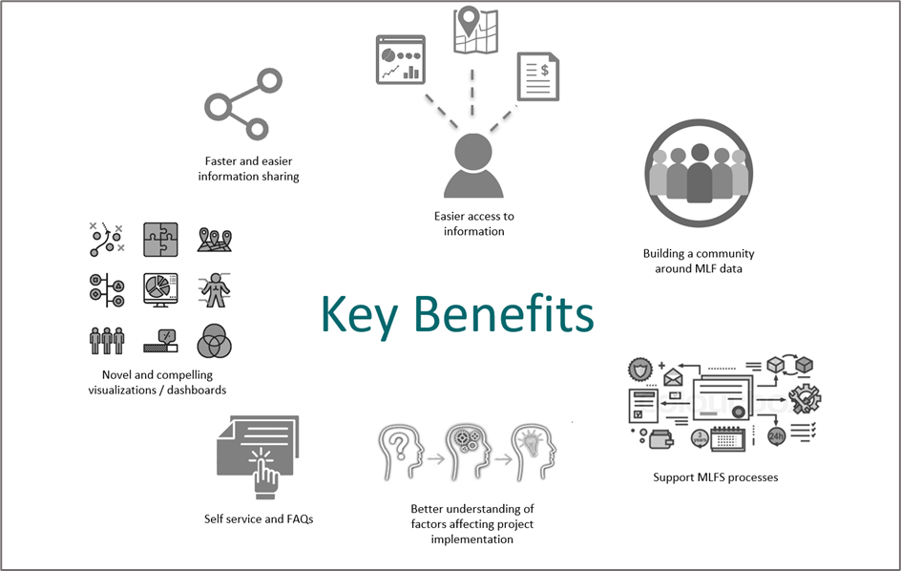

- Relevant timelines and estimated costs

As explained in section III, a phased approach is proposed for the creation of the new knowledge management system as follows:
Phase 1: Creation of master database and revamped website
Phase 2: Core products
Phase 3: Agencies’ portal and other enhancements

Phase 1 (24 months) and phase 2 (18 months) will run in parallel creating a 24-month program associated with the initial funding request and will deliver the foundations and core functionality for the system. Phase 3 will be undertaken as a separate project of nine months when phases 1 and 2 are completed and a separate funding request will be made to a later meeting of the Executive Committee. Figure 2 shows the indicative timeline and the milestones to be achieved for all phases.

Figure 2. Project timeline and milestones*
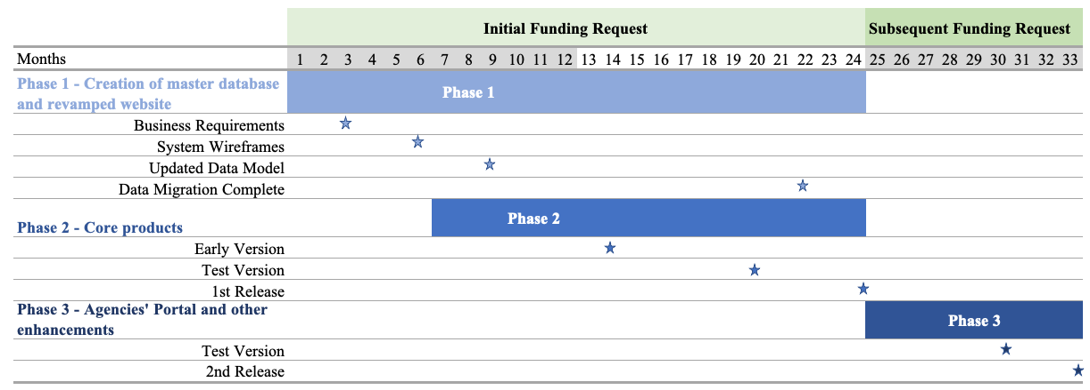
* Excluding the time required for procurement

Given the lack of historical trends and until a procurement solicitation process is finalized, it is premature to determine the exact budget provision for the new knowledge management system. Nevertheless, based on a comprehensive market research aimed towards delivering the associated activities, the Secretariat presents in table 4 below a lower and upper cost range, from US $700,000 to US $900,000 for phases 1 and 2, along with the timescale for each phase. The provision does not include staff time of the Secretariat.

The proposed budget will initially provide for the upper limit cost estimate of phases 1 and 2 while phase 3 will be requested once the former phases are completed. In alignment with the project timeline and milestones presented in figure 2 above, the budget will be broken down in two years to reflect equal portions of US $175,000 for phase 1 while phase 2 will be provisioned for US $183,000 (33 per cent) in the first year and US $367,000 (67 per cent) in the second year (see document UNEP/OzL.Pro/ExCom/91/7). The proposed budget will be adjusted in the following year to reflect the more accurate contractual and committed services.
Table 4. Summary of phases and estimated costs and timescales*
Phase 1: Master database and website
Tasks |  | Cost | Timescale
1.1 | Define and prioritise more detailed user requirements (functional and non-functional) | $250,000  to $350,000 | 24 months
1.2 | User processes (and advice on governance and administering and managing data) | $250,000  to $350,000 | 24 months
1.4 | Identify the technology and any customisations needed for the MLF | $250,000  to $350,000 | 24 months
1.5 | Unify databases into a new master database (migration) | $250,000  to $350,000 | 24 months
1.6 | Implementation of a new technology - configuration (proxies, security assessment, new coding) | $250,000  to $350,000 | 24 months
1.7 | Revamped website (including user interface design) | $250,000  to $350,000 | 24 months
1.8 | Testing and acceptance | $250,000  to $350,000 | 24 months

Phase 2: Core products
Tasks |  | Cost | Timescale
2.1 | Online reporting of country programme data | $450,000  to $550,000 | 18 months
2.2 | Online reporting of project completion reports | $450,000  to $550,000 | 18 months
2.3 | Meeting portal | $450,000  to $550,000 | 18 months
2.4 | Country profiles | $450,000  to $550,000 | 18 months
2.5 | “Handbook” / Electronic document management system | $450,000  to $550,000 | 18 months
2.6 | Data portal including country programme data, projects, lessons learnt | $450,000  to $550,000 | 18 months
2.7 | Pilot project for project review on IS projects | $450,000  to $550,000 | 18 months
2.8 | Testing and acceptance | $450,000  to $550,000 | 18 months

Phase 3: Agencies’ portal and other enhancements
Tasks |  | Cost | Timescale
3.1 | Agencies’ portal – Online submission and review | $300,000  to $400,000 | 9 months
3.2 | Enhanced support for external users (data download, creation of an API) | $300,000  to $400,000 | 9 months
* Excluding time required for procurement

To keep the Executive Committee informed of the progress of implementation of the new knowledge management system, the Secretariat will report on this until the completion of phases 1 and 2 as part of the Secretariat activities.
- Recommendation

The Executive Committee may wish:

To note the report on the update of the information strategy of the Multilateral Fund including a detailed plan for information and knowledge management, website/information technology requirements, resources needed and clear timelines for implementation (decision 89/1(c)(ii)) contained in document UNEP/OzL.Pro/ExCom/91/70;

To approve the actions for the implementation of the new knowledge management system described in the document referred to in sub-paragraph (a) above with their corresponding timelines and estimated associated costs for phases 1 and 2;

To request the Secretariat to report on the progress of implementation of the new knowledge management system until the completion of phases 1 and 2 as part of the Secretariat activities; and

To request the Secretariat to submit a request for funding for implementation of phase 3 after phases 1 and 2 have been completed.

UNEP/OzL.Pro/ExCom/91/1
The updated knowledge management system is aligned with the Secretary General’s vision for the United Nations 2.0, as defined in “Our Common Agenda” report (https://www.un.org/en/common-agenda) through the development of new capabilities that promote agility, integration, and cohesion across the system.
Documents included pre-session, in-session and post-session documents of the meetings of the Executive Committee, and the document on “Policies, procedures, guidelines and criteria of the Multilateral Fund” and its two supplements, namely “HCFC phase-out management plans and HCFC production phase-out management plans” and “Phase-out plans and projects”.
Approved 2023, 2024 and proposed 2025 budgets of the Fund Secretariat

