联 合 国 |  | EP
   | 联 合 国  环 境 规 划 署 |  | Distr.  GENERAL  UNEP/OzL.Pro/ExCom/87/18  9 June 2021  CHINESE  ORIGINAL: ENGLISH
执行蒙特利尔议定书
多边基金执行委员会
第八十七次会议
2021年6月28日至7月2日， 蒙特利尔
世界银行2021年工作方案
背景

在第八十六次会议上，世界银行根据其2020年工作方案修正案， 提交了编制马来西亚逐步减少氢氟碳化物管理计划的申请。

在同一次会议上，执行委员会讨论了为编制逐步减少氢氟碳化物管理计划供资的准则草案， 注意到，根据第84/54号决定(a)(三)段，各双边和执行机构代表第5条国家向该次会议提交的编制逐步减少氢氟碳化物计划的供资申请，将在准则获准后予以核准。执行委员会无法就准则草案达成协议，决定在第八十七次会议上继续审议准则草案（第86/93号决定）。

根据第86/93号决定，执行委员会决定推迟至第八十七次会议审议世界银行提交的编制马来西亚逐步减少氢氟碳化物计划的供资申请（第86/60号决定）。

根据第86/60号决定，世界银行请执行委员会为表1所列其2021年工作方案核准250,000美元，机构机构支助费用17,500美元。

表1: 世界银行2021年工作方案
国家 | 活动/项目 | 申请数额  (美元) | 建议数额  (美元)
建议单独审议的活动
氢氟烃减排管理计划项目的编制
马来西亚 | 氢氟烃减排管理计划的编制 | 250,000 | *
小计 |  | 250,000 | *
机构支助费用 |  | 17,500 | *
合计 |  | 267,500 | *
* 单独审议

基金秘书处的评论和建议

项目说明

如表1所示，作为指定执行机构，世界银行提交了编制马来西亚逐步减少氢氟碳化物管理计划的申请。项目提案载于本文件的附件一。

秘书处的评论

作为指定执行机构，世界银行使用氟氯烃淘汰管理计划各阶段项目编制申请格式，提供了编制马来西亚逐步减少氢氟碳化物总体战略需要开展的各项活动的说明。来文中包括根据实施扶持活动期间所收集信息和数据，对氢氟碳化物和氢氟碳化物混合物的估计进口量数据；项目编制活动清单，包括更新氢氟碳化物消费情况调查；拟订逐步减少氢氟碳化物战略，包括利益攸关方协商；以及拟订氢氟碳化物消费行业的投资和技术援助活动。

编制逐步减少氢氟碳化物所申请金额系基于为扶持活动的供资（载于第79/46号决定(c)段）。秘书处注意到，项目编制申请的供资额是指导性的，因为实际数额将在执行委员会完成其对编制第5条国家逐步减少氢氟碳化物计划的准则草案（UNEP/OzL.Pro/ExCom/87/46）的讨论后决定。

尽管编制逐步减少氢氟碳化物管理计划的实际供资额仍有待决定，但秘书处根据审查编制氟氯烃淘汰管理计划的经验审查了来文，同时考虑到执行委员会为此种项目所提供的指导意见和通过的决定。继审查后，秘书处注意到，关于马来西亚申请的来文满足了作为已批准《基加利修正案》的国家来文的要求，来文中包括了核可信函，表明该国打算尽早就逐步减少氢氟碳化物采取行动。项目编制所列各项活动也与编制氟氯烃淘汰管理计划所需要开展的活动类似；一些活动类似根据逐步减少氢氟碳化物扶持活动开展的活动，为这些活动的供资已经提供，并正在进行中。

世界银行澄清说，马来西亚逐步减少氢氟碳化物总体战略的项目编制将以扶持活动下正在实施的活动为基础，因为这些活动是与逐步减少氢氟碳化物相关的第一批行动，推动了《基加利修正案》的批准工作。第八十七次会议核准为申请供资，将让逐步减少氢氟碳化物的执行工作能在2022年底之前开始，并实现遵守《基加利修正案》。

秘书处通知世界银行，秘书处将无法就这些申请提出建议，因为这些申请的供资准则将在第八十六次会议上讨论。第八十七次会议将继续关于准则草案的讨论。

秘书处的建议

执行委员会不妨根据关于编制逐步减少氢氟碳化物管理计划的供资准则草案（第86/93号决定）的议程项目13(c)下的讨论情况，审议为编制表1所列马来西亚逐步减少氢氟碳化物管理计划供资的申请。

Annex I
REQUEST FOR PROJECT PREPARATION OF STAGE I KIGALI HFC PHASEDOWN MANAGEMENT PLAN FOR MALAYSIA
(Extract from the World Bank’s work programme amendments for 2020)

Background

The Government of Malaysia is fully committed to the Montreal Protocol (MP) and the Climate Change Convention. It acceded to both the Vienna Convention for the Protection of the Ozone Layer and the Montreal Protocol on Substances as well as all the subsequent amendments as indicated in Table 1. Malaysia was expected to ratify the Kigali Amendment in 2020 after the Cabinet approved the ratification in early 2020. However, the change in government leadership in March 2020 requires the new Cabinet to re-approve the ratification. The Ministry of Environment and Water had already restarted the process and now expect the ratification would take place in early 2021.
Table 1: Malaysia Ratification Dates - Vienna Convention, MP, and Amendments
Instrument | Date of Ratification
Vienna Convention | 29-Aug-1989
Montreal Protocol | 29-Aug-1989
London Amendment | 16-Jun-1993
Copenhagen Amendment | 5-Aug-1993
Montreal Amendment | 26-Oct-2001
Beijing Amendment | 26-Oct-2001
Kigali Amendment | Expected early 2021

As of 1 January 2010, Malaysia has fulfilled its commitment to phase out consumption of all controlled substances with the exception of hydrochlorofluorocarbons (HCFCs).
Findings from Enabling Activities for HFC Phasedown in Malaysia
The enabling activities for HFC phasedown in Malaysia was approved by the 80th ExCom (decision 80/52) and completed in June 2020.
HFC Consumption in Malaysia
Based on the information and data collected during the implementation of the enabling activities, total consumption of HFCs from 2015 through 2018, grouped into pure HFCs and HFC blends, are shown in Table 2. The import data collected from both the primary and secondary sources indicate that only 11 out of the total 18 pure HFCs controlled by the MP were imported during 2015–2018. In addition to pure HFC imports, Malaysia also imported 19 HFC blends during the same period. Malaysia does not produce HFCs.
Table 2: Consumption of Bulk HFCs and HFC Blends from 2015 to 2018 (MT)
Chemical | 2015 | 2016 | 2017 | 2018
Pure HFCs | 3,067.45 | 4,124.54 | 4,313.48 | 4,552.96
HFC blends | 3,822.00 | 3,790.58 | 3,901.75 | 3,813.25
Total | 6,889.45 | 7,915.12 | 8,215.23 | 8,366.21

Major consumption of HFCs can be classified into six sectors: (a) AC, (b) refrigeration, (c) mobile AC, (d) foam, (e) fire protection, and (f) solvent cleaning as depicted in Figure 1.
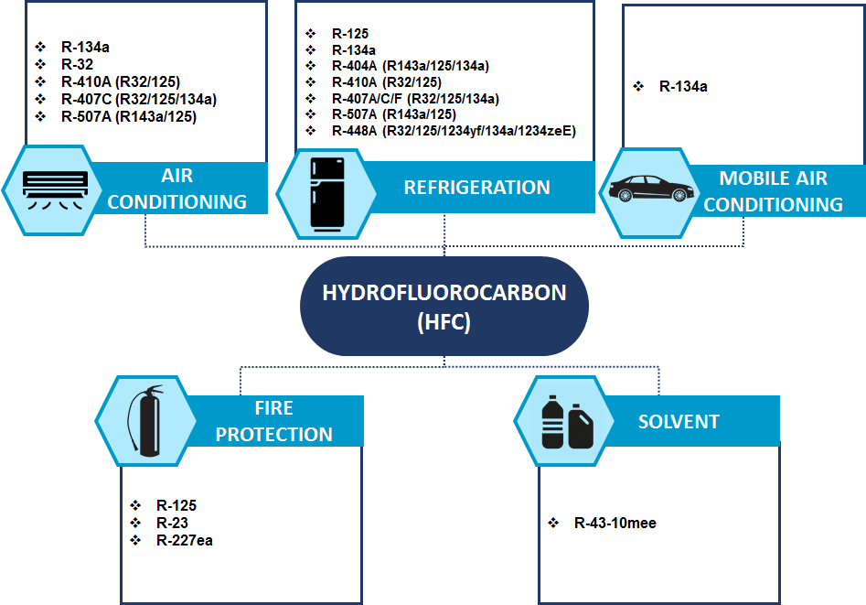
Figure 1: HFC Consumption by Industry Sector
Kigali HFC Baseline for Malaysia
According to the Kigali Amendment, the HFC baseline consumption for Malaysia (as an Article 5, Group 1 country) will be determined by the average HFC consumption between 2020 and 2022 plus 65 percent of the GWP of the HCFC baseline. The calculated GWP of 65% of HCFC consumption baseline of Malaysia is 8.20 million tons CO2 equivalent.
The average HFC consumption between 2020 and 2022 is estimated from the data collected from 2015 through 2018 with the assumption that HFC consumption for each subsector/application will follow the same growth rate. The average HFC consumption for the baseline period (2020 to 2022) is estimated to be 10,631.31 MT, which is equivalent to 21.93 million tons of CO2 equivalent (mtCO2e). Thus the estimated HFC baseline for Malaysia is 30.13 mtCO₂ (21.93 mtCO₂ from HFCs and 8.20 mtCO₂ from 65 percent of the HCFC baseline).
HFC Projection under Business-as-Usual Scenario
Based on the 2015-2018 consumption data and growth rate in each application, consumption forecast in key sectors under the business-as-usual (BAU) scenario from 2018 to 2045 is shown in Figure 2 below.
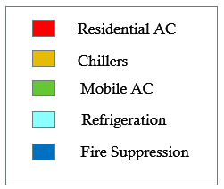
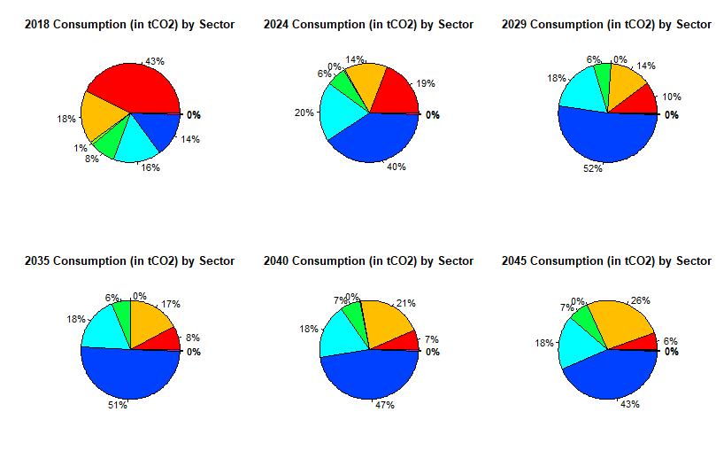
Figure 2: 2018 versus Projected 2024 Consumption in Key Sectors under BAU Scenario
Under the BAU scenario, Malaysia HFC consumption would quickly grow and exceed the freeze target in 2024 as shown in Table 3.

Table 3: HFC Consumption under the BAU Scenario (million tCO2)
million tCO2 | 2018 | 2024 | 2029 | 2035 | 2040 | 2045
HFC Consumption (BAU) | 16.32 | 32.21 | 50.52 | 70.30 | 92.51 | 123.58

Phasedown Intervention
The study developed under the HFC enabling activities considers sector-specific interventions from 2024 to 2045 to support full compliance with all the phasedown targets during the same period. Considering the likely technology pathways that the sectors and applications will follow under the BAU scenario, and taking into account the Stage II HPMP, a series of interventions in the key HFC sectors and subsectors are considered for each major control period of the KA that would enable Malaysia to, at a minimum, comply with the estimated baseline consumption and subsequent reductions up to the final 2045 reduction step. HFC consumption projections for the four scenarios described earlier are shown in Figure 3. All proposed scenarios would secure Malaysia’s full compliance with its estimated phasedown obligations under the KA.
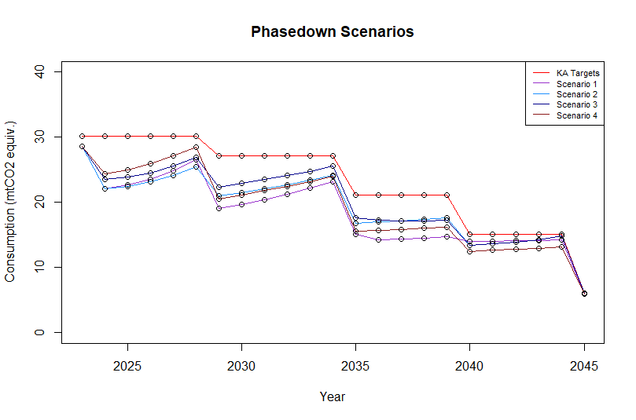
Figure 3: Malaysia's HFC Phasedown Schedule against Intervention Scenarios
However, the COVID-19 pandemic could depress the demand for HFCs and HFC-based equipment during the baseline years (2020–2022). This could result in a lower HFC baseline than the estimate presented above. Phasedown options that are more aggressive than those considered may be required if the demand is restored to normal levels after the baseline years.

Objectives

The Stage I Kigali HFC Phasedown Management Plan (KPMP), to be developed under this activity, will support Malaysia in meeting its compliance with the first two target steps: freeze by 2024 and 10% reduction by 2029. It will serve as the platform for reflecting Malaysia’s evolving situation while proposing needed investment, policy, and technical assistance interventions for achieving sustainable HFC reductions.

Proposed approach and activities

The proposed approach includes the following activities:

    - Update Malaysia HFC survey (inclusion of 2019 and 2020 HFC consumption) and analyze the impact of COVID-19 pandemic that may depress the demand of HFCs and HFC-based equipment during the baseline years (2020 – 2022), resulting in a lower HCFC baseline than the previous estimate. Update HFC consumption projection for the immediate period (2024 – 2029) after the baseline years in case the demand returns to normal post COVID-19 pandemic.
    - Develop sector policies and plans to curb the demand of HFC for the fire suppression sector and refrigeration and air-conditioning sectors which are identified as major and high growth HFC consumption sectors by the previous study undertaken as part of the HFC enabling activities. Conduct comprehensive surveys of manufacturing and servicing enterprises in these sectors;
    - Develop investment and technical assistance activities in the manufacturing and servicing fire suppression and, refrigeration and air-conditioning sectors including technical and financial viability of recovery, recycle and disposal of HFCs;
    - Develop HFC quota allocation options and procedures for consideration of DOE, METI and Customs Department and action plan for implementing the new WCO HS system for HFCs will enter into force in 2022.
Estimated budgets
Activities | Unit cost (US$) | No. | Budget(US$)
National workshops | 10,000 | 2 | 20,000
National consultant service |  |  | 100,000
International consultant service |  |  | 30,000
Domestic travel | 600 | 10 | 6,000
International travels and accommodation | 8,000 | 4 | 32,000
Industry consultation workshops | 4,000 | 6 | 24,000
Communication, translation, printing, etc. |  |  | 5,500
Review the consultant’s report and finalize the KPMP document |  |  | 10,000
Sub-total |  |  | 227,500
Contingency (~10%) |  |  | 22,500
Total |  |  | 250,000

由于2019冠状病毒病（COVID-19），将于2021年6月和7月举行在线会议和闭会期间批准程序。
UNEP/OzL.Pro/ExCom/86/99。
UNEP/OzL.Pro/ExCom/86/88。
所提交项目提案摘自世行2020年9月提交的2020年工作方案修正案。

