UNITED  NATIONS |  | EP
   | United Nations  Environment  Programme | Distr.  GENERAL  UNEP/OzL.Pro/ExCom/93/12/Rev.1  18 December 2023  ORIGINAL: ENGLISH
EXECUTIVE COMMITTEE OF
THE MULTILATERAL FUND FOR THE
IMPLEMENTATION OF THE MONTREAL PROTOCOL
Ninety-third Meeting
Montreal, 15-19 December 2023
Item 6(c) of the provisional agenda
TERMS OF REFERENCE FOR THE EVALUATION OF
THE COMPLIANCE ASSISTANCE PROGRAMME
(DESK STUDY)
Introduction

At its 91st meeting, the Executive Committee approved the monitoring and evaluation work programme for 2023. The work programme included the preparation of terms of reference (TORs), to be presented at the 93rd meeting, for an evaluation of the Compliance Assistance Programme (CAP) of the United Nations Environment Programme (UNEP) to be undertaken in 2024. In response to this request, the Senior Monitoring and Evaluation Officer (SMEO) has prepared the present document for the consideration of the Executive Committee.
Rationale for the desk study

The CAP is a cornerstone of the institutional architecture in place to assist Article 5 countries to comply with their obligations under the Montreal Protocol. The last evaluation of the CAP was prepared in 2006 (desk study) and 2007 (final evaluation). Given the CAP’s crucial role in promoting compliance, the planned evaluation will take stock of its evolution and achievements since 2008 through a desk study aimed at compiling, analyzing, and summarizing updated information on the programme. On this basis, the Executive Committee could decide whether a second phase of the evaluation would be relevant.

This evaluation arrives at a unique juncture for the Montreal Protocol and its Multilateral Fund. Countries are now seeking compliance through the concomitant phase-out of HCFCs and phase-down of HFCs and must ensure the mid- and long-term sustainability of their achievements. Furthermore, funding is now available for new activities, such as disposal, energy efficiency, and gender mainstreaming, among others, that go beyond purely compliance-oriented measures.

The CAP’s services have been instrumental in creating a strong community on the ground through close relationships with National Ozone Officers, who engage with the programme’s corresponding regional offices. The results of the proposed evaluation could be used by UNEP OzonAction and all involved stakeholders to continue ensuring high-quality results, and to support all activities funded by the Multilateral Fund to strengthen compliance with the Montreal Protocol and its amendments.

Objective and scope

The desk study will assess the impact and effectiveness of the CAP, considering its mandate and how it has evolved together with the Montreal Protocol’s amendments and Multilateral Fund funding priorities during the period 2008–2023. Ultimately, the objective is to evaluate the extent to which the CAP aligns its priorities with those of the Fund, and how it uses its resources effectively and efficiently to achieve these goals.

The desk study will review progress made since the last evaluation. It is also usual practice in evaluations to follow up on the implementation of previous recommendations made to the evaluation. However, noting that 16 years have passed, only the recommendations that are not considered to be outdated will be examined as part of the current evaluation.

The desk study will generate findings and lessons learned which would be relevant for decision makers when selecting priorities and assigning funding for the CAP. It would also be a useful management tool for the CAP itself and its staff, as well as for the Fund Secretariat, as the experience from previous phases related to CFCs and HCFCs could be considered when providing support to Article 5 countries to strengthen compliance with the Kigali Amendment. An indicative list of evaluation issues is presented in annex I to the present document.

Components of the Compliance Assistance Programme

The scope of the study will cover the CAP’s components and, to the extent necessary for a meaningful evaluation, its linkages with the remaining components addressed by OzonAction:

Figure 1: OzonAction and CAP(*)
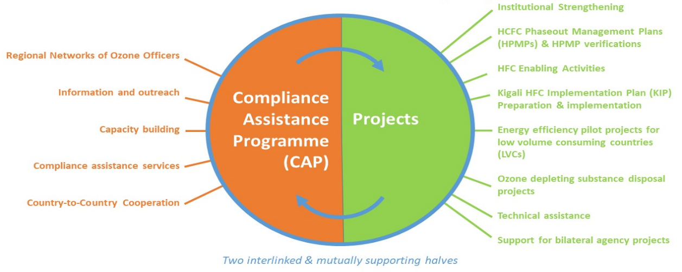
(*) Source: OzonAction (2023)

Noting that the Fund’s evaluation unit completed the evaluation of the regional networks in 2023, this critical component of the overall CAP architecture would be addressed only to the extent required for the comprehensiveness of the desk study. Findings from the evaluation of the regional networks may be used as a complement to the CAP evaluation. The desk study will examine the interlinkages between the CAP services and UNEP’s project portfolio (see figure 1). It will also identify and assess the CAP services that facilitate the work of the other bilateral and implementing agencies to assist Article 5 countries.

Performance of the Compliance Assistance Programme

The performance of the Fund’s implementing agencies is measured against established indicators which have been approved by decisions of the Executive Committee. The reports of the implementing agencies include the necessary information to assess their results against these performance indicators.

The CAP work plan, progress report and budget are approved by the Executive Committee on an annual basis. The programme is presented as an individual project in UNEP’s business plan submission. Given the significant share and relevance of CAP within UNEP’s work as an implementing agency, a specific set of performance indicators was approved for the programme by decision 48/7, in 2006.

Noting that the CAP performance indicators have not been revised since the 48th meeting of the Executive Committee, this desk study’s analysis and findings could be used to propose a revision of the performance indicators, which have remained unchanged since 2006. The indicators are currently presented as part of the business plan, and it may be worth assessing whether to present them in alignment with the triennial CAP strategy and annual work plan. The evaluation could analyze how to streamline and simplify reporting processes to avoid information duplication and/or scattering.

OzonAction has developed a logical framework for its CAP programme and uses it when reporting on the annual progress of CAP activities. This management tool was developed well after the approval of the agency performance indicators shown in annex III to the present document. The desk study could draw from the robust CAP logical framework to propose a revision of CAP performance indicators, for the consideration of the Executive Committee.
Evolution of Montreal Protocol compliance requirements

Montreal Protocol coverage of substances to be controlled has evolved significantly since 2007, moving from the initial and intermediate control measures to address CFCs and other ODSs to the phase-down and successive phase-out of HCFCs and, more recently, the phase-down of HFCs related to the adoption of the Kigali Amendment. The evaluation should look not only at how the CAP assists Article 5 countries in the face of new challenges under the Montreal Protocol regime, but also at how the programme contributes to ensuring the sustainability of previous achievements.

Noting that the first Kigali HFC implementation plans (KIPs) have been approved in 2023, this evaluation can also review what the CAP has put in place to ensure adequate assistance to Article 5 countries in meeting their compliance obligations in this regard.

More recently, new dimensions such as gender equality, energy efficiency and disposal, among others, have been included in projects funded by the Multilateral Fund. Accordingly, CAP activities have also evolved to include these dimensions.
Methodology

The desk study will be prepared in line with evaluation norms and standards. A consultant will be hired to perform the assignment. The SMEO would provide quality assurance on the final report by supervising and guiding the consultant when so required. The selected consultant would review and analyze the relevant CAP documentation as submitted to the Executive Committee, as well as internal Secretariat’s documents that may be provided by the CAP management and staff upon request, and the decisions of the Executive Committee concerning the programme.

The desk study aims at assessing the relevance, effectiveness and impact of the programme and its components measured against its expected results (logical framework and performance indicators of the CAP), through a desk review and questionnaires/interviews with selected stakeholders. The desk study will include specific sections related to some of the most recent issues covered by the Multilateral Fund, such as gender, energy efficiency and disposal. It will identify the extent to which the CAP has included new elements in its work plans.

The proposed indicative list of evaluation questions will guide the consultant in preparing the desk study. The indicative questions can be complemented by other questions identified during the preparation of the report. The data analysis will rely both on quantitative and qualitative methods, to be applied as appropriate depending on the different elements under review.

The consultant could also seek additional information through online interviews or questionnaires with CAP and Secretariat staff, if needed, as well as with representatives of other bilateral and implementing agencies to which CAP provides services for implementing their projects in Article 5 countries, other than those under UNEP’s portfolio. The extent to which additional field work would be required to refine the assessment will be determined as a result of the desk study.

The consultant will provide interim results at established milestones so that the SMEO can monitor the continuous progress towards delivery of the final report. Consultations on the advanced final draft will be held with UNEP OzonAction management, bilateral and implementing agencies, as well as with the Secretariat, to ensure data quality and information accuracy.
Budget

The budget requirements will depend on the approved scope for the proposed evaluation and on the qualifications and skills of the consultant selected for the assignment. The fees will comply with the usual United Nations standards for consultants, within the SMEO’s biennial budget to be approved by the Executive Committee at the 93rd meeting. A global envelope for evaluations to be undertaken during the biennium 2024–2025 is requested in the Monitoring and Evaluation work programme, which would cover the funding requirements for the CAP evaluation.
Final expected result

The desk study is expected to provide an evaluation of the CAP that will inform the Executive Committee on the impact of this landmark programme. The findings and recommendations are expected to be relevant to the CAP, to its partners in implementation, to the Secretariat, and ultimately to the beneficiary countries of the programme.

The draft report prepared by the consultant will identify key lessons learned from the implementation of the CAP during the past 15 years, for the period 2008–2023 and propose specific, measurable, achievable, relevant and time-bound (SMART) recommendations for the consideration of the Executive Committee. The final desk study would include the key findings, lessons learned and recommendations in the Executive Summary. This desk study, together with the final report if a second phase is deemed necessary, could serve as a management tool in walking the transformative path for the CAP to continue aligning with the evolving goals of the Montreal Protocol.

The broader range of substances that require compliance and sustainability measures, and the additional issues related to implementation (e.g., energy efficiency, disposal, gender) present new challenges in implementation for which the CAP should keep adapting its resources and skills in order to maintain the excellence of its work. The findings and recommendations are expected to be useful, inter alia, to identify strategies for the CAP to strengthen its role in providing supporting services to Article 5 countries in the context of HCFC phase-out and HFC phase-down activities.

It is proposed that after the evaluation’s completion the SMEO would follow up and report on the implementation of the recommendations made in the evaluation report. Such a review could be included in the monitoring and evaluation work programme for 2028, to be delivered in 2029, in synchronicity with relevant compliance deadlines under the Montreal Protocol.

The advanced draft of the desk study will be shared with bilateral and implementing agencies for comments, and internally with the Secretariat, prior to the finalization of the report and submission to the Executive Committee. A progress update report would be presented at the 94th meeting and the final desk study would be submitted to the 95th meeting, in 2024.
Recommendation

The Executive Committee may wish to approve the terms of reference for the desk study for the evaluation of the Compliance Assistance Programme of the United Nations Environment Programme, as contained in document UNEP/OzL.Pro/ExCom/93/12/Rev.1

Annex I
INDICATIVE LIST OF EVALUATION ISSUES AND QUESTIONS
The proposed indicative list of evaluation questions covers relevant issues to be addressed by the desk study. Other questions may be added as identified during the preparation of the study. The order of the proposed questions does not imply any hierarchy in terms of the relevance of the issues proposed.
Key evaluation issues and potential questions to be covered
The desk study aims at assessing the impact, relevance and effectiveness of the programme and its components measured against its expected results (logical framework and performance indicators of the CAP), through a desk review and questionnaires/interviews with selected stakeholders. The proposed evaluation questions below provide guidance for the consultant; additional ones could arise during the preparation of the desk study and be added if relevant to reach the objectives of the evaluation:

CAP components: How effective is the delivery of the programme regarding its different components: capacity building, information exchange, clearinghouse function, and country-to-country cooperation. Does the CAP achieve its goals in an effective and efficient manner?

CAP services: How do the CAP’s services contribute to the implementation of country projects by the implementing and bilateral agencies, including UNEP itself? How effective is this support? How does the CAP contribute to creating an enabling environment to foster compliance and to enhance national capacities for the management of controlled substances, including strengthening mechanisms in Article 5 countries on data management and reporting?

CAP internal coordination mechanisms: What are the coordination mechanisms between the Global CAP team and its Regional CAP teams and how effective are these in ensuring smooth interaction and timely delivery of high-quality services?

CAP staffing distribution and budget allocation: How does the current allocation of staff and resources respond to the needs of the programme to achieve the expected results and what are the criteria for defining the programme’s priorities?

CAP strategy and work plans: How effective is CAP in delivering the outputs of its work plans and in achieving the outcomes of its overall strategy, in line with its logical framework? How does CAP update its strategy and goals to align with decisions of the Executive Committee introducing new issues, such as energy efficiency, disposal, or any other new line of assistance to Article 5 countries?

Impact and performance indicators: To what extent are the current framework of performance indicators, as approved in the 48th meeting of the Executive Committee, fit for purpose to effectively reflect the performance of the programme? Should they stay in their current place in UNEP’s business plan or should they be consolidated within the annual CAP submission and be related to the logical framework analyses and the triennial CAP strategy?

Mechanisms for reporting to the Executive Committee: What are the existing mechanisms to report on a regular basis to the Executive Committee? Could there be any improvement in preparing shorter and more analytical and strategic reports (e.g., outcomes/impact instead of outputs/activities)?

Building, strengthening and sustaining capacities in Article 5 countries: How has the CAP contributed to effectively building and strengthening the capacities of beneficiary countries in meeting and sustaining compliance with the Montreal Protocol? What mechanisms are in place to ensure that Article 5 countries are driving the agenda to identify their needs in relation to achieving compliance with the Montreal Protocol?

Challenges in implementation: Are there systemic issues that are recurrently hampering better results in meeting compliance requirements in Article 5 countries? Based on lessons learned, how could the CAP contribute to overcoming these constraints in the future?

Working with the Secretariats: What are the working flows between CAP and the Ozone Secretariat and the Multilateral Fund Secretariat and how effective are the established mechanisms?

Partnerships with other stakeholders relevant to the implementation of the Montreal Protocol: What are the strategic partnerships in place, for which purpose, and with which results?

Gender dimension: How has the CAP integrated the gender dimension and what has been the impact in Article 5 countries?

CAP contribution to achieving compliance with the Kigali Amendment and other new issues under the Montreal Protocol: How effective has the CAP been in updating and implementing its strategies and work plans to foster compliance with the Kigali Amendment, including inter alia issues such as energy efficiency and disposal? How does the CAP support capacity of NOUs to strengthen coordination with various agencies associated with activities relating to energy efficiency, disposal and safety issues, including standards?

CAP and adaptation to the COVID-19 pandemic: How did CAP adapt to the COVID-19 pandemic and are there any issues that have been integrated into the programme to strengthen business continuity protocols and build resilience?

Challenges, good practices, lessons learned and recommendations: What are the key challenges, good practices, and lessons learned identified in the desk study? What recommendations are proposed, with particular emphasis in support to the KIPs’ implementation?

.
Annex II
MANDATE OF UNEP AS IMPLEMENTING AGENCY FOR THE MULTILATERAL FUND (EXTRACT)
OzonAction’s role as an Implementing Agency emanates from Article 10 of the Protocol, which established the Multilateral Fund to meet the agreed incremental costs of developing countries’ compliance and to provide certain other support, notably a clearinghouse function, which is part of the components of CAP.
UNEP's Implementing Agency mandate is defined by the agreement signed on 19 June 1991 between UNEP’s Executive Director and the Chair of the Executive Committee. The Executive Committee entrusts UNEP with:

Political promotion of the objectives of the Protocol;

Research and data gathering, according to the provisions of the Protocol; and
- Assistance in clearinghouse functions as per Article 10 (3)(b) of the Montreal Protocol.
The latter clearinghouse function comprises the following activities:

Assist Parties operating under paragraph 1 of Article 5, through country-specific studies and other technical cooperation, to identify their needs for cooperation;

Facilitate technical cooperation to meet these identified needs;

Disseminate information and relevant materials, hold workshops and training sessions and other related activities for the benefit of Parties that are developing countries; and

Facilitate and monitor other multilateral, regional and bilateral cooperation available to Parties that are developing countries.

Annex III
PERFORMANCE INDICATORS AND TARGETS FOR UNEP’S CAP FOR 2023 (*)
Performance Indicator | Data | Assessment | 2023 target
Efficient follow-up to regional network/thematic meetings | List of recommendations emanating from 2021-2022 regional network/thematic meetings | Implementation rate of those meeting recommendations that are to be implemented in 2023 | 90% implementation rate
Effective support to National Ozone Units (NOUs) in their work, particularly guidance to new NOUs | List of innovative ways/means/ products/services for supporting NOUs in their work, with specification of those destined for new NOUs | Number of innovative ways, means, products, services for supporting NOUs in their work, with specification of those destined for new NOUs | - 7 innovative ways, means, products, services;  -All new NOUs receive capacity building support
Assistance to countries in actual or potential non-compliance (as per Meeting of the Parties decisions and/or as per reported Article 7 data and trend analysis) | List of countries in actual or potential non-compliance that received CAP assistance outside the network meetings | Number of countries in actual or potential non-compliance that received CAP assistance outside the network meetings | All such countries
Innovations in production and delivery of global and regional information products and services | List of global and regional information products and services destined for new target audiences or that reach existing target audiences in new ways | Number of global and regional information products and services destined for new target audiences or that reach existing target audiences in new ways | 7 global and regional information products and services
Close cooperation between CAP regional teams and implementing and bilateral agencies working in the regions | List of joint missions/ undertakings of CAP regional staff with implementing and bilateral agencies | Number of joint missions/undertakings | 2 joint missions / undertakings in each region, if the COVID-19 pandemic situation allows and there are no restrictions
(*) Source: UNEP/OzL.Pro/ExCom/91/25

Annex IV
CAP ORGANIGRAM (AS OF SEPTEMBER 2023) (*)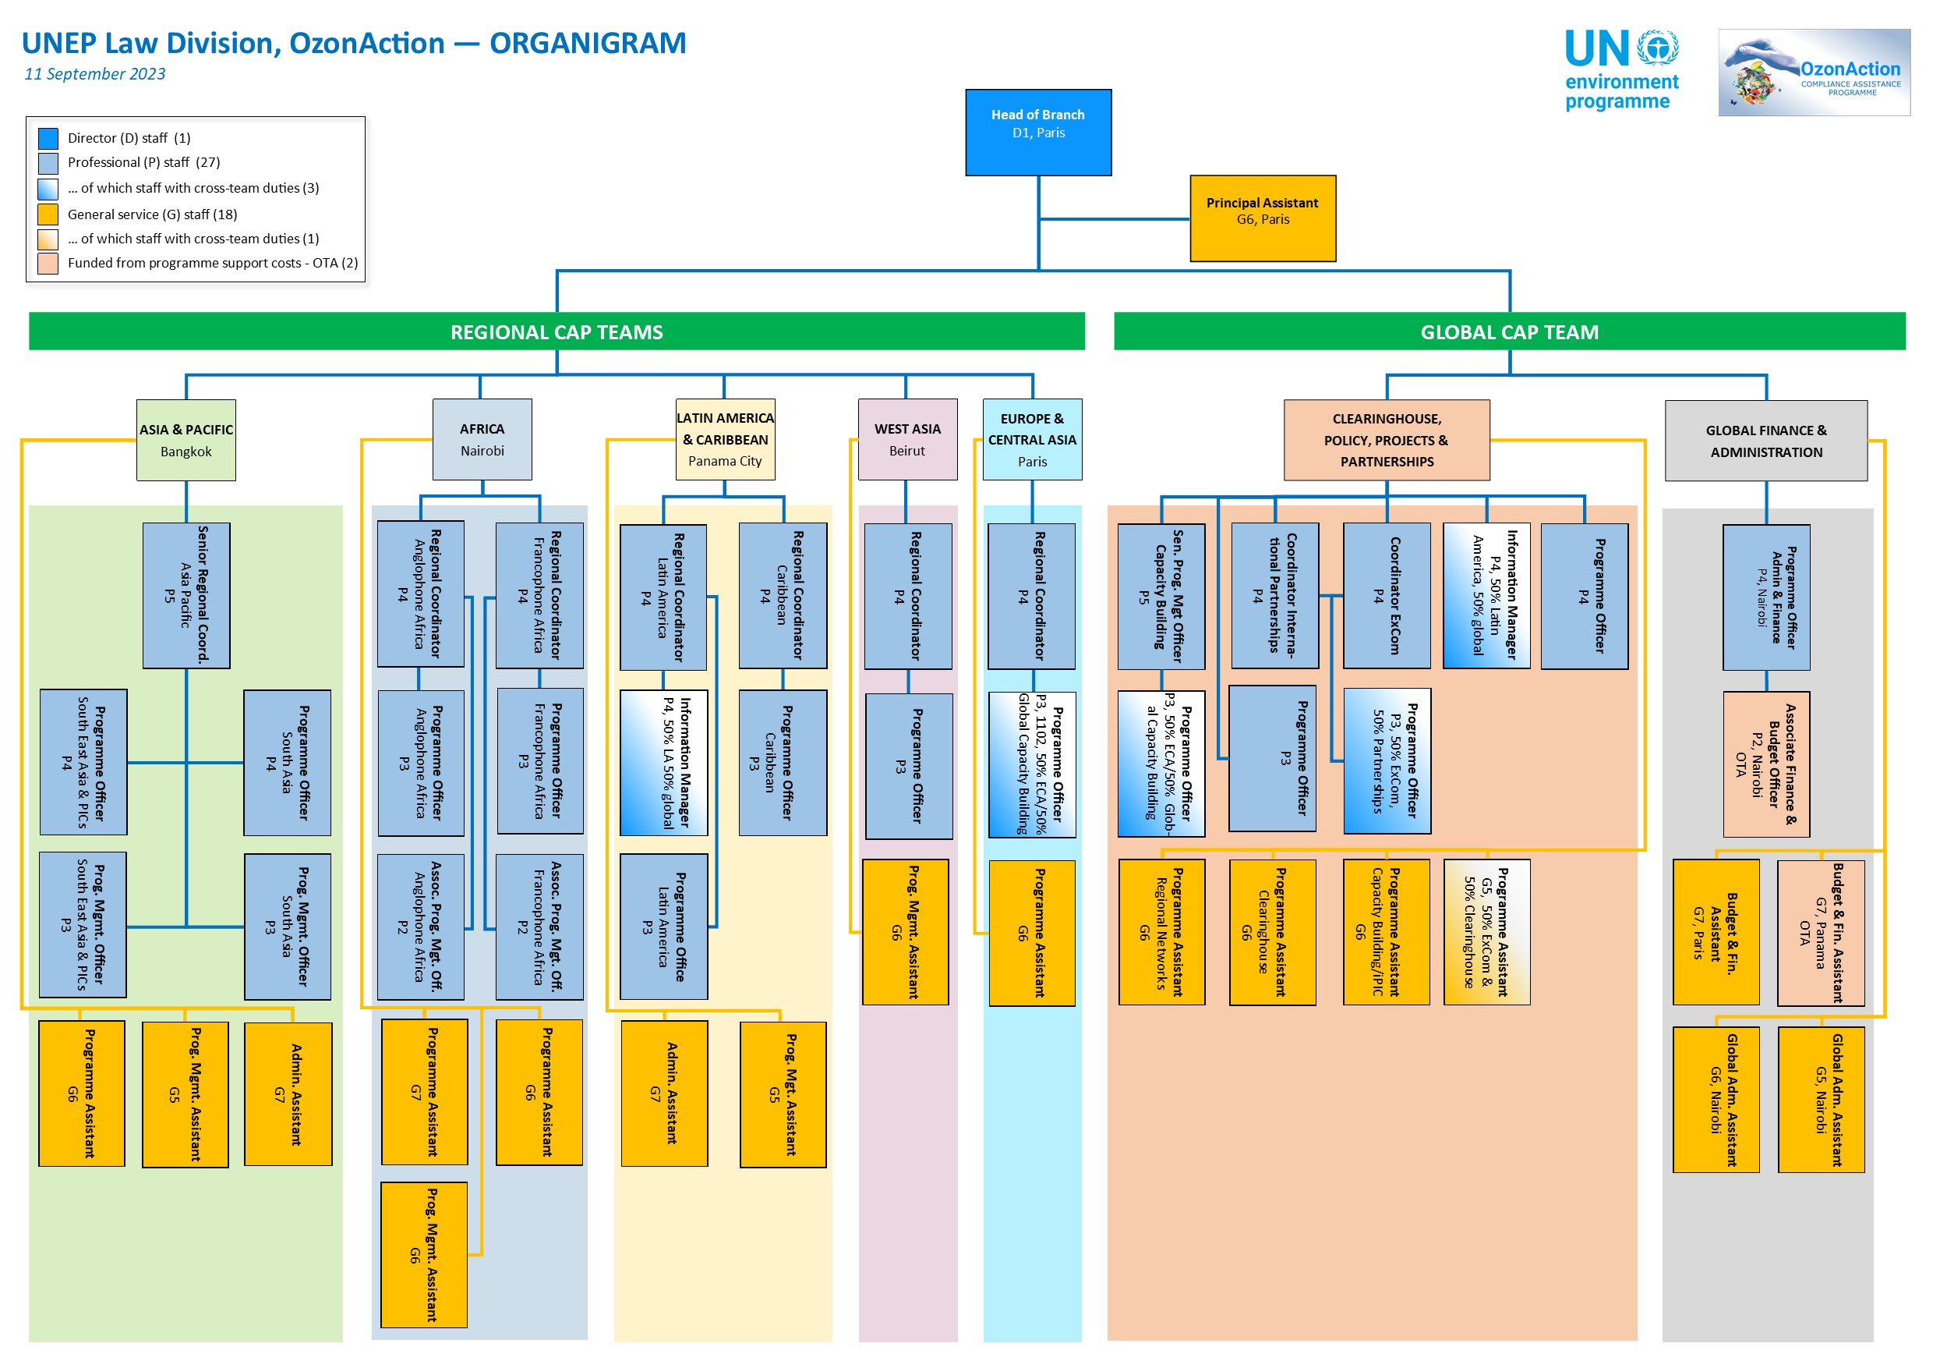
(*) Source: OzoneAction (2023)

UNEP/OzL.Pro/ExCom/93/1
UNEP/OzL.Pro/ExCom/91/11/Rev.1, decision 91/9
UNEP/OzL.Pro/ExCom/49/8
UNEP/OzL.Pro/ExCom/52/9
See annex II for a detailed extract of CAP mandate, which derives from the 1991 agreement between UNEP and the Multilateral Fund.
UNEP/OzL.Pro/ExCom/92/6
See UNEP/OzL.Pro/ExCom/48/45 and Corr.1 and annex III in this document for the details on performance indicators and targets for 2023.
See UNEP/OzL.Pro/ExCom/91/58 – UNEP’s CAP budget for 2023.
Gender mainstreaming is reflected prominently in the current 2021-2023 CAP Strategy, which identifies gender and diversity as one of the 16 thematic areas for which Article 5 countries require UNEP’s intervention.
See annex I.
See https://www.unep.org/ozonaction/what-we-do/projects-and-cap-services.
UNEP/OzL.Pro/ExCom/93/13/Rev.1
Annex IV displays CAP’s organigram as of September 2023.
Specific evaluation questions are proposed in annex I.
See figure 1 in paragraph 7.
See annex IV – CAP organigram as of September 2023.
Extract from the “Agreement between the Executive Committee of the Interim Multilateral Fund for the Implementation of the Montreal Protocol and the United Nations Environment Programme.” Mostafa K. Tolba, UNEP Executive Director, and Ilkka Ristimäki, Chair of the Executive Committee, 19 June 1991.

