UNITED  NATIONS |  | EP
   | United Nations  Environment  Programme | Distr.  GENERAL  UNEP/OzL.Pro/ExCom/82/2  17 November 2018  ORIGINAL: ENGLISH
EXECUTIVE COMMITTEE OF
THE MULTILATERAL FUND FOR THE
IMPLEMENTATION OF THE MONTREAL PROTOCOL
Eighty-second Meeting
Montreal, 3-7 December 2018

secretarIat activities

Introduction

This document presents the activities of the Secretariat since the 81st meeting of the Executive Committee.

Notification of the decisions of the 81th meetings of the Executive Committee

The Report of the 81st meeting was conveyed to all Executive Committee members, other meeting participants, and Mr. Erik Solheim, UNEP Executive Director, and was placed on the Multilateral Fund’s website. Decisions of the 81st meeting related to project approvals, HCFC phase-out management plan (HPMP) tranche submission delays, and outstanding country programme data reports were communicated to 113 Article 5 countries, and the relevant bilateral and implementing agencies. A post-meeting document summarizing decisions taken was prepared and sent to participants, to UNEP’s OzonAction Branch for onward transmission to the regional networks, and was also placed on the Multilateral Fund’s website.

Actions taken following the 81st meeting

The Chief Officer sent a letter to each of the Governments of donor countries that have pledged to provide fast-start support for the implementation of HFC phase-down, in which he explained matters related to the Kigali Amendment that were discussed at the 81st meeting.

Pursuant to decision 79/1(b), the Secretariat included a full overview of the status of all discussions with multilateral environment agreements and other relevant organizations in Annex I to this document.

Preparation for the 82nd meeting of the Executive Committee

Logistic arrangements were made for the 82nd meeting, to be held in Montreal from 3-7 December 2018. The Secretariat prepared the documents for the 82nd meeting as listed in document UNEP/OzL.Pro/ExCom/82/Inf.1. The Secretariat also prepared five documents for the meeting of the Sub-group on the Production Sector, which would take place in the margins of the 82nd meeting. The Secretariat also reviewed and updated databases, summary documents and operational guidelines including guides for HFC related projects.

A site containing meeting documents in Arabic, English, French, and Spanish, and logistical information for the 82nd meeting was created in the Multilateral Fund public website.

Meetings attended and missions undertaken
Missions of the Chief Officer

Vienna (Austria) 6 to 14 July 2018

The Chief Officer accompanied by two Senior Programme Officers attended the 60th meeting of the Implementation Committee Meeting Under the Non-Compliance Procedure of the Montreal Protocol (ImpCom), where the Secretariat made a presentation on the country programme data and prospects for compliance, and 40th meeting of the Open-Ended Working Group where they had the opportunity to interact with representatives from Article 5 countries and non-Article 5 countries, the Chair and Vice-Chair of the Executive Committee, representatives from the Ozone Secretariat and bilateral and implementing agencies for consultations. The Secretariat also used the opportunity to attend a number of side events on relevant matters.

Paris (France) 15 to 18 July 2018

The Chief Officer and two Senior Programme Officers attended the consultative meeting on refrigeration servicing sector (Second international stakeholders workshop on the refrigeration servicing sector) where the Secretariat provided opening remarks and a technical presentation on Multilateral Fund assistance for refrigeration servicing sector in relation to the phase-down of HFCs and phase-out of HCFCs. The presentation made and discussions held at the workshop were used as sources of information for the Preliminary document on all aspects related to the refrigeration servicing sector that support the HFC phase-down (decision 80/76(c)) presented to the 82nd meeting.

The mission also provided the Secretariat with an opportunity for a bilateral meeting with the UNEP Compliance Assistance Programme (CAP) team and UNIDO, and for bilateral discussion with Ms. Anne Le More, Chief of Staff of UNEP who was attending other meetings in Paris.

Nairobi (Kenya) 25 August to 1 September 2018

Upon the invitation of the Executive Office, the Chief Officer and the Senior Administrative and Fund Management Officer visited the UNEP headquarters and had the opportunity brief the Executive Director, Deputy Executive Director, and Director of the Law Division on the Multilateral Fund and its operation following the Kigali Amendment. The visit also allowed for a number of discussions with senior staff including: the Director of Law Division and the Director of OzonAction on matters related to the relocation of OzonAction from the Economy to the Law Division; senior staff of Corporate Services on Treasury matters; the staff of the Regional Office for Africa and the Director of UNEP OzonAction on projects and activities in Africa under the Multilateral Fund; and, the Ozone Secretariat on matters related to the Multilateral Fund and the Meeting of the Parties to the Montreal Protocol.

The mission also provided an opportunity to follow up on administrative and personnel matters with relevant UNEP/UNON staff, the Joint Medical Service (JMS), Office of Internal Oversight Services of the United Nations (OIOS), and the UNEP gender focal point.

Beijing (China) 15 to 19 September 2018

The Chief Officer participated in the celebration of International Ozone Day in China where he made a statement on behalf of the Multilateral Fund, and met with the Vice Minister of Ecology and Environment, together with the Executive Secretary of the Ozone Secretariat, other authorities from the Government of China, and the bilateral and implementing agencies of the Multilateral Fund. He also attended the workshop on compliance capacity building and took part in a one-day meeting with the Foreign Economic Cooperation Office of the Ministry of Environment and Ecology (MEE) on matters related to the implementation of Multilateral Fund project.

Quito (Ecuador) 3 to 9 November 2018

The Chief Officer, the Deputy Chief Officer, the Senior Administrative and Fund Management Officer and four Senior Programme Officers attended the 61st meeting of the ImpCom (3 November 2018) where the Secretariat made a presentation on country programme data and prospects for compliance, and the 30th Meeting of the Parties to the Montreal Protocol (MOP) (5 to 9 November 2018) where the Chair and the Secretariat made a presentation at the preliminary segment on the status of the work of the Executive Committee on the cost guidelines for the phase-down of HFCs. The Secretariat staff also had the opportunity to interact with representatives from Article 5 countries and non-Article 5 countries, the Chair and Vice-Chair of the Executive Committee, representatives from the Ozone Secretariat and bilateral and implementing agencies for consultations. The Secretariat also used the opportunity to attend a number of side events on relevant matters.
Missions of other staff

Buenos Aires and Villa Mercedes (Argentina) 26 August to 1 September 2018

Two programme officers together with the consultant contracted in line with decision 81/68, travelled to Argentina to visit the HCFC-22 production facility, Frio Industrias Argentinas (FIASA) in Villa Mercedes. The staff and consultant also met with the representatives of the Government of Argentina to assess the options for cost-effective control of HFC-23 by-product from FIASA, taking into account the national circumstances in Argentina. Based on the information obtained and the discussions held, the consultant submitted a report on HFC emissions in Argentina to the Secretariat.

Meetings of regional network of ozone officers

The Secretariat made presentations on recent decisions of the Executive Committee at the following regional network meetings:

Latin America Network Meeting of National Ozone Officers, 25-26 June 2018, (Guatemala City, Guatemala);

Consultation Workshop on the Implementation of the initial obligations of Kigali Amendment for Parties and the Network and Thematic Meetings of the Pacific Islands Countries Ozone Officers, 27-29 September 2018 (Bangkok, Thailand); and

The Chief Officer and the Deputy Chief Officer also briefly attended the Latin America and the Caribbean Network Meeting of National Ozone Officers, which were held in Quito, Ecuador prior to the 30th MOP.
Inter-agency coordination meeting

The Secretariat arranged an Inter-agency coordination meeting in Montreal, from 4 to 6 September 2018. Participants included Secretariat staff, the representative of the bilateral agencies of Canada, Germany and Japan, representatives of the implementing agencies, and the Treasurer.

The coordination meeting allowed the Secretariat, the Treasurer and agencies to discuss several matters regarding preparations for the 82nd meeting including inter alia the 2019-2021 business planning of the Multilateral Fund, the 2019 monitoring and evaluation programme, gender mainstreaming, submissions for the 82nd meeting, and policy matters on the agenda of the 82nd meeting.

Staffing and recruitment

The recruitment process for the P3 position (BL 1111) currently encumbered by a P2 level staff member is in progress. A Programme Management Officer was recruited on a temporary contract to replace a P4 officer on a six-month period of special leave without pay. Following decision 77/63(b)(ii), the vacancies for two General Service positions reclassified at the G6 level were advertised and a short list of applicants to take the technical test was defined.

Recruitment and contractual arrangements for three consultants for the monitoring and evaluation work programme, three consultants for the project review team, and two individual contractors to provide temporary programme assistance were finalized. The contractual arrangement for interpreters, translators, and report writers for the 82nd meeting were coordinated with UNEP and the United Nations Office in Nairobi

Staff development and training

The Chief of Unit (Information Technology) took an online short course on Cybersecurity: managing risk in the information age. The Senior Administrative and Fund Management Officer undertook training on the Investigation of discrimination, harassment including sexual harassment and abuse of authority in Geneva from 16 – 21 September 2018, organized by the OIOS. Staff undertook a number of online mandatory United Nations training courses. The 2018 United Nations Leadership Dialogue, a mandatory training programme organized by the United Nations Ethics Office, has started and all staff will participate in the programme before the 82nd meeting.

The President of the Nairobi Staff Union visited the Secretariat on 15 June 2018 to interact with staff members and exchange ideas on strengthening staff representation within the Staff Union.

Mrs. Deborah Mendez, Director of Mediation, from the United Nations Ombudsman and Mediation Services (UNOMS), paid an official visit to the Fund Secretariat on 7 June 2018 to provide training on the informal resolution of workplace conflicts and on how the Office can provide support to staff and manager.

Dr. Joshua Anino, the Officer in Charge of the JMS of the United Nations of Nairobi visited Montreal in early October 2018 and during his visit provided a short presentation to staff on work-life-balance and the also the JMS wellness programme.

Administrative matters

The Secretariat finalized the procurement process to select a broker and to start the process of reviewing the lease for the Secretariat’s office which comes to term in December 2019. This exercise required close consultations with the Government of Canada, the United Nations Headquarters in New York and relevant procurement staff of UNEP. A procurement exercise following United Nations rules and regulations on procurement matters was also conducted for the purchase and rental of computer equipment for the 82nd meeting. Contractual arrangements to hold the 82nd meeting at the International Civil Aviation Organization were finalized.
Cooperation with Multilateral Environmental Agreements (MEAs) and other organizations

Global Environment Facility (GEF)

The GEF Secretariat requested the Secretariat to review a submission from Government of India for the project “Accelerating Adoption of Sustainable Thermal Comfort: Transition towards Energy and Climate Resilient Cities in India”, with regard to a possible overlap with the activities and/or outputs of the HPMP for India being implemented with assistance from the Multilateral Fund; the Secretariat is undertaking this review.
United Nations organizations

Basel Convention on the Control of Transboundary Movements of Hazardous Wastes and Their Disposal

The Secretariat consulted with the Basel Convention on whether the movement of HFC-23 for destruction between countries might trigger restrictions under the Basel Convention.
Chemicals and Health Branch, Economy Division, UNEP

The Fund and Ozone Secretariat provided the Chemicals and Health Branch of UNEP with a combined set of comments on the advanced draft of the Global Chemicals Outlook II (GCO-II) report which includes information on matters relating to CFC-11 emissions and other matters related to the Montreal Protocol.
Ozone Secretariat

The Secretariat provide comments to the Ozone Secretariat on the on Annotations to the provisional agenda regarding agenda item 4(c) on the progress by the Executive Committee on the development of guidelines for financing the phase-down of hydrofluorocarbons (decision XXVIII/2).

Other organizations

Multilateral Organisation Performance Assessment Network (MOPAN)

The Chief Officer received a letter from the Chair and Head of Secretariat of the Multilateral Organisation Performance Assessment Network (MOPAN), a network of 18 donor countries, informing him that MOPAN’s Steering Committee took the decision to assess the Multilateral Fund in its next assessment cycle along with six other organizations. The assessment is scheduled to begin with a visit by MOPAN to the Secretariat in January 2019. The letter from MOPAN and information about the network is attached as Annex II to the present document. The Secretariat is seeking the guidance of the Executive Committee on this matter.
Recommendation

The Executive Committee may wish to consider whether the assessment of the Multilateral Fund for the Implementation of the Montreal Protocol, proposed by the Multilateral Organisation Performance Assessment Network (MOPAN), could be undertaken.

Annex I

ADVICE AND/OR INFORMATION PROVIDED TO THE SECRETARIAT OF THE MULTILATERAL FUND TO NON-MONTREAL PROTOCOL BODIES
Secretariat advice/discussions held/interaction | Meeting
Adaption Fund
Explanation of Multilateral Fund policies on interest earned. The information provided by the Secretariat can be found in document AFB/EFC.18/10 of the 18th meeting of the Ethics and Finance Committee at https://www.adaptation-fund.org/wp-content/uploads/2016/03/AFB-EFC-18.10-Investment-income-doc.pdf. | 76
Arab Forum for Environment and Development
An article on the Multilateral Fund’s experience in the Arab region for the 2018 Report of the Arab Forum for Environment and Development. | 81
Center for Climate and Energy Solutions (formerly, Pew Center on Climate Change)
Documents UNEP/OzL.Pro/ExCom/37/59, UNEP/OzL.Pro/ExCom/38/54 & Add.1; text of decisions 37/62 and 38/63; Guidelines on funding of technology not in the public domain (Annex XIV of UNEP/OzL.Pro/ExCom/38/70/rev.1); Observations on technology transfer license fees and royalties for different types of projects (liquid carbon dioxide, metered-dose inhalers, tobacco fluffing, HFC-32 for the refrigeration sector, supercritical CO2, the HCFC production sector. | 75
Climate and Clean Air Coalition to Reduce Short-Lived Climate Pollutants (CCAC))
Overview of approved HCFC demonstration projects and options for additional projects to demonstrate climate friendly and energy efficient alternative technologies to HCFCs (UNEP/OzL.Pro/ExCom/72/40). Briefing on Multilateral Fund financed surveys of ODS alternatives; possible opportunities for CCAC in Countries with Economies in Transition (CEIT); lessons learned from the Multilateral Fund that might be applicable to the technical review process and funding cycle of CCAC projects. | 75
Document 72/40, Overview of approved HCFC demonstration projects and options for additional projects to demonstrate climate-friendly and energy efficient alternative technologies to HCFCS (decision 71/51(a)), which summarizes the results of Multilateral Fund HCFC demonstration projects approved so far. | 74
Climate Technology Centre and Network
Presentation on capacity building under the Multilateral Fund as resource material for the Sixth meeting of the Advisory Board. General information on the Multilateral Fund and background documents. | 75
European Union / European Parliament
During the 25th MOP, the Chief Officer received a request from the European Parliament to have a bilateral discussion on issues related to the Multilateral Fund including the resources needed for the replenishment of the Multilateral Fund and proposals for additional contributions to fund climate benefits. Accordingly, the Chief Officer provided the two representatives of the European Parliament with a short briefing explaining the operation of the Multilateral Fund. | 71
German Ministry for Economic Cooperation and Development
Information on the achievements of the Multilateral Fund and a summary of approved projects implemented by the bilateral agency of Germany | 77
Global Environment Facility
Review of one project: Accelerating Adoption of Sustainable Thermal Comfort: Transition towards Energy and Climate Resilient Cities in India”, | 82
Review of four projects: Completion of the phase out of HCFCs consumption with support of low GWP technologies in Belarus, GEF project ID 6046; Kazakhstan, HCFC Phase-out in Kazakhstan through promotion of zero ODS low GWP energy efficient technologies, GEF project ID 6090; Complete HCFC phase-out in Tajikistan through promotion of zero ODS low GWP energy efficient technologies, GEF ID 6030; Complete HCFC Phase-out in Uzbekistan through promotion of zero ODS low GWP energy efficient technologies, GEF ID 6003. | 80
Review of the project on the introduction of ODS alternatives in agriculture and in post-harvest sector in Kazakhstan ( GEF project ID 9184) | 76
Comments on the proposal for a methyl bromide project for Kazakhstan (GEF funding);  Provided ideas on the use of funds under GEF 6 for ODS phase-out in non-Article 5 CEIT countries. Information on the discussions at recent Montreal Protocol meetings regarding proposals for an amendment to the Protocol. | 75
Review of a project (Introduction of ODS alternatives in agriculture and in the post-harvest sector in Kazakhstan) against the Multilateral Fund’s policies and guidelines. | 72
The Fund Secretariat received an invitation to attend the 45th GEF Council Meeting that would be held from 5 to 7 November 2013. In a further invitation letter to the new Chief Officer, the CEO and Chairperson of the GEF welcomed a renewal of the past cooperation in providing assistance to parties to meet their obligations under the Montreal Protocol and a renewal of historic ties. In response, the Chief Officer informed the CEO that the Fund Secretariat would not be able to attend the Council Meeting due to preparations for the 71st meeting; however, he advised the CEO that he looked forward to meeting her with a view to strengthening the relationship with the GEF Secretariat. | 71
The Secretariat participated in a meeting of the Global Environment Facility (GEF) Chemicals and Waste Technical Advisory Group (TAG) to provide feedback on the draft focal area strategy for chemicals and wastes to guide the sixth replenishment of the GEF (GEF-6). The draft strategy includes the Montreal Protocol related activities of the GEF | 69
Since the 67th meeting there was an interchange of correspondence with the Chief Executive Officer of the Global Environment Facility (GEF) on issues related to cooperation between the two funding mechanisms. Consideration is being given on the possibility of issuing a joint Multilateral Fund/GEF publication on the implementation of the Montreal Protocol over the last 25 years. | 68
Government of France
Information on the modalities for additional contributions to the Multilateral Fund. | 77
Green Climate Fund (GCF))
Meeting documents related the modalities of reporting administrative costs of implementing agencies including the following documents: UNEP/OzL.Pro/ExCom/26/67, UNEP/OzL.Pro/ExCom/34/52 and, UNEP/OzL.Pro/ExCom/38/59, UNEP/OzL.Pro/ExCom/55/48, and UNEP/OzL.Pro/ExCom/80/43 | 81
Conference call to provide information on the Multilateral Fund practices regarding concessional lending and incremental. | 80
Provided link to documents relevant to the Technology and Economic Assessment Panel, Scientific Assessment Panel, and the Environmental Effects Assessment Panel on the Ozone Secretariat’s website, and also an introduction to the Ozone Secretariat’s Communications Officer;  Documents were provided including inter alia: the Executive Committee Primer; Multilateral Fund policy, procedures, guidelines and criteria; the presentation entitled “The Multilateral Fund: Governance, Business Model, Accomplishments, Challenges”; examples of pre-session documents for business planning, project proposals; monitoring and evaluation work programme and project completion reports; business plan templates; progress reporting guidelines; reports of the two evaluations on institutional strengthening; and the monitoring and evaluation work programme. | 77
The Fund Secretariat’s experience in establishing legal arrangements with implementing entities and establishing a progress reporting system for the Multilateral Fund. | 76
Information on performance indicators developed for the Multilateral Fund;  Information on the discussions at recent Montreal Protocol meetings regarding proposals for an amendment to the Protocol;  Information on the Multilateral Fund’s monitoring and accounting framework including Chapter XI of the Multilateral Fund policies, procedures, guidelines and criteria (monitoring and evaluation);  presentation on capacity building under the Multilateral Fund. | 75
Presentation on Multilateral Fund (MLF) and a sample of key documents including Secretariat activities, status of the Fund, consolidated business plans and progress reports, a sample of project proposals and policy papers. Further details and discussions on the Multilateral Fund. | 74
Overview of the objectives and operation of the Multilateral Fund (MLF) including its project review process, policy development, meeting process, implementation of Executive Committee decisions. | 72
The Interim Secretariat of the Green Climate Fund wrote to the Multilateral Fund on 24 September 2013 with an invitation to attend the 5th meeting of the Board of the Green Climate Fund as an observer, although the letter noted that observer status for the Multilateral Fund had not yet been approved. The Fund Secretariat could not attend the Board meeting, which took place from 8 to 10 October, due to preparations for the 71st meeting. A further letter of 21 October 2013 informed the Fund Secretariat that the next Board meeting would take place in Indonesia from 19 to 21 February 2014, that observer status for the Multilateral Fund had been approved by an amendment to decision B.04/15, and also requested the Fund Secretariat to nominate a contact person. | 71
Grenoble School of Management
Information on the policies and procedures of the Multilateral Fund and the process of project approval for a study on technology learning curves | 80
Intergovernmental Platform on Biodiversity and Ecosystem Services (IPBES)
Information on practices regarding financial support to meeting participants/delegates. | 75
Joint Inspection Unit of the United Nation
An updated summary of the information on technical assistance and funding provided to Small Island Developing States (SIDS) under the Multilateral Fund, which had previously been provided in February 2015. Further clarifications were provided on 20 October and 7 November 2016. | 77
Comments on the draft document “Review of Activities and Resources Devoted to Address Climate Change in the United Nations System Organizations.  Substantive information including a summary of technical assistance and funding provided to Small Island Developing States (SIDS) under the Multilateral Fund and comprehensive information on Multilateral Fund projects approved for each country. | 74
The Secretariat completed a questionnaire with regard to the review of activities and resources devoted to address climate change. | 73
Comments and factual corrections to information on the Multilateral Fund in the report “Post-Rio+20 review of environmental governance within the United Nations system”. | 72
With regard to the 2013 evaluation/review entitled “Post-Rio+20 review of environmental governance within the United Nations system, the Secretariat provided the JIU with information about the Fund’s structure, funding levels, number and characteristics of meetings, meeting participants, project approval process, support costs, Secretariat personnel levels, history of approvals from 2006-2013, implementation modalities, compliance, governance framework, strategic planning, synergies and coordination with other MEAs, scientific assessments, advocacy and outreach, administration, gender distribution and geographical balance of the Executive Committee and Secretariat. | 70
Kigali Cooling Efficiency Fund (K-CEF)
Continued informal sharing of experience of the Multilateral Fund. | 80
The Director and one other representative of the Kigali Cooling Efficiency Fund (K-CEF), which will coordinate the work of 19 philanthropic foundations on matters related to energy-efficiency and cooling with regard to implementation of the Kigali Amendment, visited the Secretariat on 26 January 2017 to learn more about the Multilateral Fund. K-CEF aims to allocate approximately US $53 million from philanthropic foundations by the end of 2017 for targeted support through country programmes in a small number of countries and more general support to over 100 countries to improve energy efficiency. Information provided included the Executive Committee Primer; a presentation that summarizes how the Multilateral Fund operates; Guidelines for submitting progress and financial reporting; Guide for preparation of project proposals; the templates for project completion reports; and document UNEP/OzL.Pro/ExCom/74/51 on the Review of institutional strengthening and document the associated decision 74/51. | 78
Lawrence Berkeley National Laboratory
The Secretariat provided comments on a draft report on opportunities and risks of efficiency improvement and refrigerant transition in room air-conditioning. | 80
Natural Resources Defense Council
Multilateral Fund Climate Impact Indicator (MCII) including the tool (Excel file), the manual (PDF) and an explanation of the tool (Word file). | 81
Minamata Convention on Mercury
In July 2013 the Secretariat received an invitation from the Government of Japan to attend the Conference of Plenipotentiaries for the adoption and signature of the Minamata Convention on Mercury, held from 9 to 11 October 2013 in Kumamoto and Minamata, Japan. However, the Secretariat was unable to attend. | 71
Technology and Economic Assessment Panel (TEAP)
Pre-session Executive Committee documents regarding HFC phase down policy matters (UNEP/OzL.Pro/ExCom/77/70/Rev.1, UNEP/OzL.Pro/ExCom/78/4 to 78/9, UNEP/OzL.Pro/ExCom/79/45-79/48, and UNEP/OzL.Pro/ExCom/80/54 to 80/56 including Corrs., and UNEP/OzL.Pro/ExCom/80/59) and information on the status of the development of the cost guidelines for HFC phase-down as contained in the Report of the 80th meeting of the Executive Committee (UNEP/OzL.Pro/ExCom/80/59). | 81
United Nations Auditors
Background information on the Multilateral Fund and other information including inter alia UNEP interim financial statements on the Multilateral Fund; report on contributions and disbursements; progress report; 2015 Monitoring and evaluation work programme; and the link to policy and procedures manual. | 75
United Nations Environment Programme
Together with the Ozone Secretariat, provided the Chemicals and Health Branch, Economy Division of UNEP with comments on GCO-II) report to the Chemicals and Health Branch including inter alia information related to: the accelerated phase-out of HCFC, the Kigali Amendment regarding HFCs, the increased emissions of CFC-11 according to the publication by Montzka et al. in 2018; compliance with the Montreal Protocol’s control measures and data reporting; | 82
United Nations Framework Convention on Climate Change (UNFCCC)
Comments on the draft technical summary of the mitigation benefits of actions, initiatives and options to address non-carbon dioxide greenhouse gas emissions | 74
The Secretariat received an invitation in early October 2013 to attend the 19th session of the Conference of the Parties to the UNFCCC and the 9th session of the Conference of the Parties serving as the Meeting of the Parties to the Kyoto Protocol that would take place in Warsaw, Poland, from 11 to 22 November 2013. The Chief Officer informed the UNFCCC Secretariat that he was unable to attend due to preparations for the 71st meeting. Noting that the UNFCCC Secretariat was invited to attend the 25th MOP, he suggested an informal meeting to exploit potential opportunities for collaboration between the two Secretariats. The Executive Secretary of UNFCCC Secretariat responded that the Coordinator of the Mitigation, Data and Analysis Programme, who would be attending the MOP, would arrange to meet bilaterally with him. The representatives of both Secretariats met and discussed informally ways in which the two Secretariats could collaborate in the future as any need arises. | 71
World Trade Organization, Trade and Environment Division
Update of the MEA Matrix for the WTO's Committee on Trade and Environment (https://www.wto.org/english/tratop_e/envir_e/envir_matrix_e.htm) | 75

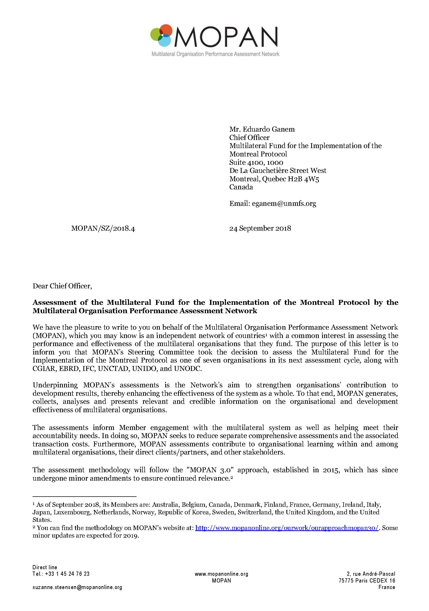
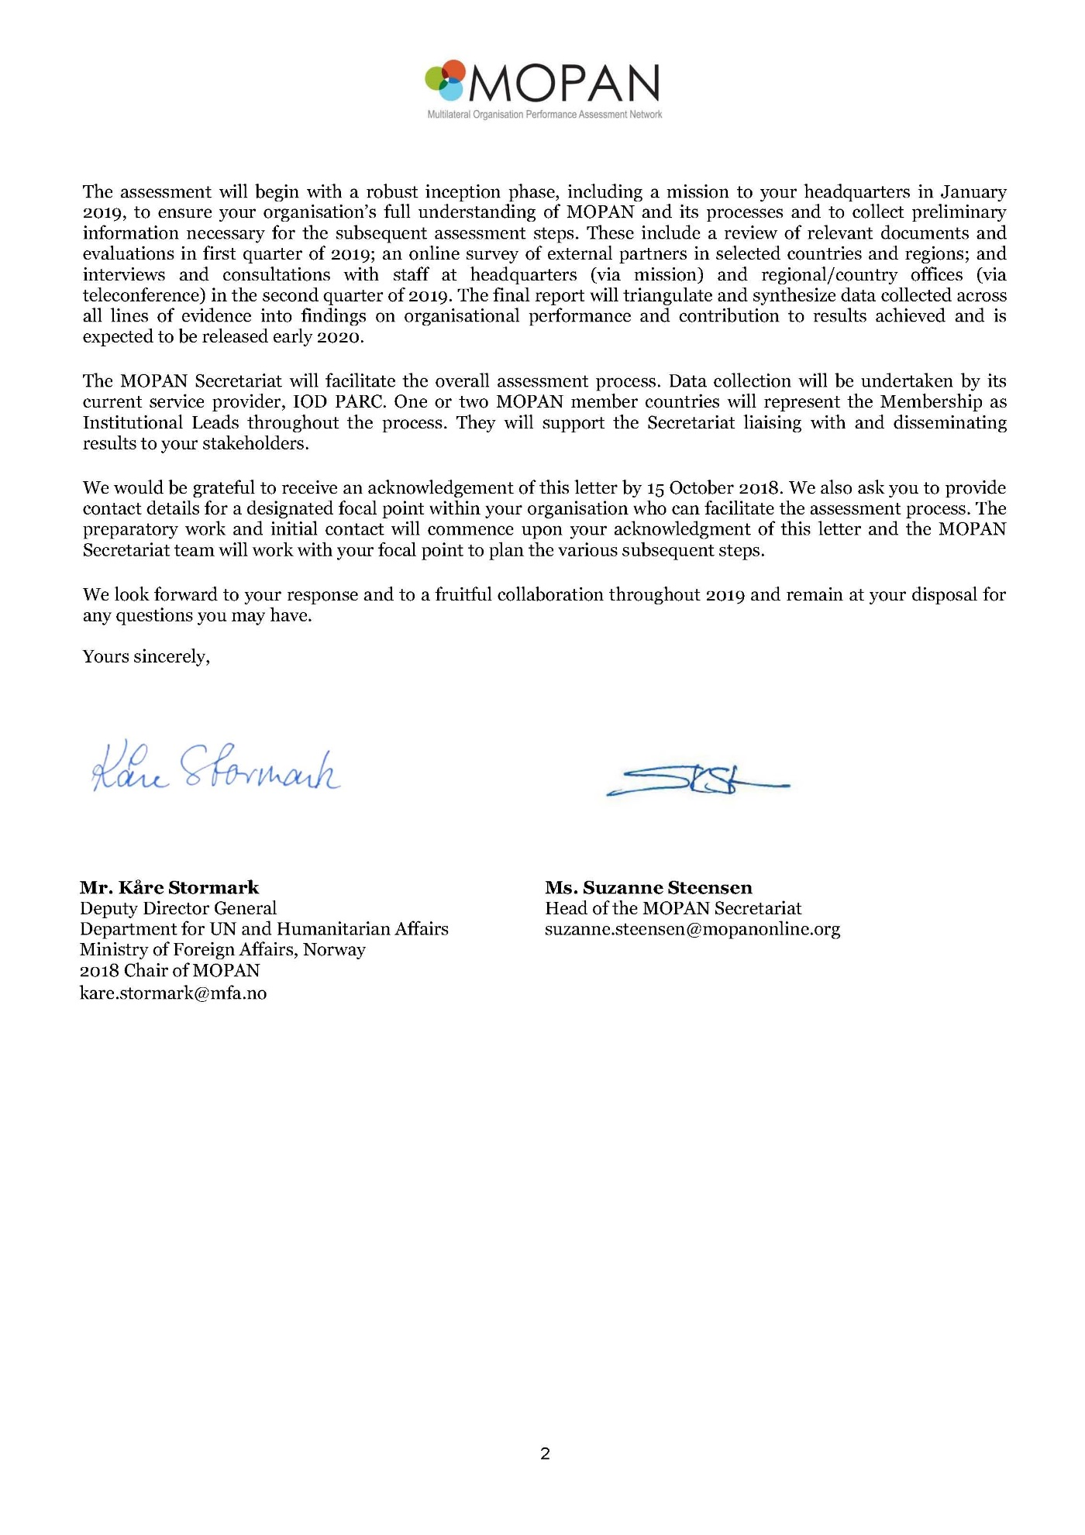

Overview of the Multilateral Organisation Performance Assessment Network (MOPAN)

The Multilateral Organisation Performance Assessment Network (MOPAN) was launched in 2002 as a network of like-minded donor countries for monitoring the performance of multilateral development organisations at the country level. All members have a common interest in knowing more about the effectiveness of multilateral organisations, through joint assessments of these organisations, exchange of information and expertise in monitoring and evaluation.

The Network’s assessments identify strengths and areas for improvement in the multilateral organisations. Findings are used for discussions with the organisations and with their partners, and as ways to further build the organisations’ capacity to be effective. Network members also use assessment findings as a source of input for strategic decision-making about their ways of engaging with the organisations, and as an information source when undertaking individual reviews.

The Network has taken steps over the last years to become more ambitious and professional, with a reshaped assessment approach, more organisations assessed and a permanent Secretariat. This is hosted by the OECD’s Development Co-operation Directorate in Paris since 2013, through a Memorandum of Understanding on the Hosting Arrangement. The Secretariat is the focal point in the assessment process and other MOPAN activities. Its main objective is to co-ordinate the MOPAN assessments and support the Network and its members.

MOPAN membership

In 2018, the Network members are: Australia, Belgium, Canada, Denmark, Finland, France, Germany, Ireland, Italy, Japan, Luxembourg, Netherlands, Norway, Republic of Korea, Sweden, Switzerland, the United Kingdom and the United States of America.

MOPAN assessment approach

MOPAN works with an external service provider to carry out the assessments. The provider gathers information both at the organisations’ headquarters and in countries where they operate through reviews of documents and evaluations; surveys of MOPAN members, clients, and other relevant actors; and interviews and consultations with the organisations’ staff. The Secretariat and MOPAN member countries guide the assessments, providing the interface between the service provider, host countries and organisations.

MOPAN 3.0 is a new operational and methodological iteration of how the Network will assess organisations; it was finalised and first implemented in 2015. Under MOPAN 3.0, the Network is assessing more organisations concurrently than previously, collecting data from more partner countries, and widening the range of organisations assessed over a two-year cycle.

MOPAN 3.0 aims to generate assessments that are credible, fair and accurate. Credibility will be ensured through an impartial, systematic and rigorous approach. MOPAN 3.0 seeks to balance breadth with depth by adopting an appropriate balance between coverage and depth of information from a variety of sources, through multiple streams of evidence. Quality of information will be prioritised over quantity, and structured tools will be applied for enquiry and analysis. Efficient measures of assessment practice will be applied through building layers of data, with a view to limiting the burden on organisations undergoing assessment. A focus on organisational learning aims to ensure utility of findings by multiple stakeholders.

MOPAN 3.0 seeks to provide a diagnostic assessment, or snapshot, of an organisation at present. It will aim to ‘tell the story’ of an organisation’s current performance. It is not an external audit of an organisation, nor it an institutional evaluation. The assessments will not comprehensively assess all operations or all processes of an organisation, nor can it provide a definitive picture of all the organisation’s achievements and performance during the time period of the assessment. MOPAN 3.0 will also not offer comprehensive documentation or analysis of ongoing organisational reform processes.

MOPAN assessed organizations
MOPAN has assessed 27 organisations since 2003 using three different approaches (Annual Survey, Common Approach and MOPAN 3.0).
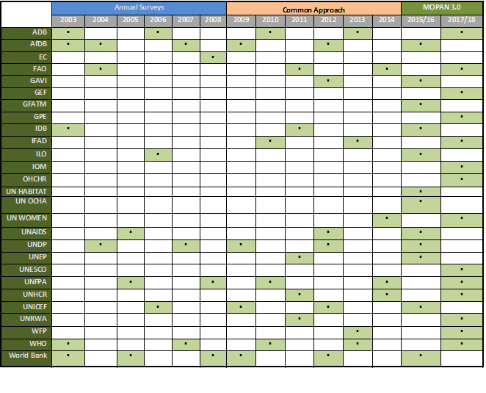
In 2017-2018, MOPAN is assessing the following 14 multilateral organisations that have been selected (the final reports will be published in early 2019):
- Asian Development Bank (ADB)
- Food and Agricultural Organization (FAO)
- Global Environment Facility (GEF)
- Global Partnership for Education (GPE)
- International Fund for Agricultural Development (IFAD)
- International Organization for Migration (IOM)
- United Nations High Commissioner for Human Rights (OHCHR)
- UN Women
- United Nations Educational, Scientific and Cultural Organization (UNESCO)
- United Nations Population Fund (UNFPA)
- United Nations High Commissioner for Refugees (UNHCR)
- United Nation relief and works agency (UNRWA)
- United Nations World Food Programme (WFP)
- World Health Organization (WHO)

UNEP/OzL.Pro/ExCom/81/58
Letters of invitation were sent to members of the Executive Committee, the President of the Bureau of the Twenty-ninth MOP, the President and Vice President of the Implementation Committee under the Non-Compliance Procedure of the Montreal Protocol, the Executive Director of UNEP, the Executive Secretary of the Ozone Secretariat, the implementing agencies, the Global Environment Facility (GEF), and non-governmental organizations.
The provisional agenda was prepared in consultation with the Chair and Vice-Chair of the Executive Committee. The Status of contributions and disbursements, the status of additional contributions, the final accounts for 2017, and the reconciliation of the 2017 accounts were prepared jointly with the Treasurer of the Fund.
Limited distribution documents for the Sub-group are placed on a restricted area of the website for members of the Executive Committee. Restricted documents are sent by email to members of the Sub-group on the Production Sector.
Inventory of approved projects as of June 2018; Policies, procedures, guidelines and criteria as of June 2018; the guide for the submission of stand-alone investment projects pursuant to decisions 78/3(g) and 79/45; the guide for the submission of enabling activities; the guide for the preparation of stage I of the HCFC phase-out management plan (HPMPs); the guide for the presentation of the tranches of HPMPs; the guide for preparation of stage II of HPMPs; the guide for the presentation of stage II of HPMPs; the guide for the presentation of tranches of HCFC production sector phase-out management plans (HPPMPs); and the guide on preparing institutional strengthening projects.
UNEP/OzL.Pro/ExCom/82/64
The report, Control of HFC-23 emissions in Argentina, based on quantities produced, is attached to document UNEP/OzL.Pro/ExCom/82/69.
The presentation was made via Skype.
The 2018 United Nations Leadership Dialogue will entail a one-and-a-half hour ‎dialogue session on the topic, “Speaking Up: When Does It Become Whistleblowing?” More details can be found at http://www.un.org/en/ethics/leadership_dialogue.shtml
The Global Chemicals Outlook report, compiled by UNEP in cooperation with international experts, was designed to inform governments and industry on trends in chemicals production, use and disposal in terms of the goals of Strategic Approach to International Chemicals Management (SAICM). The GCO-II report goes beyond the 2020 SAICM goals and anticipates what a sustainable future for chemicals could be. See: https://www.unenvironment.org/explore-topics/chemicals-waste/what-we-do/policy-and-governance/global-chemicals-outlook
UNEP/OzL.Pro.30/2, paras. 25-30
http://www.mopanonline.org/

