UNITED  NATIONS |  | EP
   | United Nations  Environment  Programme | Distr.  GENERAL  UNEP/OzL.Pro/ExCom/91/7  15 November 2022  ORIGINAL: ENGLISH
EXECUTIVE COMMITTEE OF
THE MULTILATERAL FUND FOR THE
IMPLEMENTATION OF THE MONTREAL PROTOCOL
Ninety-first Meeting
Montreal, 5-9 December 2022
Item 4(d) of the of the provisional agenda

REVISED 2023 AND 2024, AND PROPOSED 2025 BUDGETS
OF THE FUND SECRETARIAT

Introduction

The document consists of the following sections:

- Actual 2021 budget
- Revised 2023 budget
- Revised 2024 budget
- Proposed 2025 budget
- Proposed additional resources
- Proposed budget format
- Recommendation

The tables of the revised 2023 and 2024, and proposed 2025 budgets of the Fund Secretariat are presented in Annex I of the present document. Annex II presents the current organigram of the Secretariat while Annex III presents a proposal for revised budget format.

- Actual 2021 budget

The Treasurer has submitted the final 2021 accounts to the 91st meeting. Schedule 1.3 (actual expenses of the Secretariat budget in 2021) of the document, indicates an unspent balance of US $1,491,964 after rephasing US $264,136 (US $249,136 from the Secretariat budget and US $15,000 from the monitoring and evaluation work programme budget) to the approved 2022 budget. The unspent balance will be returned to the Multilateral Fund at the 91st meeting.
II. Revised 2023 budget

At the 87th meeting, the Executive Committee considered and approved the 2023 budget (decision 87/3(b) based on a 3 per cent increase against the revised 2022 budget which included a 20 per cent reduction in staff costs. In preparing future budgets, the Secretariat committed to consider actual staff costs incurred on the personnel budget lines.

In analysing its monthly actual staff costs during the first three quarters of 2022, the Secretariat projects a net overrun of US $290,000 against its staff budget lines as of 31 December 2022. The projected deficit is broken down by US $443,000 under the professional staff category and is partially offset by US $153,000 of savings under the general services staff category. Table 1 below presents more details on the actual and projected staff costs for 2022.

Table 1: 2022 actual and projected staff budget performance (US $)

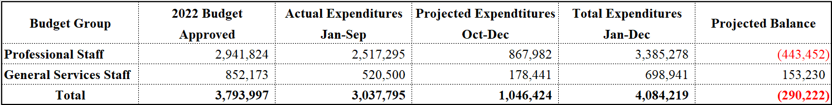

Accordingly, the Secretariat hereby presents the revised 2023 budget based on the 2022 actual and projected staff costs. The provision considers the 2022 projected overrun of US $290,000 but excludes the non-recurrent costs related to the installation entitlements for the three professional staff members recruited in 2022. The overall 2023 revised budget is US $7,624,640 as compared to the approved budget of US $7,039,830. While this revision reflects an increase of US $584,811 or 8.3 per cent, when excluding the 2022 overrun, the increase would only be US $294,588 or 4 per cent.

The non-staff budget estimates have not been revised in this document. However, given the sharp increase in prices brought by the global inflation rates, the Secretariat is in the process of analyzing and testing its current non-staff budget provisions against the 2022 actual costs. This mainly relates to the conference and meeting services costs that have been subject to significant increases in terms of conference rooms rentals, translation, interpretation, report writing, and travel. To ensure the most financially viable data, the expenditure trends for all three meetings held in 2022 will be used as a basis for presenting a revised budget for the year 2023 and thereafter.

- Revised 2024 budget

The Secretariat adjusted the approved 2024 budget to reflect the revised 2023 estimates and applied a 3 per cent inflation rate. All remaining budget lines remain unchanged.

- Proposed 2025 budget

The proposed 2025 budget is based on the revised 2024 budget. It makes provision for two meetings of the Executive Committee and continues to apply 3 per cent inflation rate to staff costs only.

- Proposed additional resources

The Secretariat would like to seek the Executive Committee’s guidance and approval for the following additional resource requirements. Subsequently, if approved and where applicable, the 2023 budget onwards will be adjusted to reflect the associated cost estimates.

Staffing changes – US $495,400 (2023 onwards)

As presented in the analysis related to the capacity of the Multilateral Fund institutions to address HFC phase down, adjustments are required to address new areas of work and improvements of existing areas for the Secretariat, inter alia restructure of the current business planning and progress reporting responsibilities to focus on business intelligence and finance for enhanced analysis of the Fund’s financial management; strengthening project review capacity including building technical capacity on issues related to energy efficiency and other emerging issues; and management of the new knowledge management system. The Secretariat therefore presents, for consideration of the Executive Committee, a request for the establishment of two staff positions at P-4 level, starting 2023 and each with a budget implication of US $247,700.
Travel and daily subsistence allowance (DSA) for an additional Article 5 delegate – US $7,700 (2023 onwards)

Decision XXXIV/17 of the Parties requested the Executive Committee to consider increasing the funding allocated for travel by parties operating under paragraph 1 of Article 5 of the Protocol in the budget of the Fund Secretariat, with a view to supporting the participation in Executive Committee meetings of one party operating under paragraph 1 of Article 5 of the Protocol that is not eligible through the existing rotation system for a seat on the Executive Committee for the year in question, on the understanding that the Party concerned could be co-opted by another Party operating under paragraph 1 of Article 5 of the Protocol holding the rotating seat for the year in question. Pending the decision of the Executive Committee on the matter, the costs for an additional Article 5 delegate to participate in biannual Executive Committee meetings are estimated at US $7,700.

Knowledge management system – US $358,000 (2023) and US $542,000 (2024)

As presented in the update of the information strategy of the Multilateral Fund, the estimated cots for the creation of the new knowledge management in three phases will range from US $1 million to US $1.3 million. The proposed cost estimates are currently only for phase 1 (US $250,000 to US $350,000) and phase 2 (US $450,000 to US $550,000) while phase 3 will be requested once the former phases are implemented. In alignment with the project timeline and milestones, the budget for phases 1 and 2 will be broken down in two years (2023 and 2024) to reflect equal portions of US $175,000 for phase 1 while phase 2 will be provisioned for US $183,000 (33 per cent) in the first year and US $367,000 (67 per cent) in the second year. The proposed budgets will be adjusted in the following year to reflect the more accurate contractual and committed services.
Umoja support – US $115,000 (2023) and US $60,000 (2024 onwards)

In its resolution 63/262, the General Assembly endorsed the cost-sharing arrangement for financing the Umoja enterprise resource planning project for the United Nations Secretariat worldwide. The corporate costs comprise the Umoja project, Umoja maintenance, and Umoja master data maintenance. In 2022, the total costs amounted to US $30,645,700; out of which US $18,905,473 is paid by New York based offices while the remaining amount of US $11,740,227 is paid by Offices Away from Headquarters (OAHs). UNEP’s 2022 overall share of these corporate costs is US $2,321,600; out of which, the amount of US $54,260 is charged to the Multilateral Fund Secretariat.

It is worth noting that prior to 2021, the methodology and total cost of the project was much lower, and the Multilateral Fund annual cost was around US $9,000 only. In 2021, with a change in methodology and increase in total costs, the share of the Secretariat was US $53,680 and was exceptionally absorbed by UNEP. However, through memorandum reference EO/CSD/BU/21/Umoja, dated 10 May 2021, UNEP requested Conventions and Multilateral Environmental Agreements (MEAs) to absorb these costs and explore the option of funding them from their core budgets through consultations with their Executive Committees/Conferences/Meetings of Parties.

Accordingly, the Secretariat hereby requests the Executive Committee to consider the Umoja costs in the Multilateral Fund Secretariat annual budgets. To cater for the 2022 charges, the Secretariat requests the amount of US $115,000 in 2023 and the amount of US $60,000 from 2024 and thereafter.

Table 2 presents the additional resource requirements by item for the years 2023-2025.
Table 2. Additional resource requirements by item for the years 2023-2025 (US $)
Item | 2023 | 2024 | 2025
Staff changes | 495,400 | 510,262 | 525,569
Travel and DSA for an Article 5 delegate* | 7,700 | 7,700 | 7,700
Knowledge management system | 358,000 | 542,000 | 0**
Umoja support | 115,000 | 60,000 | 60,000
Total | 976,100 | 1,119,962 | 593,269
* Provision is made for each year; the year where funding is not applicable, the respective amount will be returned to the Fund.
** Phase 3 (US $300,000 to US $400,000) will be requested once the former phases are implemented.

- Proposed budget format

At the 3rd meeting, under agenda item 6 “Revised budget for the Fund Secretariat for 1991”, the Executive Committee decided on the budget components, sub-components, and budget lines as well as the extent to which the Chief Officer should be given flexibility to switch expenditure between budget lines. The budget and presentation format allowed to synchronize the budget implementation and reporting with the previous “IMIS” financial system structure and capabilities.

In June 2015, in line with the UN Secretariat wide corporate initiative, UNEP deployed a new “Umoja” Enterprise Resource Planning Solution. Among several new modules, the new system introduced revised chart of accounts as well as budget classifications and a business intelligence reporting tool.

Since the deployment of Umoja, the Multilateral Fund Secretariat budget format and classifications have not been fully aligned with the Umoja financial module structure. This necessitated manual adjustments and creative methods for implementing, monitoring, and reporting on approved budgets. Accordingly, under Annex III, the Secretariat hereby proposes for the Executive Committee consideration and approval, a new format presentation that balances the need for more transparency and accountability with a preparation process that is efficient and sustainable and that allows alignment with the Umoja structure as well as the operational realities of the Multilateral Fund. The introduced improvements to the presentation format ensure consistency and continuity from previous plans. It also aggregates the staff budget provisions for a condensed view that considers the privacy of staff members in terms of their actual salaries and entitlements. As an exception, to allow for comparison with the current format and provide the budget workings, Annex IV disaggregates the staff budgets at the position level along with the current budget line (2-figure code).

In terms of accountability and budget management flexibility, the Secretariat proposes no change to the current mechanism. The Chief Officer will continue to have complete flexibility within each component and up to a limit of 20 per cent for switching or redeploying funds between components. If faced with a situation where the redeployment of funds would exceed the 20 per cent cap, the Chief Officer should seek the approval of the Executive Committee. However, given the newly proposed format and classifications, this mechanism would be applied to the new components.

Table 3 below provides a cross walk mirror between the current and proposed budget components while Annex V provides detailed mapping of both formats at the budget line level.
Table 3: Budget format mapping at the component level
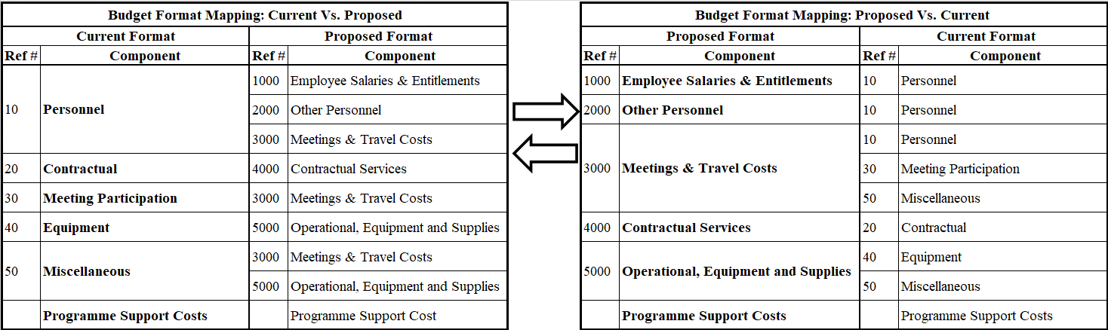

VII. Recommendation

The Executive Committee may wish:

To note:

The document on the revised 2023, 2024 and proposed 2025 budget of the Fund Secretariat contained in UNEP/OzL.Pro/ExCom/91/6;

The return, to the Multilateral Fund at the 91st meeting, of US $1,491,964 from the approved 2021 budget of the Fund Secretariat;

To consider the following additional requirements and the related costs for the Secretariat:

Establishment of two staff positions at P-4 level, each in the amount of US $247,700, in 2023 and thereafter with a 3 per cent inflation rate;

Travel and daily subsistence allowance for one additional Article 5 delegate to Executive Committee meetings, in the amount of US $7,700, in 2023 and thereafter;

Knowledge management system, in the amount of US $358,000 in 2023 and US $542,000 in 2024;

Umoja support, in the amount of US $115,000 in 2023 and US $60,000 in 2024 and thereafter.

To approve:

The revised 2023 budget of [US $7,624,640] as contained in Annex I to the present report based on the 2022 actual staff costs, including the projected overrun of US $290,000; and a 3 per cent increase in staff costs; [and [US $976,100] of the related costs arising from the additional requirements referred to in sub-paragraph (b) above];

The revised 2024 budget of [US $7,444,138] as contained in Annex I to the present report based on the 2023 revised budget, excluding the 2022 projected overrun; and a 3 per cent increase in staff costs [and [US $1,119,962] of the related costs arising from the additional requirements referred to in sub-paragraph (b) above];

The proposed 2025 budget of US $7,584,054 as contained in Annex I to the present report based on the 2024 revised budget; and a 3 per cent increase in staff costs; [and [US $593,269] of the related costs arising from the additional requirements referred to in sub-paragraph (b) above noting that phase 3 of the knowledge management system has not been included therein];

To approve the proposed format, as contained in Annex III to the present document, for presenting the budget of the Fund Secretariat.

UNEP/OzL.Pro/ExCom/91/1
UNEP/OzL.Pro/ExCom/91/5
UNEP/OzL.Pro/ExCom/91/67
UNEP/OzL.Pro/ExCom/91/70

